Rapid Screening Solution Deployment Guide (Power Platform) V1.7

Summary: This is a technical whitepaper which outlines steps for deploying the Rapid Screening Solution.

Disclaimer: This technical whitepaper and recommendations are solely provided to help deploy rapid screening solution. Recommendation should be used in conjunction with your organizations best practices and processes with data privacy, security, and retention policies.

Change History:

|  |  |  |  |
| --- | --- | --- | --- |
| Version History | Date | By | Notes |
| V1.0 | March 19 , 2021 | Microsoft | Created the first draft of the deployment guide |
| V1.1 | March 30 , 2021 | Microsoft | Updated GitHub links and general reivew |
| V1.2 | April 19, 2021 | Microsoft | Added Exchange (outlook) requirement   * Page 18, page 9   Added presona and legacy licensing requirmenets   * Page 14, page15 |
| V1.3 | April 19, 2021 | Microsoft | Updating notes for shareing error workaround   * P72, p73, p74, p75 |
| V1.4 | April 19, 2021 | Microsoft | Power BI deployment Update   * Pages79 to 82 |
| V1.5 | April 21, 2021 | Microsoft | Added Self screening additions   * p54 self screening settings   Added environment variables   * p54, p55   Facility note for self screening   * p56   facility type note for self screening   * p49 |
| V1.6 | May 19, 2021 |  | Added Appointment Booking Email   * pg. 52   Updated Solution Settings image   * pg. 55   Added new Environment Variables   * pg 56-57   Added Colour Template   * pg. 69-71   Auto Generated Operating Hours   * pg. 72   Field-level Security   * pg. 90 |
| V1.7 | August 26, 2021 | Microsoft | Fixed typos |

Table of Contents

Executive Summary 6

The System Overview 6

The Document Outline 6

Technical Specification 7

An Architecture Overview 7

The Architecture Diagram 7

Design Reference 8

Prerequisites and Requirements 10

Business Requirements and Decision Points 10

License Requirements 14

Persona Description 14

Persona Licenses 15

Device Requirements 15

Employee 15

Health and Safety Officer 16

Power Apps Requirement 16

The Azure Active Directory 16

Supported OS Platform 16

A Supported Browser 16

IP Addresses and Services 16

License Requirement 16

Power BI Requirement 17

License Requirement 17

Power BI System Requirements 17

Power Automate Requirement 17

License Requirement 17

Power Platform Environment Requirement 17

Environment 17

DLP (DATA LOSS PREVENTION) Policies 18

Azure Active Directory Requirement 18

Azure AD Security Groups 18

Exchange/Outlook Requirement 18

Service Users Requirement 19

Solution Deployment Permission Requirement 19

Deployment Steps 20

1. Azure Active Directory (AAD) Security Groups Setup 20

2. The Power Platform Environment Setup 23

3. Assigning Licenses 26

Power Apps 26

Power Automate 27

3. Solution Deployment in the Development Environment 27

4. Power Automate Flow Configuration 39

5. Solution Data Configuration 42

Template Data Import 42

Manual Data Configuration 46

6. Sharing Apps 79

7. Launch Apps for the First Time 86

8. Add Power Apps in Microsoft Teams 88

Post Deployment Steps 88

Enable Auditing 88

Audit & Activity Loging 88

Availability Monitoring 88

Power Platform Center of Excellence(COE) Starter Kit 88

Processes 88

Application Process Flows 89

Power Automate Flows 89

Power BI Deployment 90

Assign Licenses 90

Power BI – Deployment 90

Refreshing Data 93

Security 93

Sharing 93

**Field-level Security** 93

Application Lifecycle Management 97

Backup & Restore 97

Solutions Deployment 97

Test/UAT Deployment 97

Production Deployment 97

Application Lifecycle Management (ALM) 97

Extensibility 97

Appendix A - Reference 98

# Executive Summary

The Rapid Screening Consortium system provides end users with a facility for booking tests for the COVID-19 virus. The system was built using Microsoft’s Return-To-Work (RTW) solution based on the Power Platform. The employers participating in the consortium are called “Members” and the centralized datastore is called the “Hub”. The system functions by collecting test schedules and aggregate results and sending them to the hub.

## The System Overview

The technical solution is composed of two parts: the end-user data collection application hosted in the consortium members’ computing environment and the Consortium Hub that collects and aggregates the information in a centralized repository. **This document details the deployment and installation of technical details for the member portion of the Rapid Screening Consortium application specific to the Power Platform**. The Hub implementation is described in a separate document.

The member application consists of two systems:

1. The end-user interface, automation, and BI, are implemented via Microsoft Power Platform (focus on this document)
2. The backend file transmission system implemented in Microsoft Azure.

## The Document Outline

This document outlines the Power Platform component of the rapid screening solution.

The technical specification section describes the overall architecture and technical implementation details.

The deployment section highlights details steps to install and configure the solution.

Processes and BI section review the key components of Power Automate and Power BI reports.

The document contains an appendix reference section that provides links to detailed external documentations for each of the components used.

# Technical Specification

## An Architecture Overview

The member system is primarily implemented using Microsoft Power Platform. The user interface screens are created as Microsoft Power Apps and the data is stored in the Dataverse (see the appendix for product links). When the data is collected, it is extracted, encrypted, and transferred to the Consortium Hub for processing.

## The Architecture Diagram

The flow of the architecture diagram below is described in detail in Section 2.1.3.



## Design Reference

1. **The Power Platform Dataverse**

All the data captured via Power Apps is saved to the Dataverse on the Power platform. The Dataverse is a secure database as a service hosted by Microsoft cloud.

Data is entered into the system by the end users, using the Power App UI.

1. **Dataverse REST API**

The Dataverse Web API provides development experiences that can be used across a wide variety of programming languages, platforms, and devices. The Web API implements the OData (Open Data Protocol), version 4.0, an OASIS standard for building and consuming RESTful APIs over rich data sources. The Azure function uses these APIs to call into the Dataverse.

1. **Employee Power Apps (MS RTW)**

Employee Power App is a Canvas Power App used by employees to setup their profile, provide consent and attestation as well as book rapid screening, etc. This application is the extension of Microsoft Return to Work (RTW) employee template. The app can be used on any browser on a desktop or on mobile devices using a Power Apps player.

1. **Screening (HSO) Power App**

Health and Safety Rapid screening Power App is a Canvas app used by Health officers to check employees in and capture rapid screening results.

1. **Facility Management Power App (MS RTW)**

The Facility Management Power App is a model driven Power App based on the Microsoft Return to Work (RTW) template. This app is used by test facility manager or system admins to setup the solution and configure the testing facilities, operation hours and general solution settings such as attestation question and consent language, etc.

1. **Case Management Power App (MS RTW)**

Case Management Power App is a model driven Power App based on the Microsoft Return to Work (RTW) template. This app can be used by care managers to report and view cases throughout their organization globally, and manage active cases through testing, quarantine and identify others exposed.

1. **The Leaders Power BI Dashboard**

Power BI dashboard is being used by member’s org leaders and facility managers.

1. **Power Automate Flows**

Power Automate is an online workflow service that allows automating tasks across multiple services using connectors or UI automation. The solution uses multiple flows to orchestrate processes such as email notifications, data sharing, etc.

1. **Connectors**

A connector is a proxy or a wrapper around an API that allows the underlying service to talk to Microsoft Power Automate, Microsoft Power Apps. It provides a way for applications to connect to many other applications inside or outside of the Microsoft ecosystem.

1. **Office 365 Users (Connector)**

Office 365 user connector is being used inside the Power Apps to identify the users and their related information.

1. **Office 365 Outlook (Connector)**

Office 365 outlook connector is being used in communication flows to send emails to employees.

1. **The Azure Active Directory**

All users’ access is governed and authenticated by the Azure Active Directory. Power Apps and Power Automate relies on Azure Active Directory (AAD) for authentication. This means that you can leverage the full functionality of AAD to manage and restrict access to users.

1. **The Member’s Azure Subscription**

All the Azure components such as Azure Function, key Vault or Azure Data Share, are hosted on the member azure subscription, which will orchestrate the encryption and ETL process from Dataverse to the Consortium Hub tenant

# Prerequisites and Requirements

## Business Requirements and Decision Points

The data points below need to be defined as part of the solution deployment:

1. Define the list of employees who want to participate in the program – this list can be extended in future once more employees sign up for the program.
2. Define a list of Health and Safety Officers (HSO) that are administering the screenings per facility (screening location).
3. Define the facility managers or solution admins who will maintain facility information’s such as operating hours, etc.
4. Define a list of screen type names: so far 2 types of screening are being used: Abbot Panbio and BD Veritor.
5. Define screening facilities province.
6. Define if self/home screening is allowed – if yes, prepare self-screening consent language which will be displayed to employees during the self-screening process on the employee app.
7. Prepare program consent language in HTML format – this is the consent language that employees will agree on their profile page of the employee app.
8. Prepare Opt-out program message – this is a message that will be shown to employees on the employee app if they opt out of the program on their profile page – below is a sample message:

*“You have not provided your consent to the collection, use and sharing of your personal data. To continue using the Rapid Screening Application, please change your Privacy Consent answer to Yes. Otherwise please exit the application.”*

1. Attestation language in the HTML format. These are questions that will be shown on the employee app to confirm employees do not have any COVID19 symptoms before going to the screen.

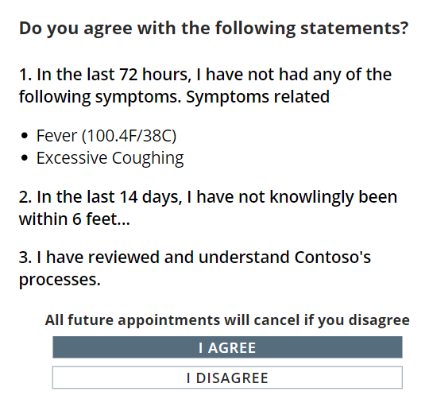

1. Prepare the attestation text shown to employees who have COVID19 symptoms outlined on the previous bullet (bullet number 8).
2. The organization’s health and safety email address or the HR (Human Resources) email address – this email address will be shown along with the instructions defined in the previous step (step 9) –

See the screenshot below for bullets 9 and 10.

The text *“Please stay at home and take care of yourself and contact us if you need any support. You can contact health authorities if your symptoms worsen.”* – is configurable in the Solution settings.

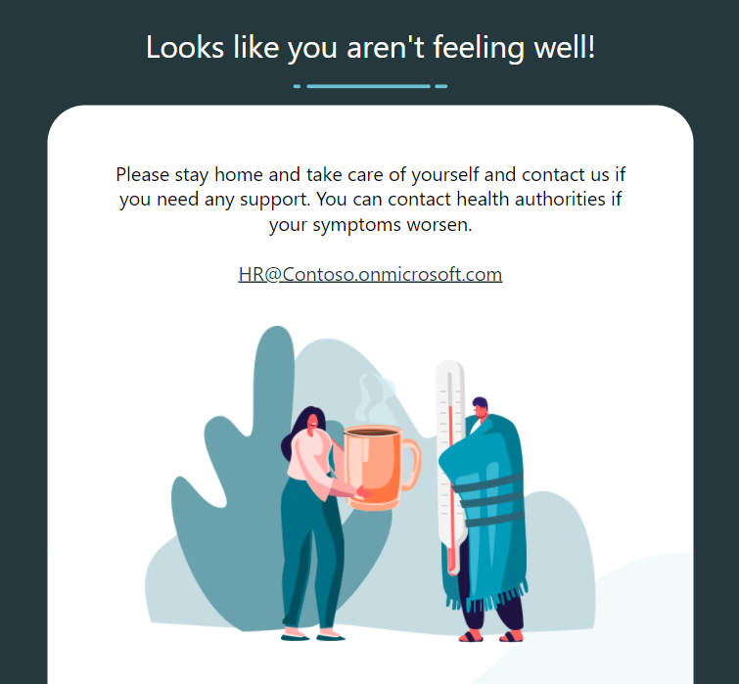

1. List of facilities in below format
   1. A Facility Name.
   2. Facility time zone
   3. List of Provinces that screening facilities will operate.
   4. Optional: Facility closed days (could be none)
   5. Optional: Email address (es) to notify positive results
   6. Type of screen is being used in the facility (from step 4)
   7. Floor(s) at the facility.
   8. Screening Area in the facility (this could be the name of the room or area)
   9. Define each facility operating hours:
      1. Start date.
      2. End date
      3. Start hour
      4. Start minute
      5. End hours
      6. End minutes
      7. Length of appointment (choices between 20, 30 and 60 minutes)
      8. Capacity per appointment timeslot
2. Email body – for the result communication to the employee. Sample contents (Can be HTML):

*“Thank you for participating to the Employee Screening Pilot Program. Please be advised that your screening result is now available. Please review the attached document for your result. CONFIDENTIALITY NOTICE The information transmitted in this communication is intended only for the use of the party named and is confidential. If you are not the intended recipient or received this communication by error, please notify the sender and delete the message without copying or disclosing it. Thank you. Merci de votre participation au programme pilote de dépistage rapide s’adressant aux employés. Veuillez noter que le résultat de votre test de dépistage est maintenant disponible. Veuillez consulter le document ci-joint relativement à votre résultat. AVIS DE CONFIDENTIALITÉ Ce message est destiné à l'usage exclusif de la partie désignée: son contenu est confidentiel. Si vous n'êtes pas le destinataire ou croyez avoir reçu par erreur ce message, nous vous saurions gré d'en aviser l'émetteur et d'en détruire le contenu sans le communiquer à d'autres ou le reproduire. Merci.”*

1. Decision point: Mask employee name on pass (Yes/No) on the employee app when employee’s book appointment and present pass to HSO

Screenshot for Yes:

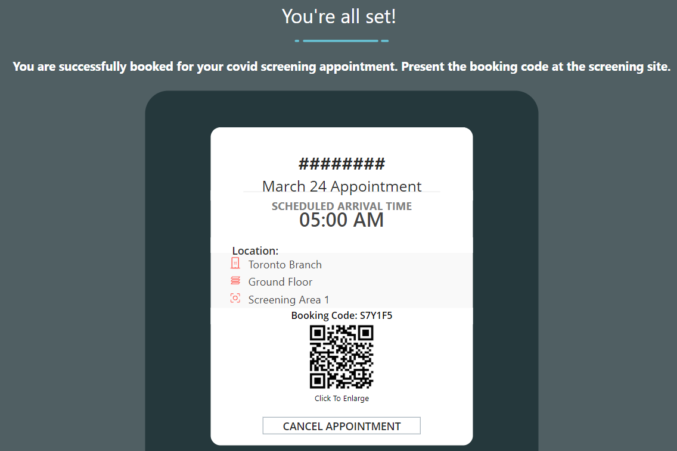

Screenshot for No:

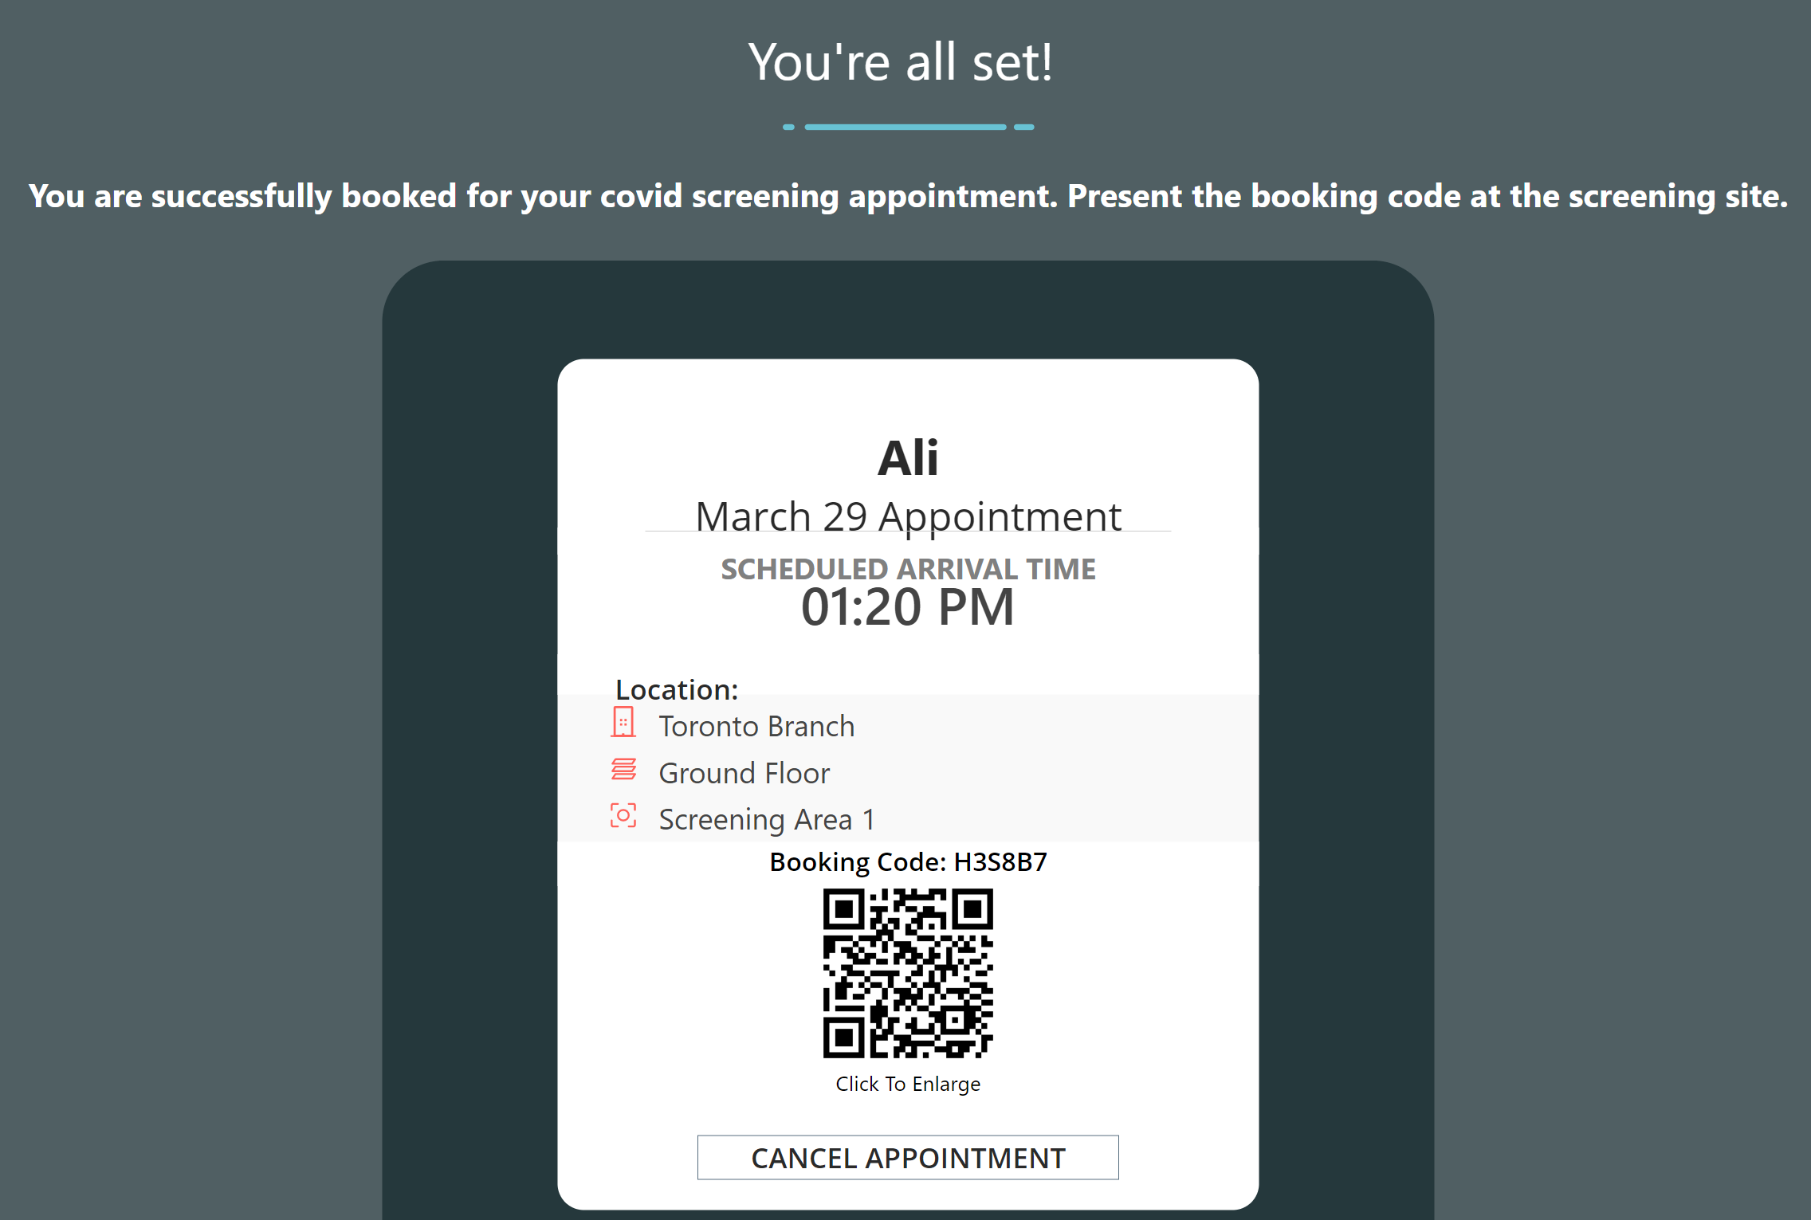

1. Decision point: mask employee info on the screening app (Yes/No): This setting will hide the employee’s name from HSO screening app on the screening result summary page if an employee tests positive.
2. Decision point: Hide phone number for employees (Yes/No): This setting will hide the employee phone number from HSO screening app on the screening result summary page if an employee tests positive.
3. Decision point: Hide personal email for employees (Yes/No):  This field enables capturing personal emails in the employee’s profile page.

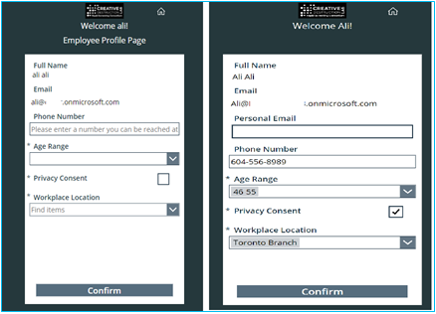

## License Requirements

### Persona Description

|  |  |
| --- | --- |
| Persona | Description |
| Employees | A person that uses the employee rapid screening Canvas app to provide attestation, book appointments – This user will have Azure Active Directory (AAD) account (corporate account) |
| Health and safety officers | Any member of the organization with AAD account and proper access that uses Screening Canvas app to check-in employees and update screening results in the screening app |
| Leaders and facility managers | Anyone using Power BI dashboards |
| Admins (or facility manager) | Office 365/Azure Active Directory or Power Platform admins (or a user with the facility manager security role) that are maintaining the environment and configuration as well as accessing Facility safety management app |
| Service Users | Licensed Service user that will be used to provision Power Platform environments, deploy the solution and owner of Flows and Apps |

### Persona Licenses

Make sure below licenses are procured and available in the tenant.

Contact your Microsoft account manager if clarification is required.

|  |  |  |
| --- | --- | --- |
| Persona | License Type | Note |
| Employees** | Power Apps per app plan | Or Power apps per user plan (unlimited)  Or legacy P1 or Legacy P2 |
| Health and safety officers | Power Apps per app plan | Or Power apps per user plan (unlimited)  Or legacy P1 or Legacy P2 |
| Leaders and facility managers | Power BI Pro | Or E5 or Power BI premium capacity |
| Admins | Power Apps per user plan | Or Legacy P2 |
| Service Users | Power Apps per user plan & Power Automate per user plan | Power Automate per flow plan can also be used instead of Power Automate per user plan* |

*In this version of solution (ver: 1.0.0.120), there are 5 Power Automate Flows in the solution and if Per Flow plan is going to be used (instead of power automate per user plan), each flow requires a per flow license on each Power Platform environment. i.e., if there are 3 environments (Development, Test/UAT, Production), 15 per flow plan is required.

** Azure Active Directory (AAD) is required to access all the apps including the employee app. Free tier of AAD can be used if the target tenant has less than 500k objects in AAD and does not require advance features of AAD: [Pricing - Active Directory | Microsoft Azure](https://azure.microsoft.com/en-us/pricing/details/active-directory/)

Note: There might be a need to purchase extra Dataverse(CDS) Database storage capacity depending on the volume of licenses that are being purchased and also existing capacity usage across the tenant. Power Platform admin can validate that on PP admin center if enough Dataverse capacity exist. Minimum 10 GB of Dataverse DB storage is recommended which can be purchased.

## Device Requirements

Rapid screening apps are available on multiple platforms for maximum flexibility, this includes supported browsers, mobile operating systems such as Android and IOS as well as Microsoft Teams Platform.

Power Apps on Android and iOS are integrated with Intune and support Intune policies for mobile application management, enabling customers to have better control and security over their data.

### Employee

* Browser: Employees can use the employee rapid screening app on any devices such as workstations, tablet, laptops or mobile with supported browser. For more details see next section for Power Apps requirements
* Mobile/tablet app: Employees can use the employee rapid screening app on supported mobile devices via Power apps mobile app: [Run canvas app and model-driven apps on Power Apps mobile - Power Apps | Microsoft Docs](https://docs.microsoft.com/en-us/powerapps/mobile/run-powerapps-on-mobile#:~:text=The%20Power%20Apps%20mobile%20app%20is%20now%20integrated,work%20on%20iOS%2C%20see%20Shortcuts%20User%20Guide%20.)
* Microsoft Teams: Employees can access the employee app on Microsoft Teams if the organization has enabled the app inside the Microsoft Team – see deployment steps for more details.

### Health and Safety Officer

* Browser: HSO’s can use the rapid screening app on any devices such as workstations, tablet, laptops or mobile with supported browser. Screening app in browser does not support QR reader and HSO officers can use booking code instead of QR codes to check employees in.

For more details see next section for Power Apps browser requirements

* Mobile/tablet app: HSO’s can use the rapid screening app on supported mobile devices via Power apps mobile app. IOS and Android mobile/tablet operating systems support QR code reader via camera: [Run canvas app and model-driven apps on Power Apps mobile - Power Apps | Microsoft Docs](https://docs.microsoft.com/en-us/powerapps/mobile/run-powerapps-on-mobile#:~:text=The%20Power%20Apps%20mobile%20app%20is%20now%20integrated,work%20on%20iOS%2C%20see%20Shortcuts%20User%20Guide%20.)

## Power Apps Requirement

### The Azure Active Directory

The Power Platform authentication is handled by AAD and each user should have AAD account.

### Supported OS Platform

Please make sure users have a proper platform to run the Power Apps: [System requirements, limits, and configuration values for canvas apps - Power Apps | Microsoft Docs](https://docs.microsoft.com/en-us/powerapps/maker/canvas-apps/limits-and-config#supported-platforms-for-running-canvas-apps-using-the-power-apps-mobile-app)

### A Supported Browser

Please review the browser system requirements for Power Apps

[System requirements, limits, and configuration values for canvas apps - Power Apps | Microsoft Docs](https://docs.microsoft.com/en-us/powerapps/maker/canvas-apps/limits-and-config#supported-browsers-for-running-canvas-apps)

### IP Addresses and Services

IP address ranges and required services that should be allowed for end users. Make sure to look at your Power Platform environment region to define which IP range would apply:

[System requirements, limits, and configuration values for canvas apps - Power Apps | Microsoft Docs](https://docs.microsoft.com/en-us/powerapps/maker/canvas-apps/limits-and-config#ip-addresses)

[System requirements, limits, and configuration values for canvas apps - Power Apps | Microsoft Docs](https://docs.microsoft.com/en-us/powerapps/maker/canvas-apps/limits-and-config#required-services)

### License Requirement

To develop and run a Power App, you need a Power Apps standalone premium capacity (Per app/Per user). You will also need to make sure enough storage capacity exists in your tenant. After the licenses are purchased, you can view the capacity details from the Power Platform admin center.

[New Microsoft Dataverse storage capacity - Power Platform | Microsoft Docs](https://docs.microsoft.com/en-us/power-platform/admin/capacity-storage#capacity-page-details)

## Power BI Requirement

### License Requirement

Organization leaders or facility administrators require Power BI licenses to access Power BI reports through Power BI service. One of the licenses below should be in place for Power BI:

* Microsoft 365 E5 (per user)
* or Power BI pro (per user)
* or premium capacity (Tenant level license)

### Power BI System Requirements

To be able to deploy and publish the Power BI reports, the Power BI admin should open the report in the Power BI desktop first, configure and then push it from Power BI desktop to Power BI service.

Review the minimum requirement for the Power BI desktop: [Get Power BI Desktop - Power BI | Microsoft Docs](https://docs.microsoft.com/en-us/power-bi/fundamentals/desktop-get-the-desktop#minimum-requirements)

Review the Service URLs for Power BI service that should be allowed to access the Power BI service: [Add Power BI URLs to allow list - Power BI | Microsoft Docs](https://docs.microsoft.com/en-us/power-bi/admin/power-bi-allow-list-urls)

Leader can open the report on a browser or via Power BI app. See supported browsers for Power BI: [Supported browsers for Power BI - Power BI | Microsoft Docs](https://docs.microsoft.com/en-us/power-bi/fundamentals/power-bi-browsers)

## Power Automate Requirement

### License Requirement

Depending on how many service accounts you have (recommended to have at least 2), Power Automate per user plan is required to run Power Automate Flows under the context of this user. You can also user Power Automate Per Flow plan if you already have those licenses in your tenant available.

## Power Platform Environment Requirement

### Environment

To stand up the solution for your tenant it is recommended to have few environments to facilitate application lifecycle management. It is up to you and your organization policies to determine how many environments will be needed but it is recommended to have at least 3 Power Platform environments:

1. Development: type of Sandbox
2. Test/UAT: type of Sandbox
3. Production: type of production

Each environment consumes approximately 1GB of Dataverse storage in your tenant. Make sure enough capacity exists in your tenant before creating these environments.

Note: The details on setting up the environments can be found under the deployment section of this document.

### DLP (DATA LOSS PREVENTION) Policies

DLP policies enforce rules for which connectors can be used together by classifying connectors as either Business or Non-Business. You can read more about DLP: [Data loss prevention policies - Power Platform | Microsoft Docs](https://docs.microsoft.com/en-us/power-platform/admin/wp-data-loss-prevention)

If you do not have any DLP policies on your tenant (your M365 global admin or Power Platform service admin can verify) no action needs to be taken at this point but if your organization has deployed DLP policies, it is important to make sure connectors listed below are unblocked and are belonging to the same category in the DLP settings (all business or non-business):

1. Common Data Service (both)
2. Office 365 Outlook
3. Office 365 Users

## Azure Active Directory Requirement

### Azure AD Security Groups

To maintain the solution and access management we recommend creating 4 Azure Active Directory security groups (membership type: assigned) per Power Platform environment (dev/test/prod) – i.e if you have 4 Power Platform environment you would need 16 AAD security groups:

1. AAD group at the environment level which contains a list of all users including employees, HSO and facility admins. **(Please do not nest the other groups into this security group -** [**Control user access to environments: security groups and licenses - Power Platform | Microsoft Docs**](https://docs.microsoft.com/en-us/power-platform/admin/control-user-access)**)**
2. AAD security group that contains employees.
3. AAD security group that contains HSO staff.
4. AAD security group that contains Facility Safety Managers.

For More details refer to: [Create a basic group and add members - Azure Active Directory | Microsoft Docs](https://docs.microsoft.com/en-us/azure/active-directory/fundamentals/active-directory-groups-create-azure-portal)

Note: If you have an MFA (Multi Factor Authentication) or conditional access enabled on the tenant, they will apply to Power Apps as well.

Note: The details on setting up the AAD security groups can be found under the deployment section of this document.

## Exchange/Outlook Requirement

The Power Automate Flows inside the rapid screening solution is using Outlook connector to send email notification to employees, therefore Microsoft Exchange and outlook connector is required to use the application.

* With solution version < 2.x.x.x outlook connector is required for all employees since the emails are being send directly from the app to employees
* With future solution version > 3.x.x.x we are removing the outlook connector from the power apps and putting it on a flow which means only the owner of the flow (service account) need Exchange and outlook to send emails.

## Service Users Requirement

It is recommended to use service users to deploy the solutions as well as making this user owner of apps and Power Automate Flows. It is recommended to have at least 2 service users, one for production and one for non-prod environments.

Service accounts should be able to create connections in the target environment:

1. Office 365 users
2. Office 365 Outlook
3. Common Data Service (Dataverse)

These service accounts should have licenses below:

1. Microsoft 365 license (E3 or E5)
2. Power Apps Premium license (Per app/per user)
3. Power BI license
4. Power Automate per user license.

Note: Considerations for organizations that won’t be able to use the service account:

* Make sure the person or groups that are setting up the solution have proper licenses.
* The Power Platform environment will be owned by the users who creates it (system admin role)
* The Apps and Flows will be owned by the user who will upload the solution. If the person AAD account become disabled/blocked or license removed, it will affect all the applications.
* Power Automate flows are using owner email address to send email communication to employees.

## Solution Deployment Permission Requirement

For the Power Platform component as mentioned in the previous section, it is recommended to use a service account. This user should have an administrative role in the Power Platform environment that solutions being installed. If the environment is created by service user, the user will have a Power Platform System admin role in the environment by default.

Otherwise, you would need the environment creator or organization Office 365 global admin or Power Platform Service admin user (both roles are assigned on the M365 admin center) to assign environment admin role to that service user.

Review below doc on how to assign roles: [Security roles and privileges - Power Platform | Microsoft Docs](https://docs.microsoft.com/en-us/power-platform/admin/security-roles-privileges#assigning-security-roles)

# Deployment Steps

## 1. Azure Active Directory (AAD) Security Groups Setup

Create 4 AAD security groups per Power Platform environment, for instance create below groups for Power Platform development environment:

* RSC_Dev Environment Group
* RSC_Dev Employee
* RSC_Dev HSO
* RSC_Dev FacilityMgrs

Note: Above naming and (and all the naming across this documents) is just an example. You can name the AAD groups as needed based on your organization naming standards.

Follow below steps:

1. Browse to <https://portal.azure.com/>, login with a user with proper access (i.e., global admin) and search for **Azure Active Directory** from the top search menu and open

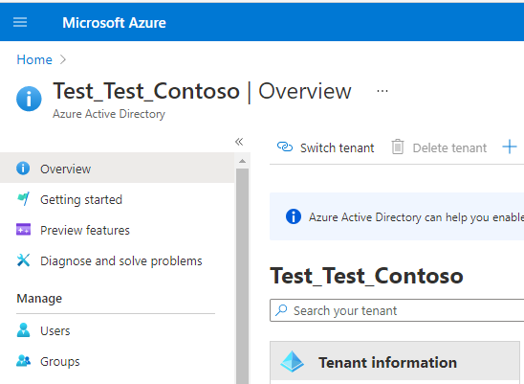

1. On the **Azure Active Directory** **| Overview** page, use the navigation to select **Groups**.

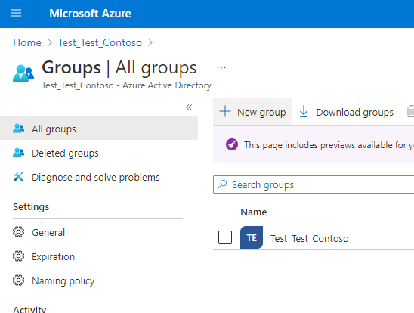

1. From the toolbar, select **New group**. Make sure to set the **Group type** to **Security**, specify the **Group name**  as **RSC_Dev Environment Group**; assign **Owners** and **Members** as needed, followed by **Create**.

This group should contain all the users that will access the apps and solutions, including employees, HSO and facility managers.

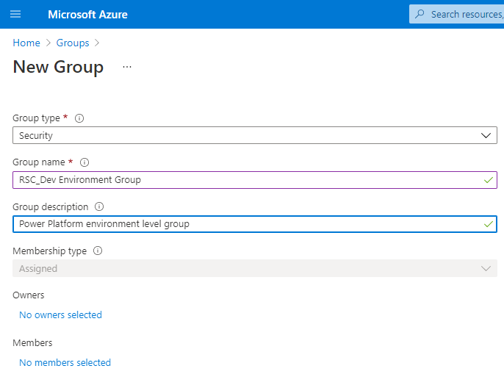

Repeat the steps for the other 3 groups and add users appropriately to each AAD group.

1. Power Apps per user license can be assigned to the AAD group (per-app plan is not supported)

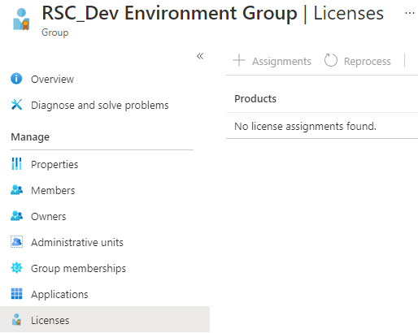

**Note:** for employees and HSO groups, make sure to add appropriate users

**Note:** repeat the steps for the other Power Platform environments and create 3 AAD groups per environment.

**Note:** if you are using the Power Apps per app plan, the assignment of licenses (aka app passes) are done on the Power Platform environment and licenses are consuming upon sharing the apps with the AAD group (of use)

## 2. The Power Platform Environment Setup

Create 3 Power Platform environments (or more depending on your organization policies) - **Development**, **Testing** and **Production**

For more details about the Power Platform environment review: [Environments overview - Power Platform | Microsoft Docs](https://docs.microsoft.com/en-us/power-platform/admin/environments-overview)

1. Browse to <https://admin.powerplatform.microsoft.com/> and login using your credentials (service account)
2. From the **Power Platform admin center**, select **Resources**>**Capacity** from the navigation and verify that you have enough **Database** capacity under the **Storage capacity usage** section. You will need a minimum 1GB per environment.

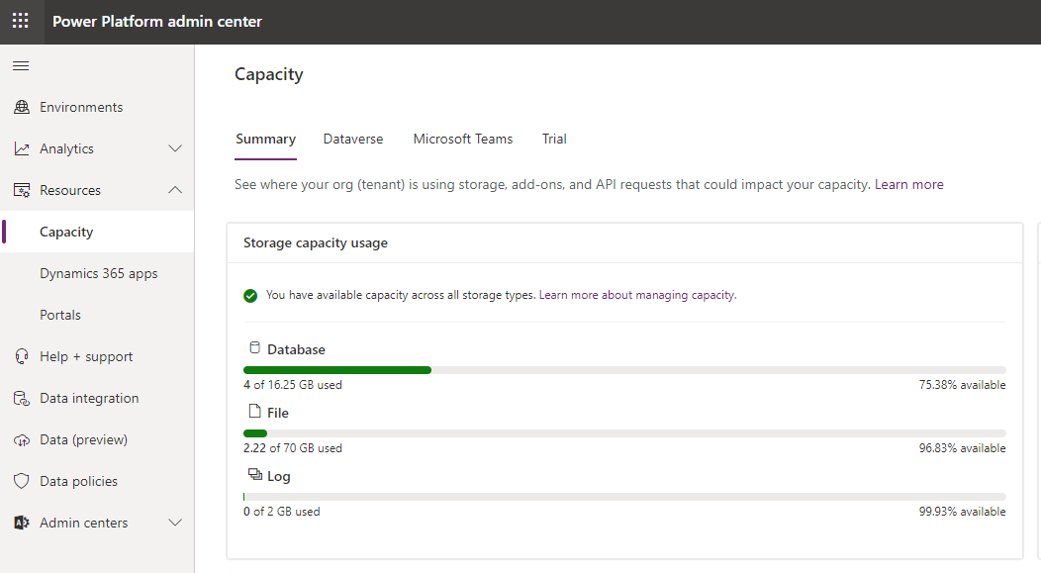

If you do not have enough Database capacity, you need to purchase Dataverse storage capacity. (Power Apps licenses also add some storage capacity depending on the license type)

1. From the navigation, select **Environment**, followed by **New**.

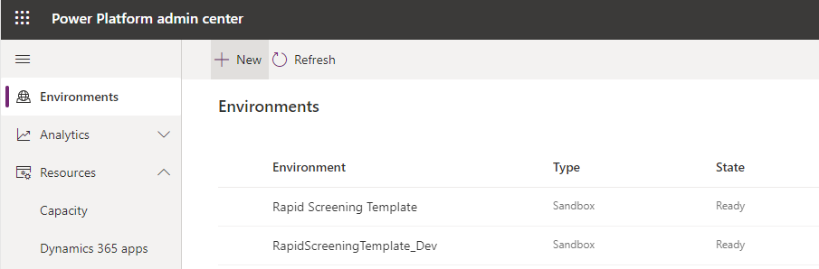

1. In the **New environment** pane that will appear, provide the required information:
   1. **Name:** provide a name (use _dev/test/prod) to define environment type e.g.: **RapidScreening_Dev** for development
   2. **Type**:
      1. If the environment is non-production, select **Sandbox**. For instance, developments and tests are **Sandbox** types.
      2. If you are creating a production environment, select the **Production**.
   3. **Region:** Select an appropriate region (**Canada** in this case)
   4. **Purpose:** optionally describe the purpose of this environment.
   5. **Create a database for this environment:** Select **Yes**.

Select **Next**.

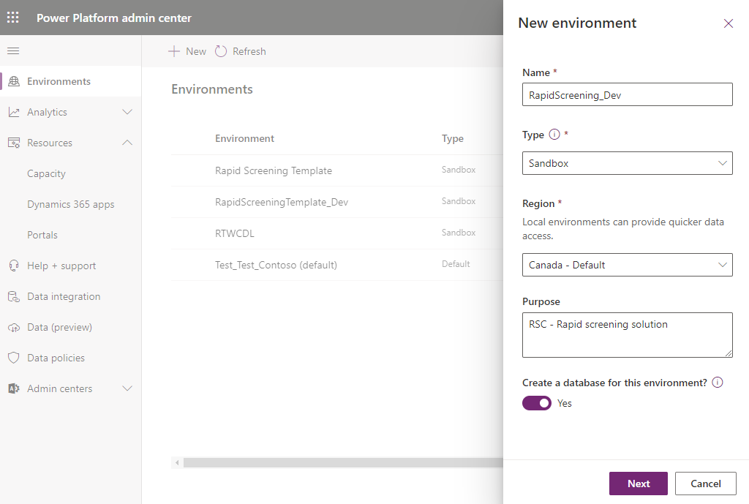

1. On the next screen, provide input as required:
   1. **Language:** **English**
   2. **URL:** this URL won’t be presented to end users but use your organization standards for naming – it is recommended to include the **dev**, **test** or **prod** nomenclature in your naming conventions. For instance, for development environment, you can use: **Contoso_RSC_Dev**
   3. **Currency:** **CAD** (or change as needed)
   4. **Enable Dynamics 365 apps:** **No**
   5. **Deploy Sample apps and data:** **No**
   6. **Security group:** select the environment level Azure Active Directory security group that you created in the previous section.

**Important:** make sure to attach the security group before saving. Also, this is AAD group that includes all users for your selected

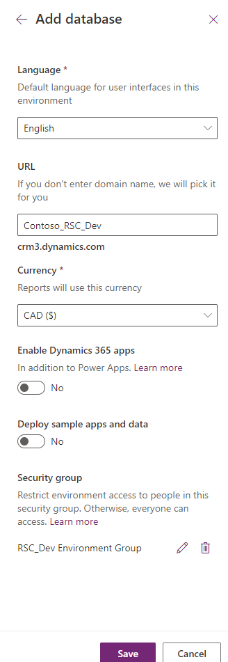

1. Select **Save**.

**Note:** If you receive an error message once you click on **Save**, there can be a few reasons:

* If you see an error indicating that the **[s]pecified domain name with a value of […] is already in use**, try a different URL – alternatively you can leave the **URL** field empty (delete the text in the **URL** field) and try to save – although this is a required field, the system will auto populate the URL.

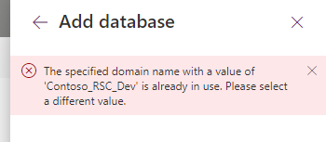

* If you see an error message saying that **This environment can’t be created because your org (tenant) needs at least 1 GB of database capacity**, this indicates that you do not have enough Dataverse database capacity to create a new environment. You will need to purchase extra capacity before proceeding further.

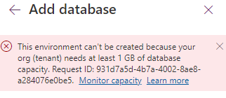

1. It will take a few minutes to prepare the instance and get prepared, you can monitor the status by looking at the **State** column – the state will change to **Ready** once the provisioning is complete.

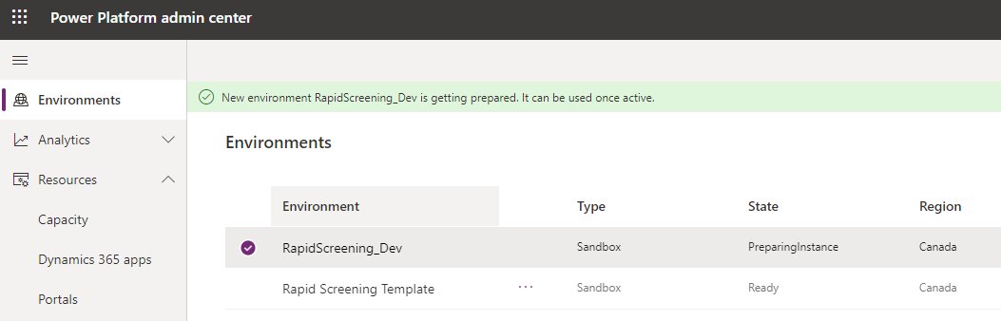

Repeat these steps to create Test/UAT and production environments.

**Important:** Please ensure that the environment **Type** for your production environment is set to **Production**

**Important:** Make sure to attach a proper AAD security group to each environment. You should have one environment level security group per environment created in AAD.

## 3. Assigning Licenses

### Power Apps

License assignment depends on the Power Apps license types in your tenant:

1. Power Apps Per User Plan:

With Per user plan, there are two methods to assign licenses:

* 1. The license can be assigned from Microsoft 365 Admin center. Either a global admin or a billing admin can assign these licenses to the users of the application.
  2. As described in section 1.4 (AAD security group setup), per user plan licenses can be assigned to the AAD group at the environment level. This is possibly a preferred option to manage licenses.

Note: Make sure the service user has a per user plan license assigned

1. Power Apps Per App Plan: This license is assigned in the Power Platform admin center and it is not required to be assigned to uses directly. The per apps licenses will be consumed upon sharing the app to AAD group or users. Follow this documentation to assign per app licenses: [About Power Apps per app plans - Power Platform | Microsoft Docs](https://docs.microsoft.com/en-us/power-platform/admin/about-powerapps-perapp)

### Power Automate

Like power apps, Power Automate license assignment depends on the type of licenses being purchased in your tenant:

1. Power Automate Per User Plan: Power Automate Per User plan is assigned to the service users in the Microsoft 365 admin center.
2. Power Automate Per Flow Plan: If you have other Power Automate Plan such as Power Automate Per Flow Plan, you can assign them to the environment and each flow once the solution is deployed in the next section. Follow these steps to assign per flow plan. [New licensing options for Power Automate standalone paid plans - Power Platform Release Plan | Microsoft Docs](https://docs.microsoft.com/en-us/power-platform-release-plan/2019wave2/power-automate/new-licensing-options-power-automate-standalone-paid-plans#allocating-the-per-flow-plan-in-the-admin-center)

## 3. Solution Deployment in the Development Environment

Once the environment is created, the next step is to import solutions into the development environment.

The typical deployment process of solutions is as follows:

1. Deploy solutions in the Power Platform development environment.
2. Export the solution (as managed) from the development environment and import into Test/UAT environments (or any other non-production environment that you might have)
3. Once ready import the exported solution from step 2 into production

Important Note: Manually backup each environment in the Power Platform admin center before releasing any new solution file into that environment: [Back up and restore environments - Power Platform | Microsoft Docs](https://docs.microsoft.com/en-us/power-platform/admin/backup-restore-environments#create-a-manual-backup)

This section focusses on the steps to initially setup the rapid screening solution on the development environment.

Follow below steps to deploy the rapid screening solution on the Power Platform Development environment:

Download ZIP the solution files from the GitHub. <https://github.com/microsoft/RTW-Rapid-Screening>

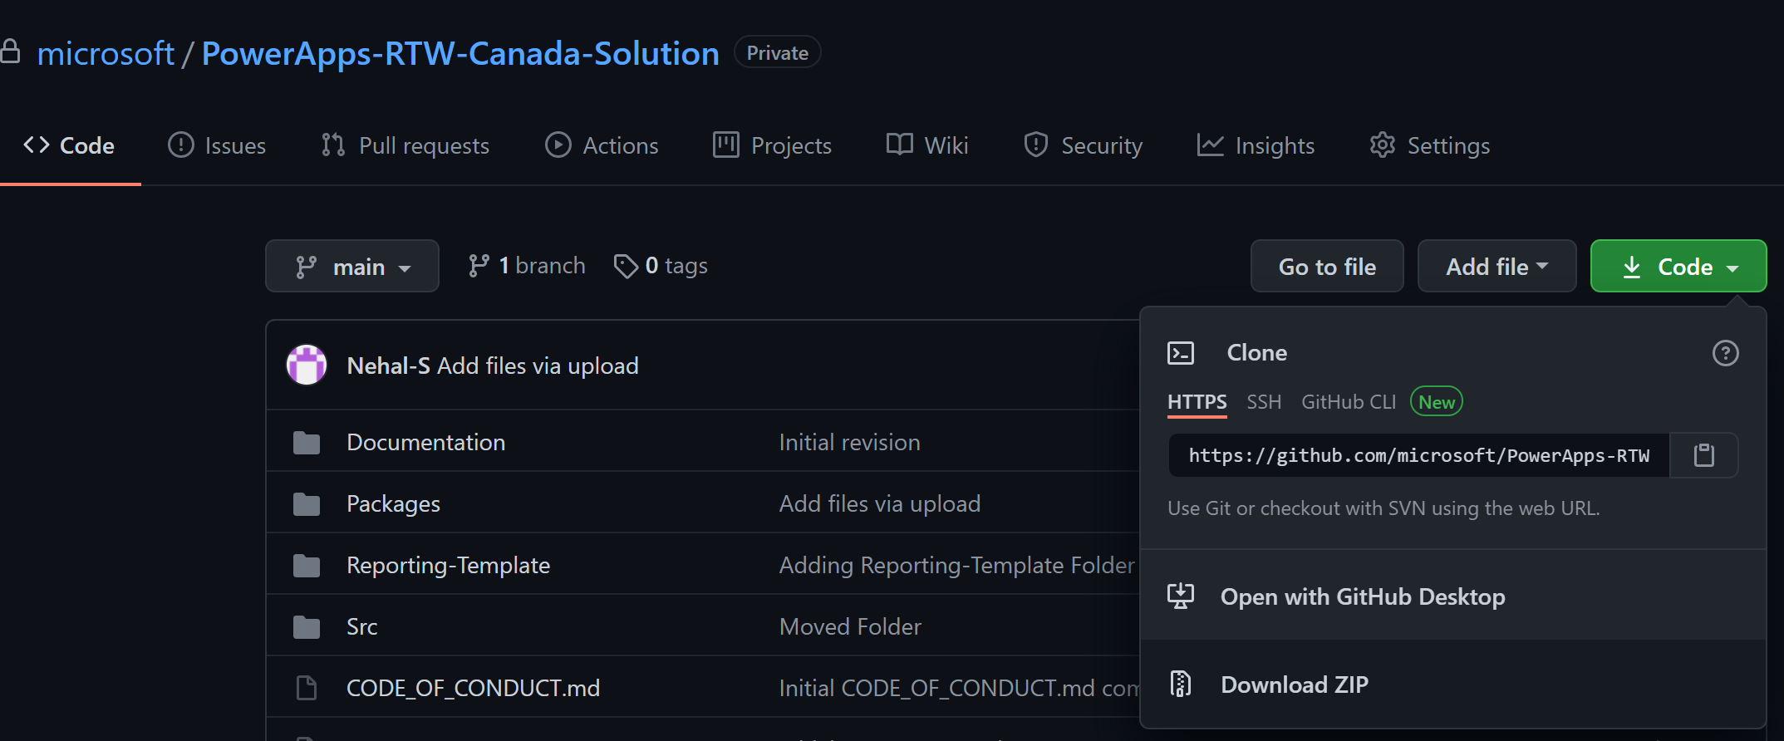

Once downloaded, there are two zip files under the Power Platform folder at: “RTW-Rapid-Screening-main.zip\RTW-Rapid-Screening-main\Packages\Power-Platform”

* ConsortiumMemberGlobal_x_x_x_xxx.zip (x is a version number and might be different during the download as we continue updating the solution with new versions)
* returntoworkplace_managed.zip

**Important:** Do not unzip the above 2 solution files.

1. Browse to <https://make.powerapps.com/> and login with the service account (same service account user that created the environment)
2. Using the environment selector, select the environment you created as your development environment.

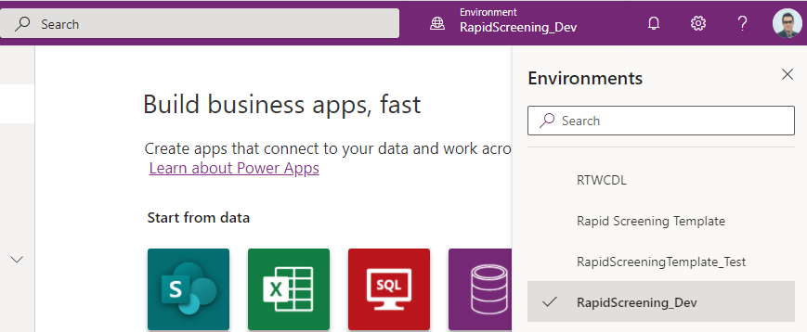

1. Once in the correct environment, use the navigation to select **Solutions**.

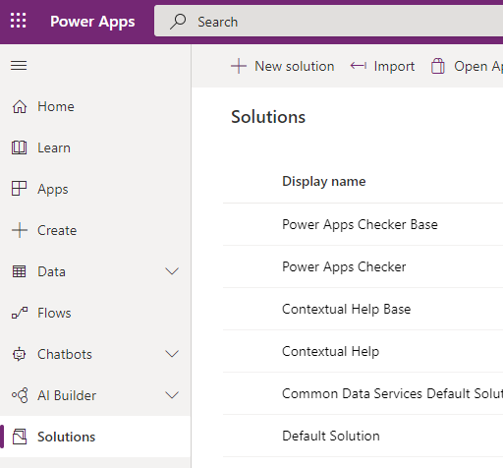

1. From the toolbar, select **Import**.

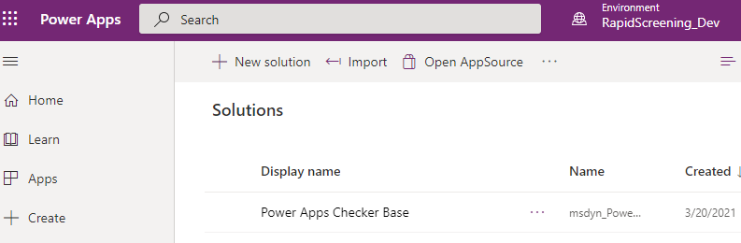

1. Select **Browse** and find the **returntoworkplace_managed.zip** solution zip file downloaded on previous steps and select **Next**.

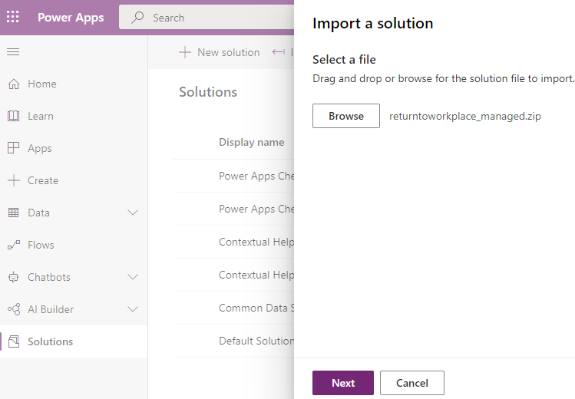

1. On the **Import a solution** Details screen, select **Next**.

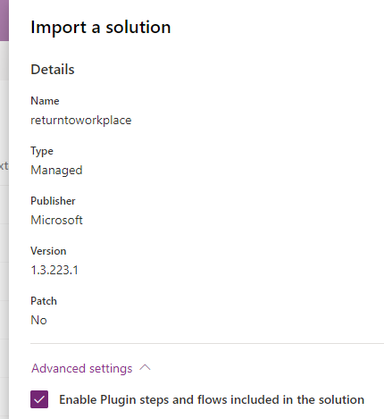

1. On the **Import a solution** Connections screen, create a connection for each of the dependencies by following these steps:
2. Using the drop down for a given connection, select **New connection.** You can also select an existing connection if one already exists.

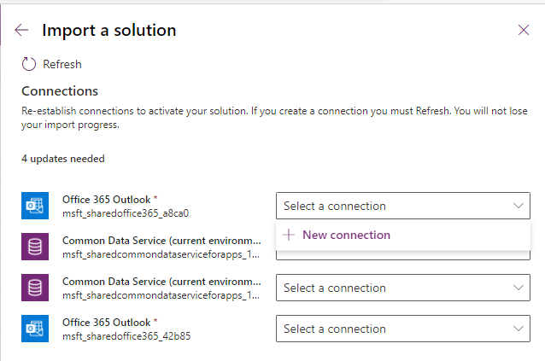

1. Your browser will launch a new tab. When prompted to create the connection, select **Create**.

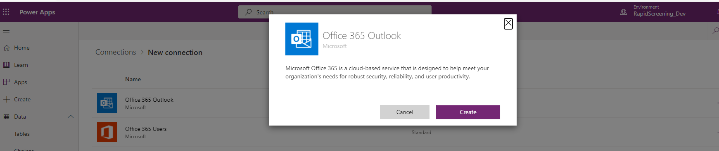

1. If prompted to log-in, sign-in with the service account that you have already signed in with and go through the authentication process.

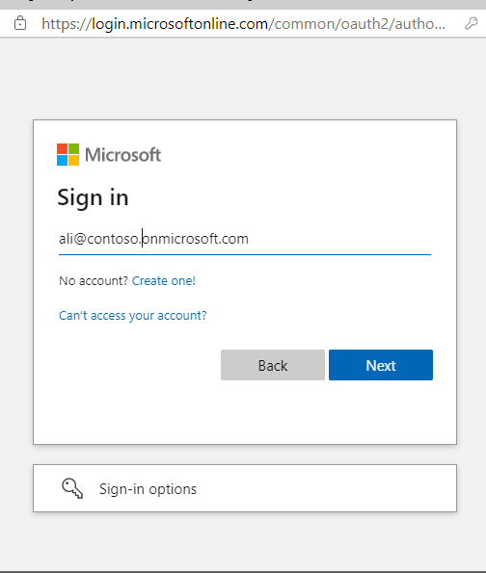

1. Once the sign-in is completed, the new connection will appear in your list of connections.
2. Go back to the previous tab on your browser. In the **Apply changes** dialog, select **Refresh** to update your list of connections.

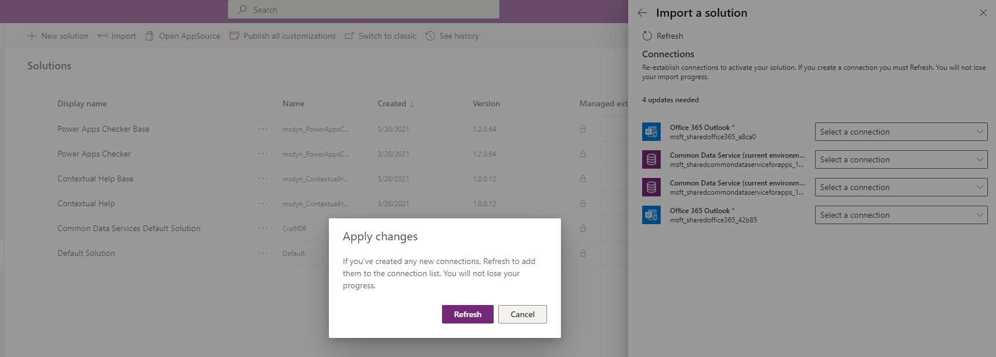

1. Repeat the same steps to create all other remaining connections.
2. Once all connections are created, select **Import** to begin importing.

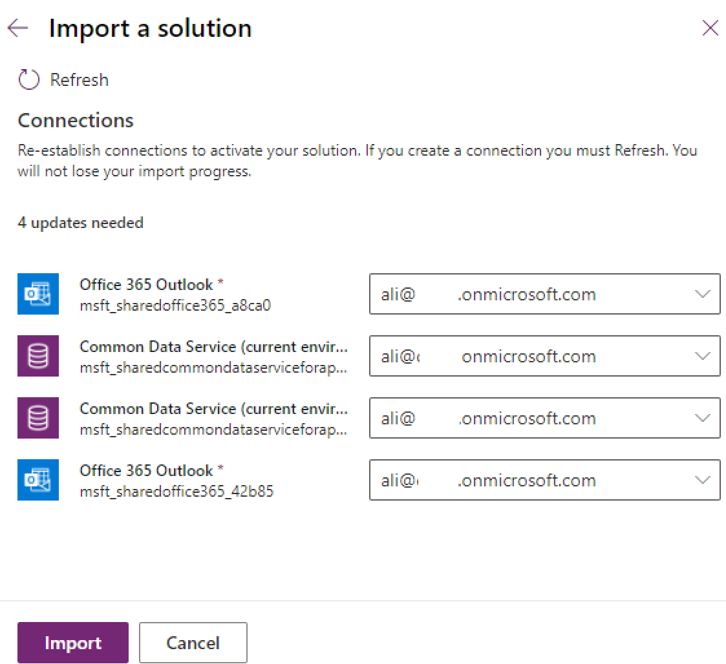

1. The solution import will take between on average 10 to 15 minutes. You can monitor the import on the **Solutions** page.

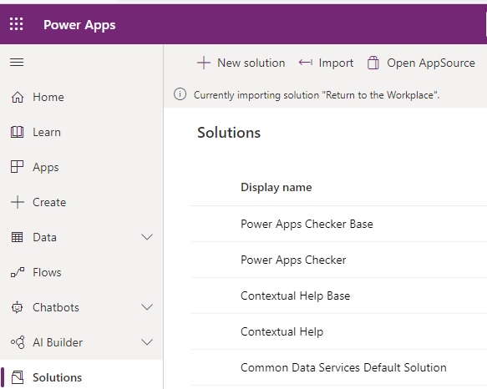

1. Once the import is completed, a notification will indicate that **Solution “Return to the Workplace” imported successfully**.

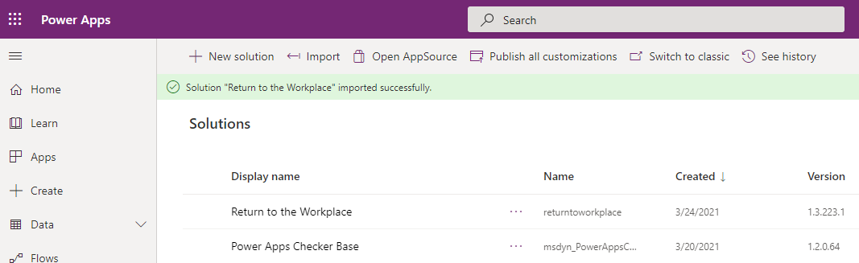

1. From the toolbar, select **Publish all customizations**.

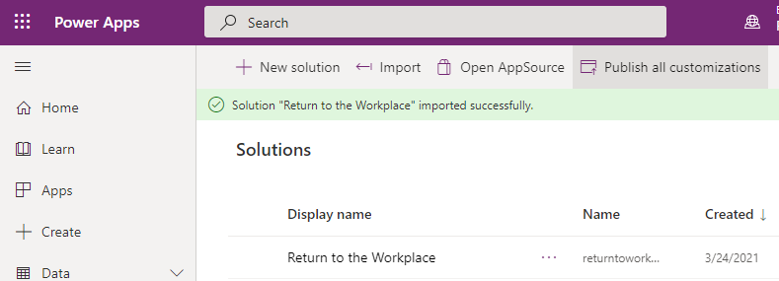

1. From the navigation, select **Apps** verify that the **Apps** list contain **Employee Return to the Workplace**, **Facility Safety Management** and **Workplace Care Management** -- if not, wait for a few minutes and select **Publish all customizations** again

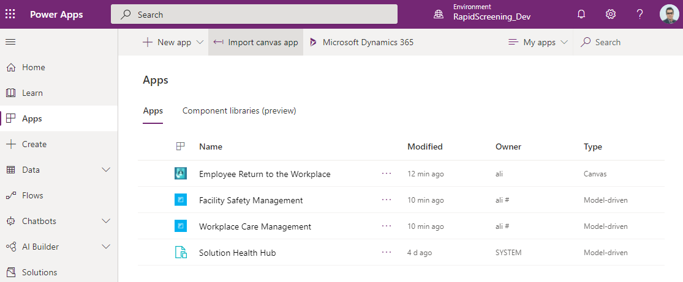

1. Next few steps are focused on importing the next solution file which contains rapid screening solution artifacts.
2. Make sure that you are still in the correct environment (dev)
3. From the navigation, select **Solutions**.

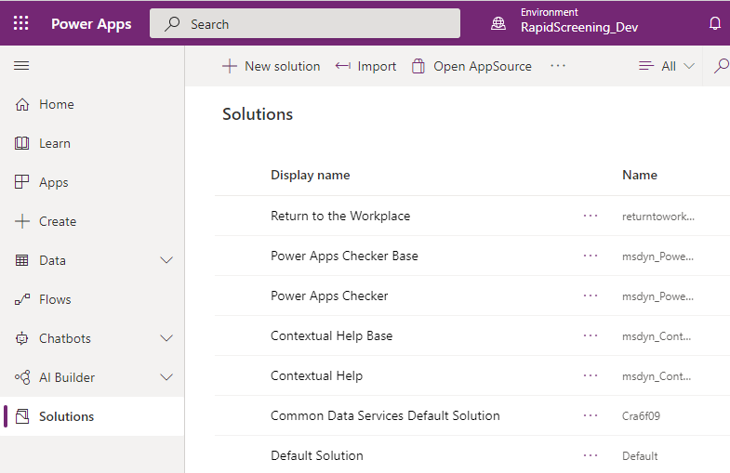

1. From the toolbar, select on **Import** and select the **RapidScreeningCombined_x_x_x_xxx.zip** you downloaded earlier.
2. In the **Import a solution** Details screen, select **Next**.

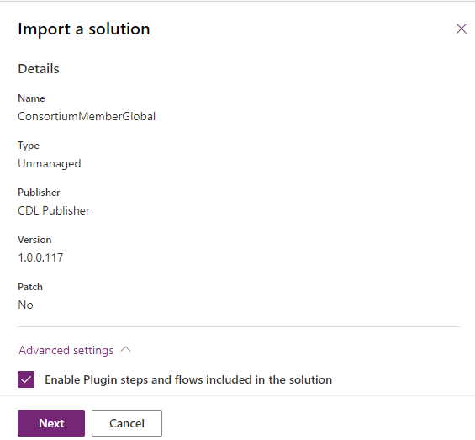

1. Create a **New connection** for each connector as described earlier

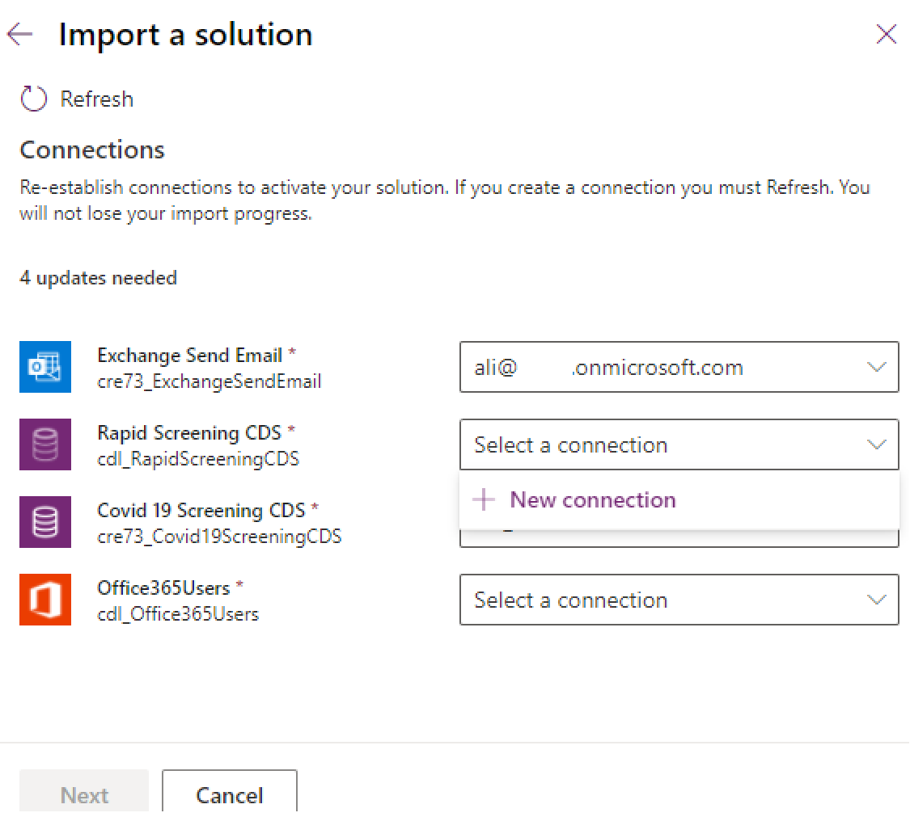

1. Once all the connections created select the **Next**

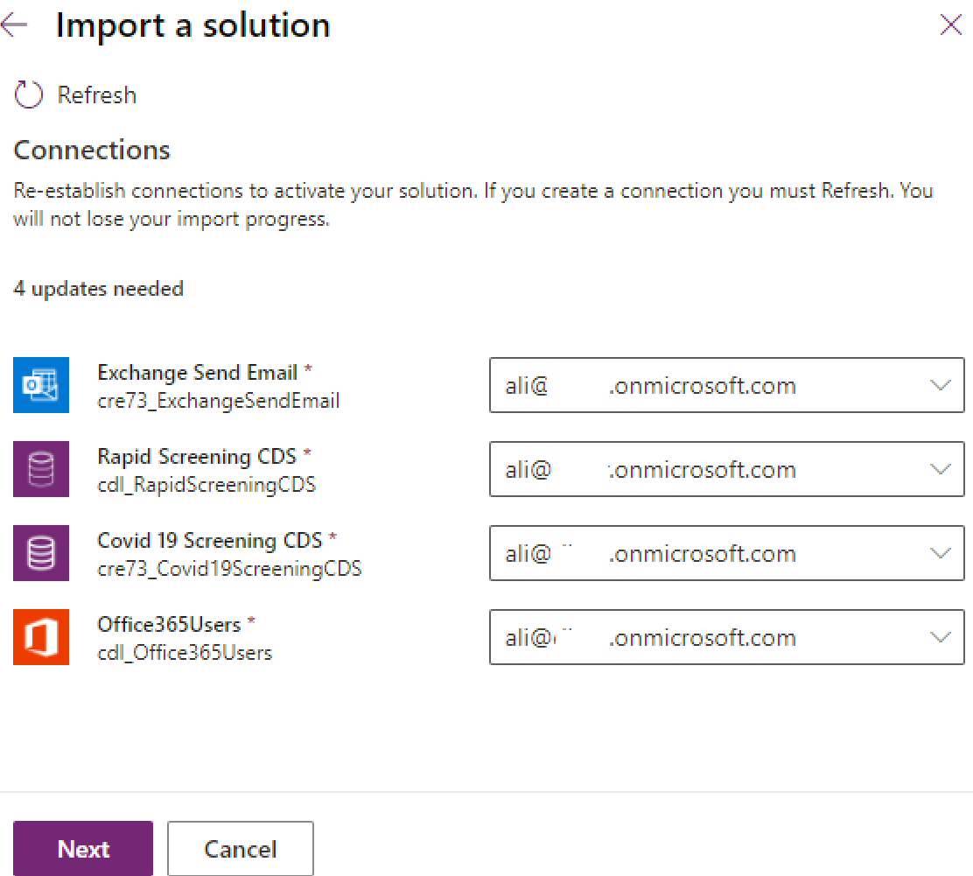

1. On the **Import a solution** Environment Variables screen, provide an **Admin Email Address** and **Send As Email For Notification Results** addresses. Leave **Emp require to Reattest** to **Yes** and select **Import**.

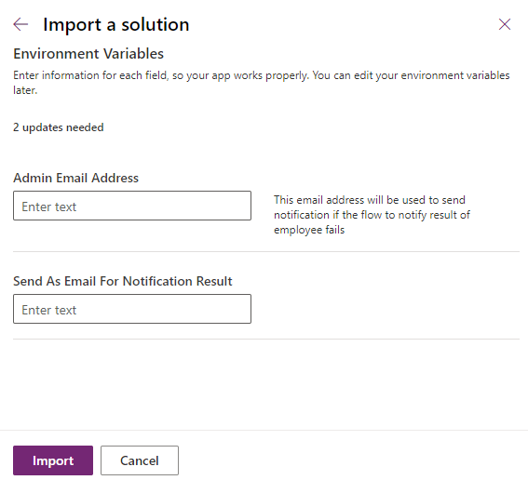

1. Like previous import, wait for 10 to 15 minutes for the solution to import successfully.

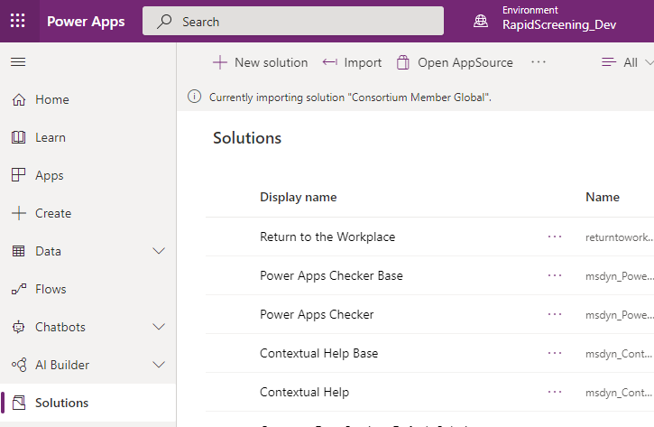

1. One the import has completed, select **Publish all customization** on the toolbar.

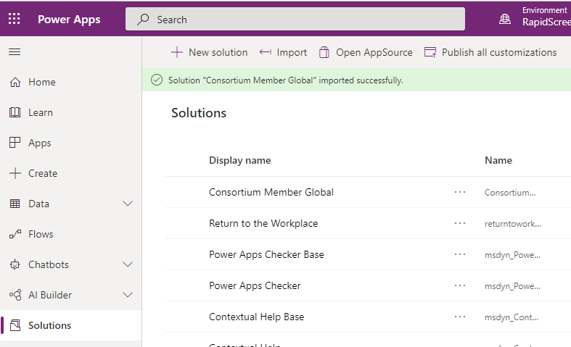

1. From the navigation, select **Apps**
2. Verify that **Rapid Screening Booking App** and **Health Safety Officer Screening App** are listed.

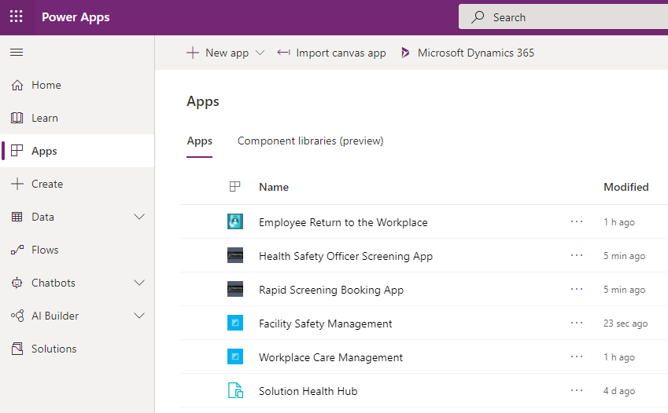

This concludes solution imports on the development environment. Next, we will focus on setting up the base data for the solution.

## 4. Power Automate Flow Configuration

Some Power Automate cloud flows are turned off once the consortium solution is imported. In this section, we will review each cloud flow and enable/configure it as required.

1. From the navigation, select **Solution**
2. From the list of **Solutions**, select the **Rapid Screening Combined** solution to edit it.

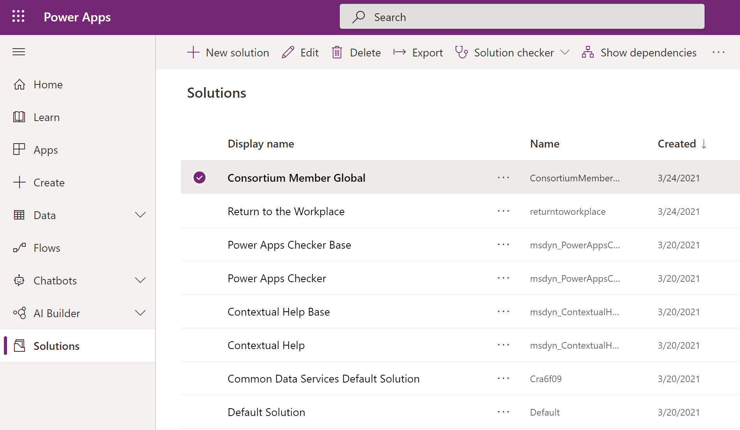

1. On the toolbar, set the **Filter** on **Cloud Flows**

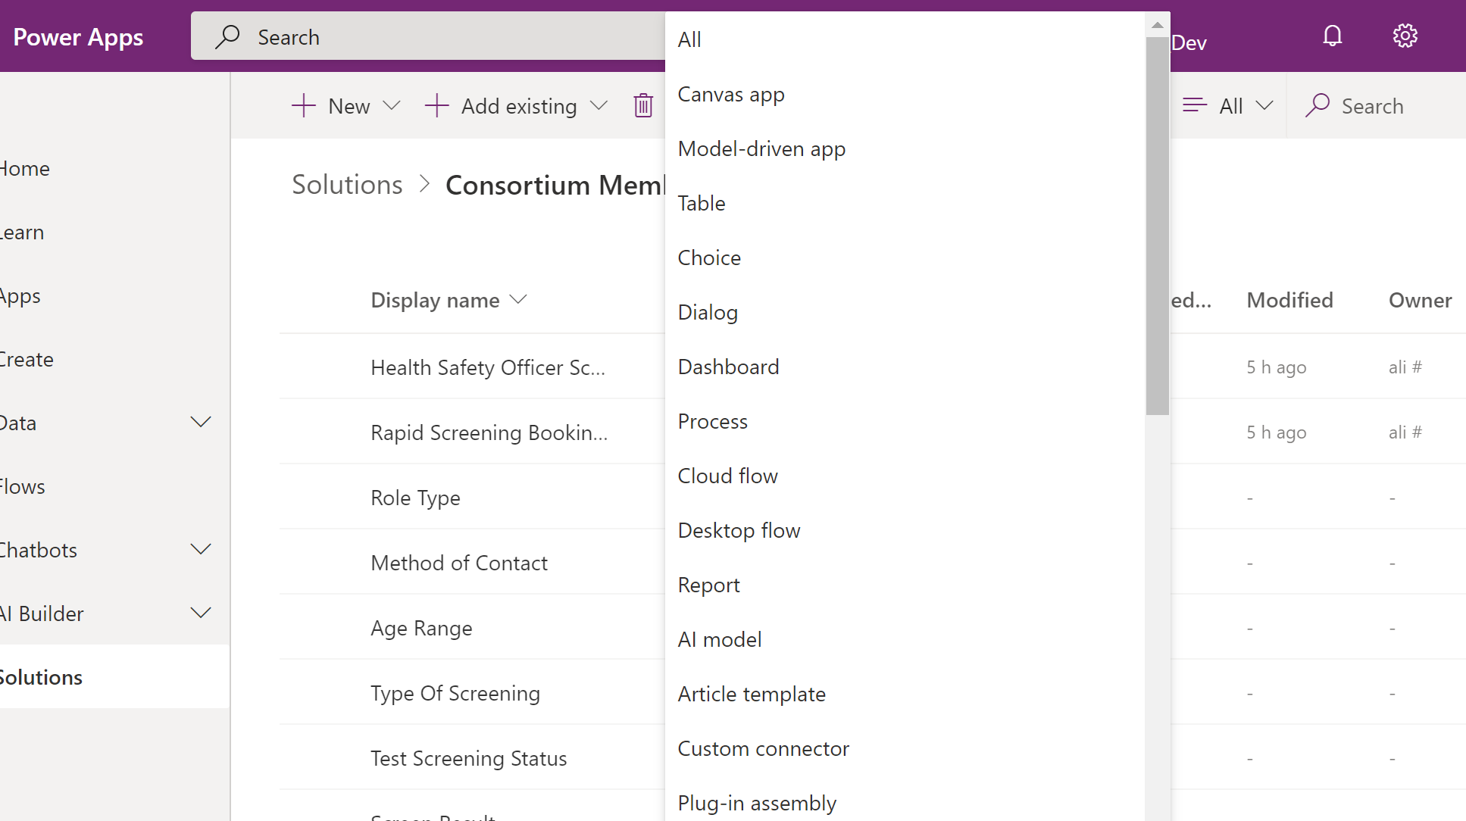

1. From the list of the cloud flows, make sure that **Status** column of the **Create Operating Hours** and **Employee Attestation-Disable Earlier Pass** cloud flows are set to **Off**.
2. Verify that all other cloud flows in the list have a **Status** set to **On**. If not, select each cloud flow and select **Edit**.

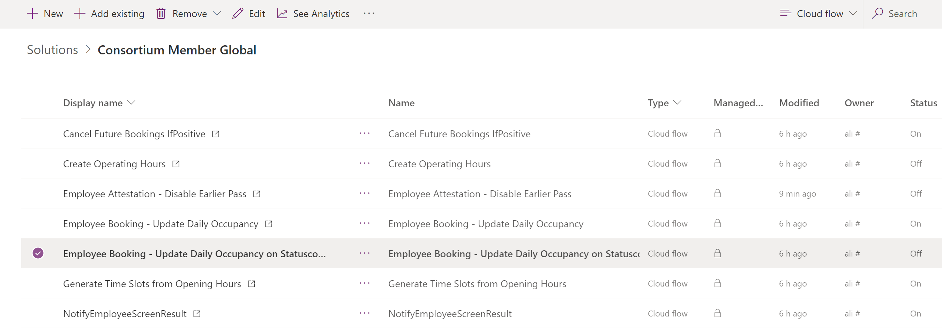

1. This will open the Power Automate flow in a new tab, select **Edit** then **Continue**.

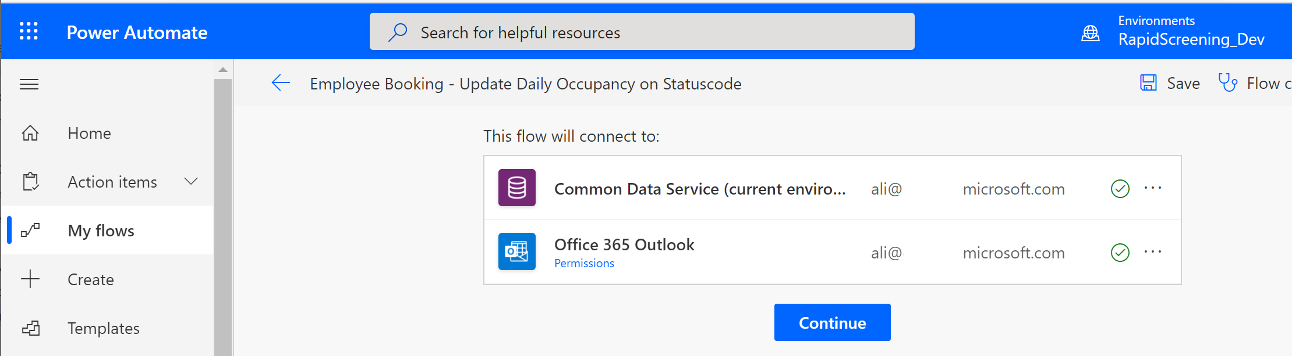

1. Once the flow designer open, select **Save**, followed by the back arrow

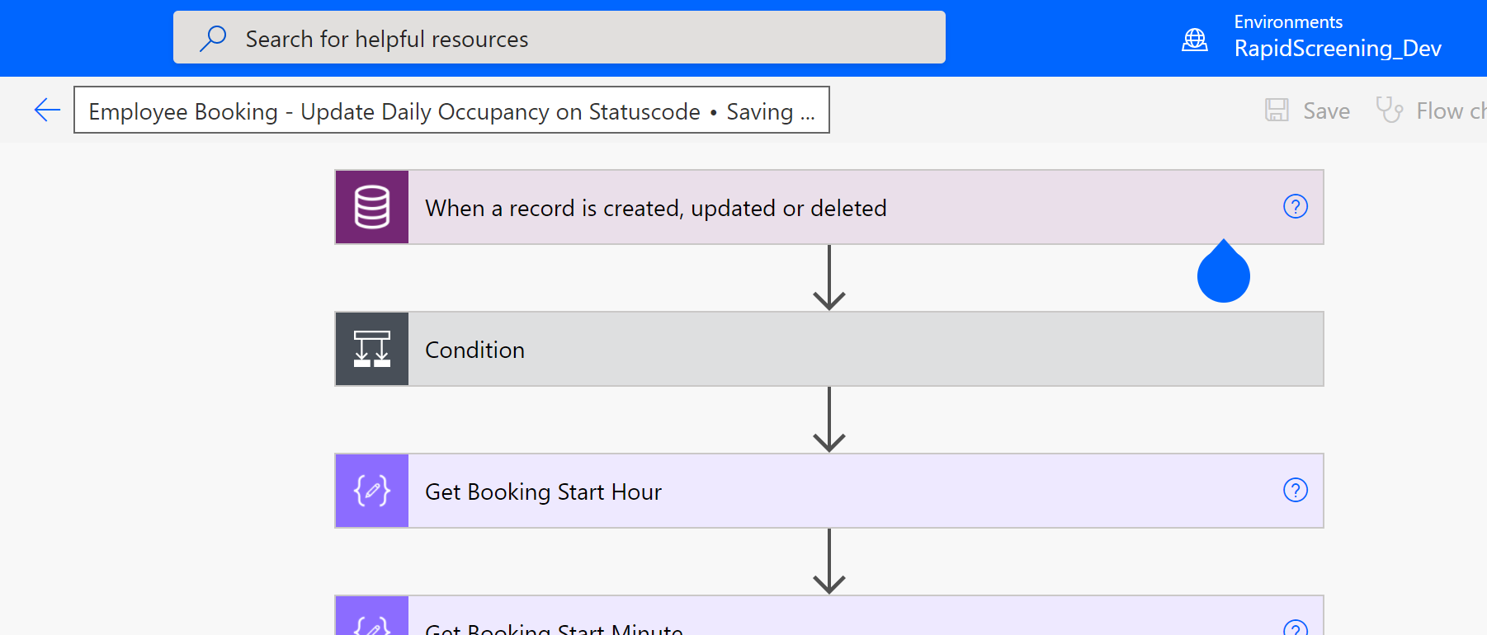

1. From the navigation, select **Turn on**.

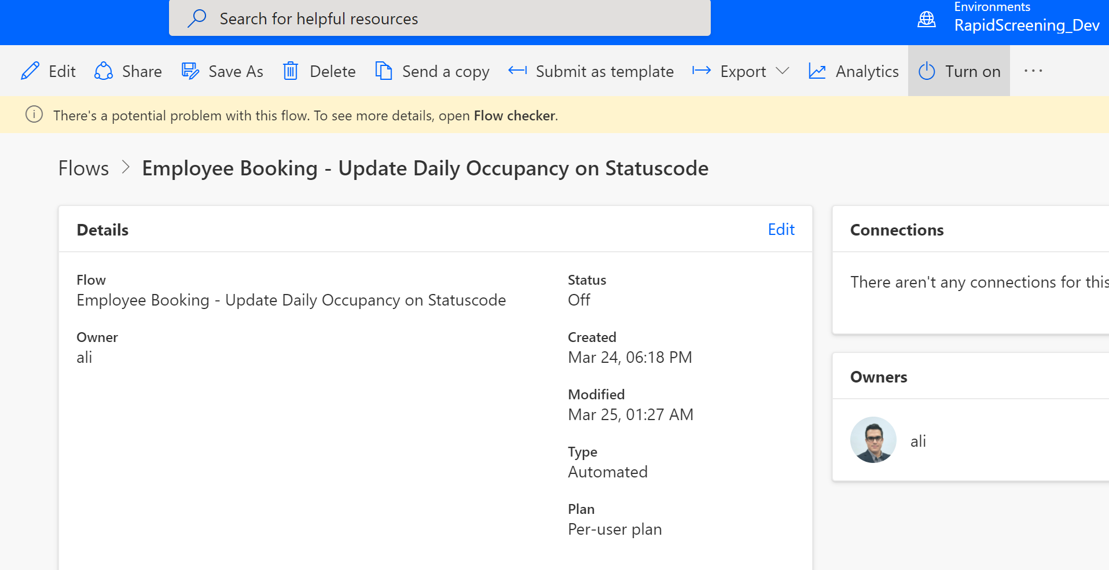

1. Repeat these steps for any other cloud flows with a **Status** of **Off** – Turn on all Flows except for **Create Operating Hours** and **Employee Attestation-Disable earlier pass**.

## 5. Solution Data Configuration

The rapid screening solution requires basic data configuration to enable the functionality of the apps.

Some of these standard configurations (data) are being templated, packaged, and delivered via the GitHub repo. In this step of deployment, we will walk through installing and importing the templatized data package and then we will walk through setting up the rest of the required data manually by admin or facility manager. It is recommended to perform these actions using the same service account that has been used earlier.

### Template Data Import

The configuration data that is templatize for import include:

1. Solution settings (Default, British Columbia, Alberta, Ontario, Quebec, …)
2. Country (Canada)
3. State/Province (British Columbia, Alberta, Ontario, Quebec, …)
4. Facility Type (Screening Site)
5. Facility Group (North America, Canada, British Columbia, Alberta, Ontario, Quebec, …)
6. Reopen Phase (Phase 4)
7. Screening Type (Abbot Panbio, BD Veritor)
8. Email Templates (excludes the pdf file)

Note: this data is just an initial config data point to accelerate the deployment. admins can modify the data if needed.

Follow below steps to import the templatized data:

1. From the downloaded package (unzipped) from GitHub go to

**RTW-Rapid-Screening-main.zip\RTW-Rapid-Screening-main\Packages\Power-Platform\Solution-Data\ConfigurationMigrationTool**

Folder and run the **DataMigrationUtility.exe**

This is a small utility that helps with data migration. You can read more about this tool: [Move configuration data across organizations - Power Platform | Microsoft Docs](https://docs.microsoft.com/en-us/power-platform/admin/manage-configuration-data)

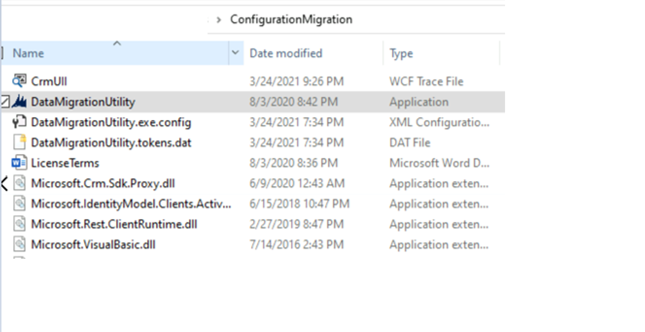

1. From the **What would you like to do with Common Data Services Configuration Migration**, select **Import data** select by **Continue**.

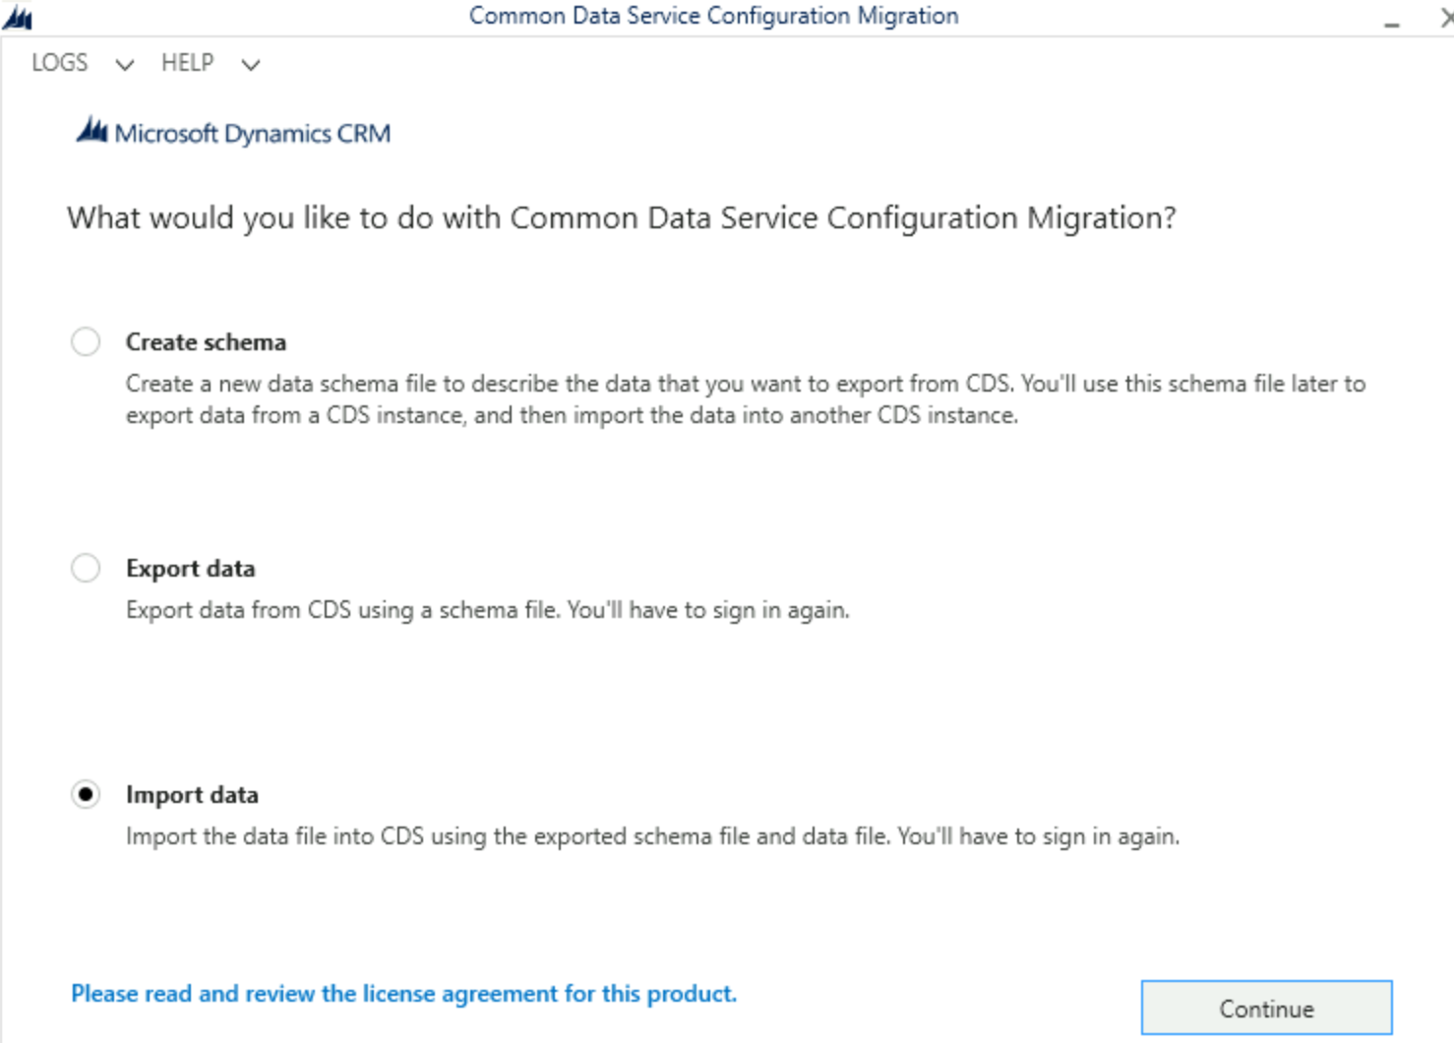

1. In the **Login** screen, select **Office365** and leave all other default settings. Select **Login**.

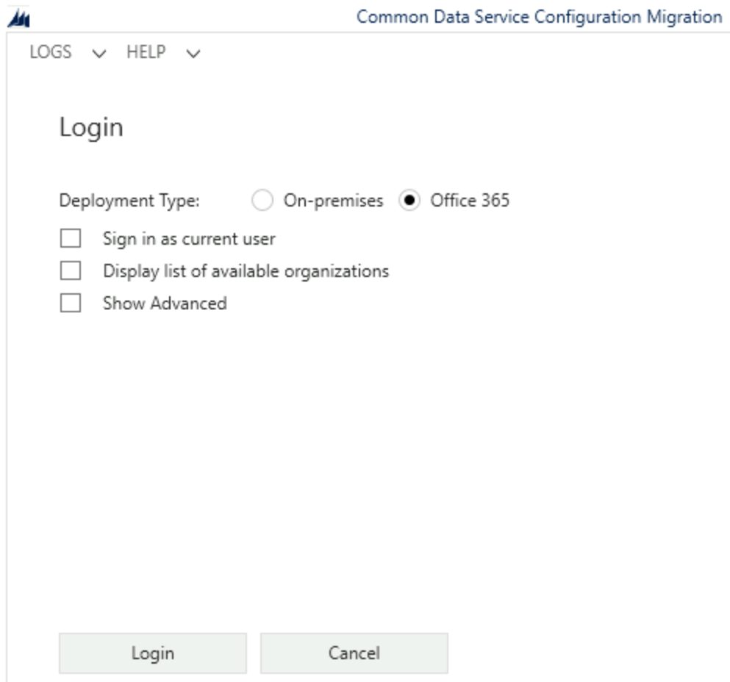

1. Once authenticated, select the environment (development) with a matching **Organization Name** from the list, followed by **Login**.

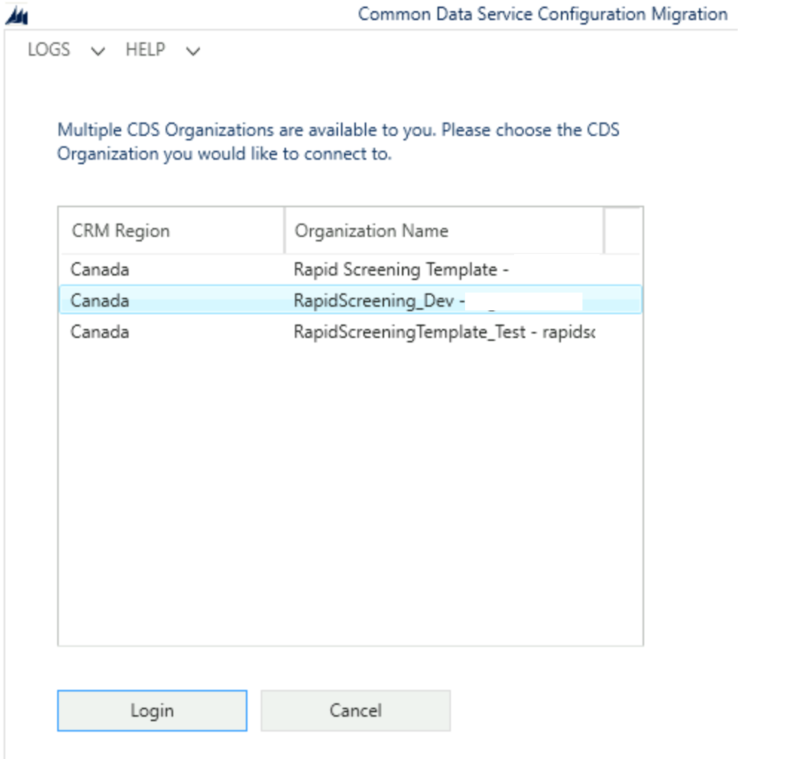

1. When prompted for a **Zip file**, select the zip file named **Solution.Config.Data.V5.zip** from the downloaded GitHub package and select **Import data**

The file is located under: **RTW-Rapid-Screening-main.zip\RTW-Rapid-Screening-main\Packages\Power-Platform\Solution-Data\Solution.Config.Data.V5.zip**

**Note:** do not unzip this file

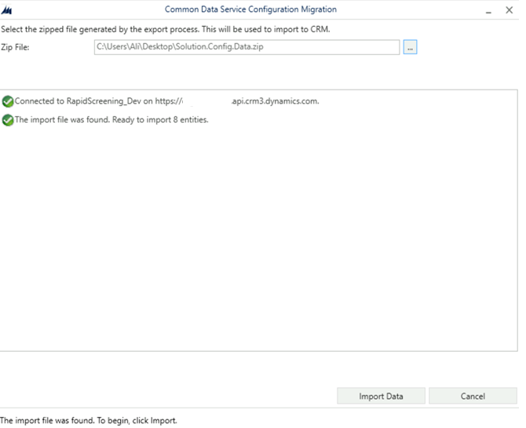

1. Close the application once the import is completed.

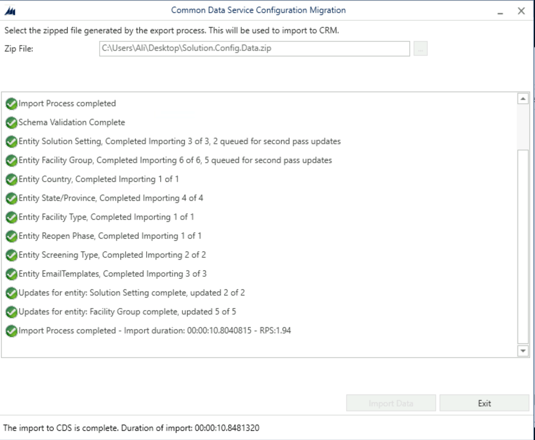

### Manual Data Configuration

On the previous step, the template data was imported using a tool. In this section, we will review the imported data from the previous steps and modify and add/upload more data points manually to the Power Platform. Many of these data points are highlighted in the “Prerequisite and Requirement” under the business requirement section earlier in this document.

Browse to the Power Apps portal (make.powerapps.com) and make sure you are on the correct environment (development)

From the list of **Apps** select **Facility Safety Management**

This app is used by admins or facility managers to setup the solution data.

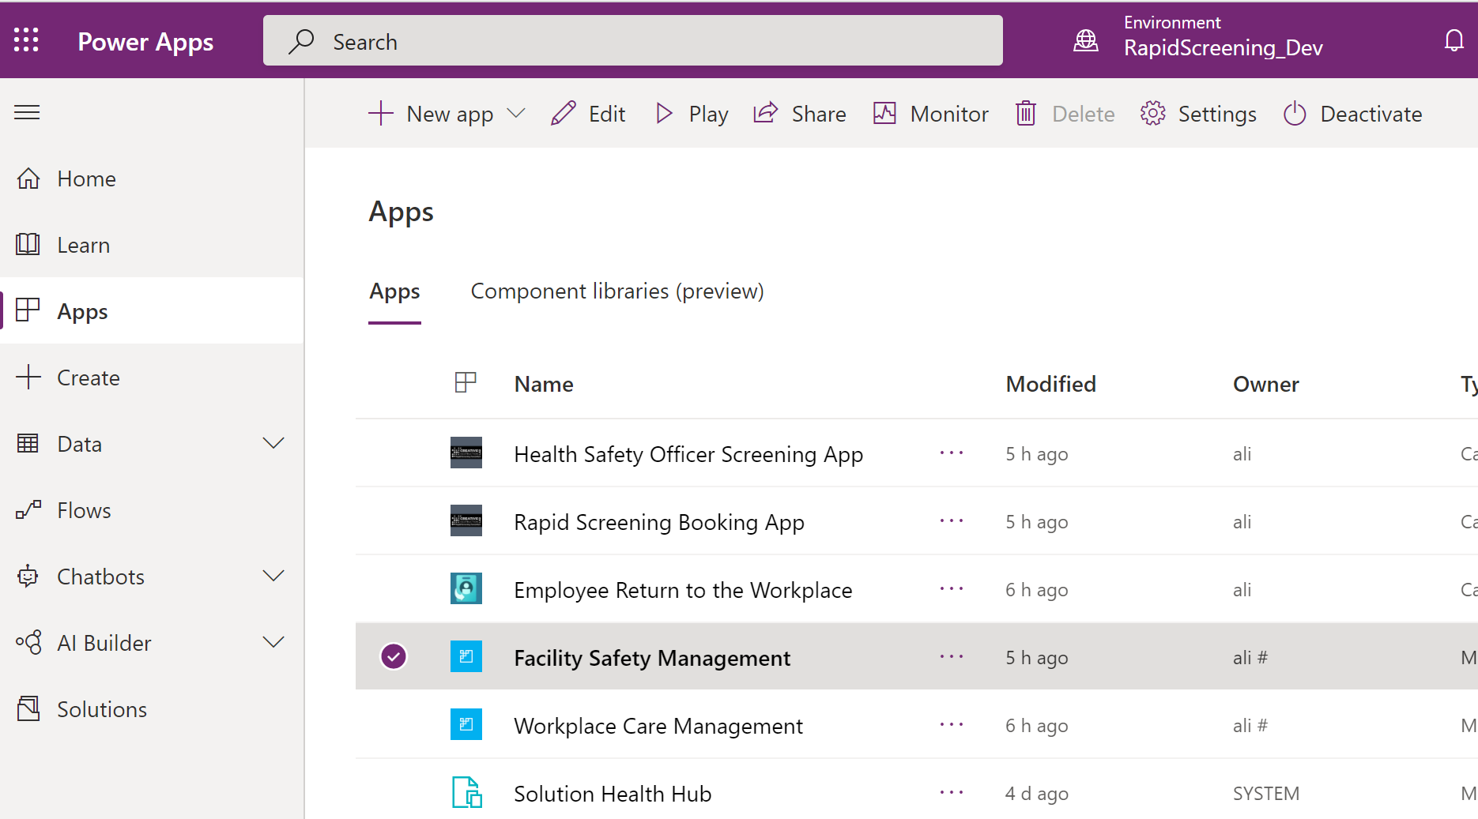

#### Countries

1. From the navigation, select **Facility** area (on the bottom left corner of the application) and change the area to **Solution Setup**.

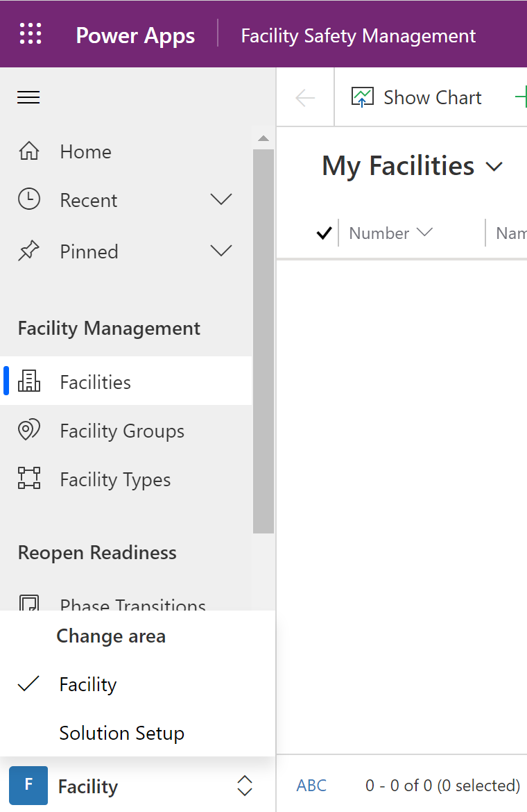

1. From the navigation, select **Countries**. The template data import process has created a single country in this table. Feel free to modify or add additional countries if needed (the country for the screening facility)

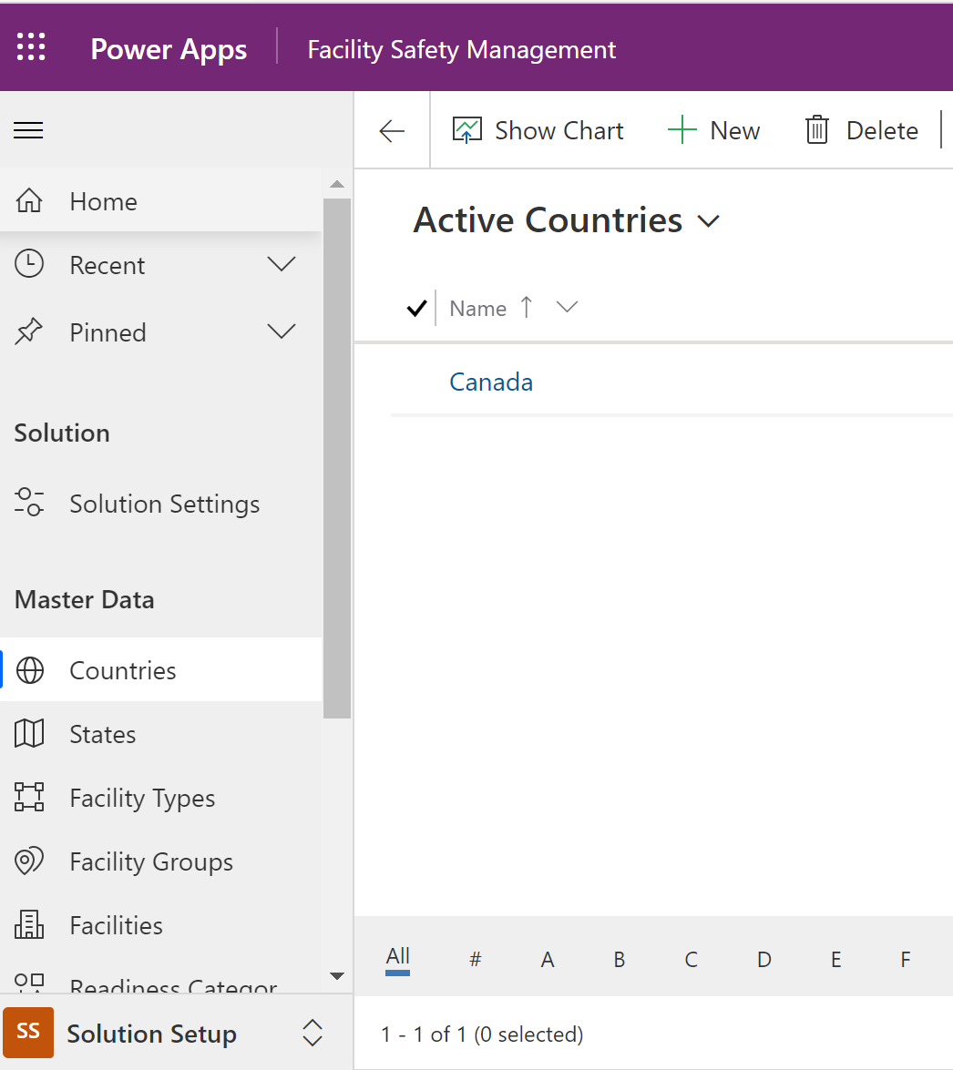

#### States (provinces)

The import created all Canadian provinces under the **States** table. You add/modify provinces as needed.

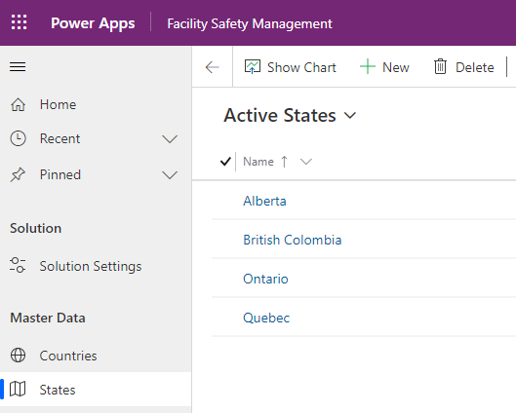

#### Facility Types

The import created a single row in the **Facility Types** table. You can add/modify types as needed.

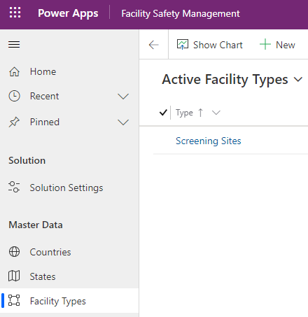

**Note:** for self-screening (on solution version>2.x.x.x), manually create a new facility type called **Home Screening**

#### Facility Groups

The import created a set of **Facility Groups**. Add/modify as needed.

Conceptually, this entity is mapped to the provinces and each group is connected to facility and its related solution setting. This enables having a different solution setting per facility groups and their related facilities. The solution setting includes many components and configuration that you can review in the following section.

There is a parent – child relationship between the groups. The current import configures Canada as the parent for all the child groups which represent provinces.

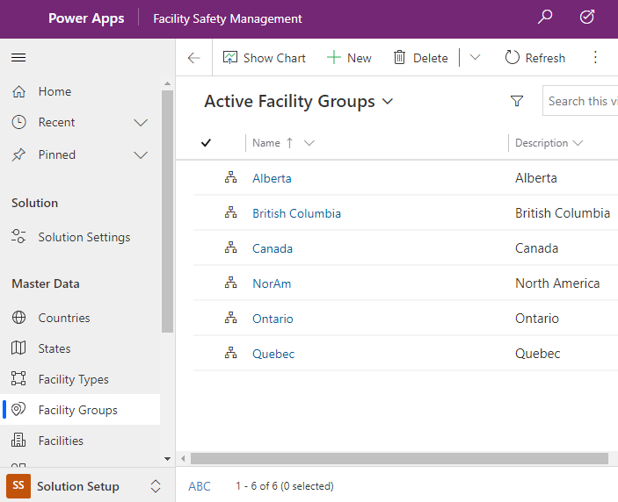

#### Solution Setting

**Solution Setting** table contains many data configuration points for the solution. These data points are being highlighted on the prerequisites and requirement section earlier in this document. The import creates a set of setting as a template that you can modify or add.

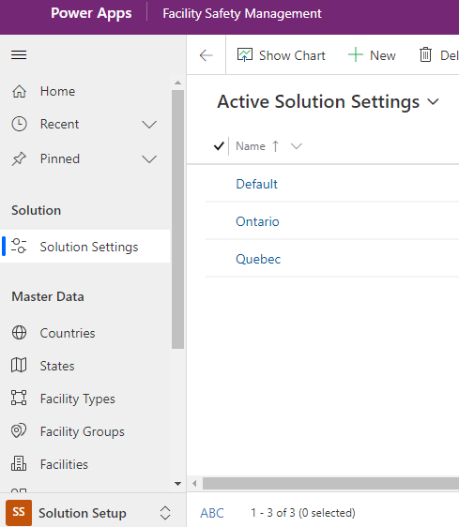

Data fields in each solution setting record includes: (please refer to the next sub section for additional setting on self-screening available on solution version > 2.x.x.x)

* **Name:** Name of the solution setting. It is recommended to match the setting name to facility group name.
* **Company:** (Optional) Name of the company – make sure to update as the import defaults this field to “Contoso”
* **Facility Group:** Lookup to a facility group (and its related facilities via group) which the setting applies.
* **Health and safety email:** Email address for employees to contact if they don’t feel well. This email address will be displayed on the employee app if an employee disagrees with the attestation.
* **Health & Safety Instructions:** Leave it empty as it is not being used.
* **Health and Safety Not feeling well Instructions:** Page text content for employees to be displayed on the employee app if an employee disagrees with the attestation along with the email address on the previous point.
* **General Terms & Agreement:** Attestation text that will be displayed in the employee app. Use HTML if any text formatting required for the attestation.
* **Program Consent:** Program consent that employees approve on the employee app profile page. Use HTML if any text formatting required.
* **Opt Out of Program Message:** A message on the employee app, if an employee opt-out of the program by revoking consent via unchecking program consent checkbox
* **Email Body for Result Email:** The body of the email that will be sent out to employees once HSO updates the result on the HSO screening app.
* **Allow Employee Sentiment:** Not being used. Leave as **No**
* **Allow Storing of Negative Attestations:** Not being used. Leave as **No**
* **Allow QR Codes:** Defines if a QR code gets generated and displayed in the last step of screening booking on the employee app.
* **Allow Guest Registrations:** Not being used. Leave as **No**
* **Allow Share Guest Registration:** Not being used. Leave as **No**
* **Mask Employee Info in Pass:** Mask employee name in the booking pass. This is displayed on the employee app when employee’s book appointment and present pass to HSO. If set to **No**, employee name will be masked and replaced with “#” character.
* **Hide Personal Email for Employees:** This field enables capturing personal emails in the employee’s profile page. See following screenshot:

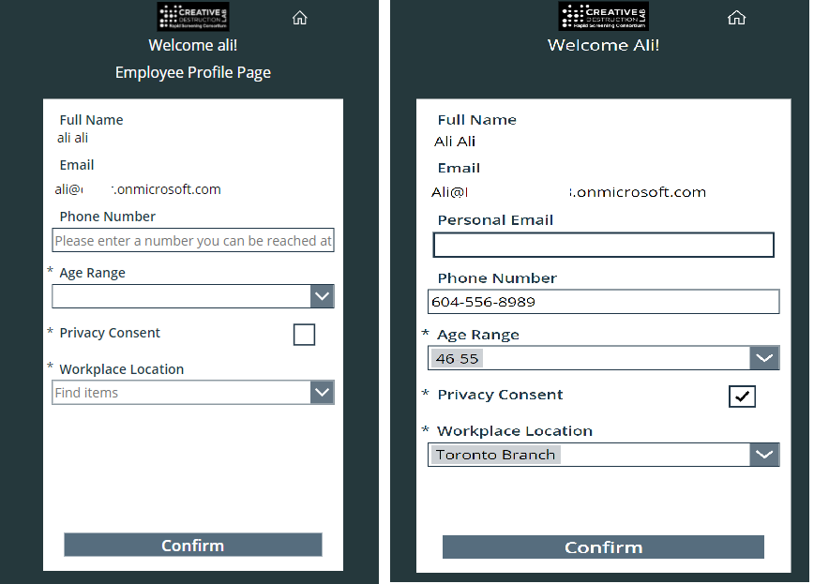

* **Mask Employee Info in Screening App:** If an employee test positive, The HSO screening can displays the employee’s name on the summary page of the update result. If set to **Yes**, the employee’s full name will not be displayed on the HSO screening app.
* **Hide Phone Number for Employees:** If an employee test positive, The HSO screening can displays the employee’s phone number (from employee profile) on the summary page of the update result. If set to **Yes**, the employee’s phone number will not be displayed on the HSO screening app.
* **Appointment Booking Email:** When an employee books a screening appointment, this is the text that they will view in the email confirmation. Please note, do not change the **“booking_time_date”**, **“location_text”**, or **“booking_code”** phrases in the default template below. The variables in the Appointment Reminder flow will not work without these phrases   
    
  The default template is:

<html><body>

Hello,

<br>

<br>You have an upcoming screening appointment.

<br><br> Booking Date & Time: booking_time_date

<br>

<br>Location: location_text

Example of above 2 points:

Following screenshot shows HSO screening app result summary screen if both flags are set to **Yes**:

(**Mask Employee Info in Screening App**: **Yes**) And (**Hide Phone Number for Employees**: **Yes**)

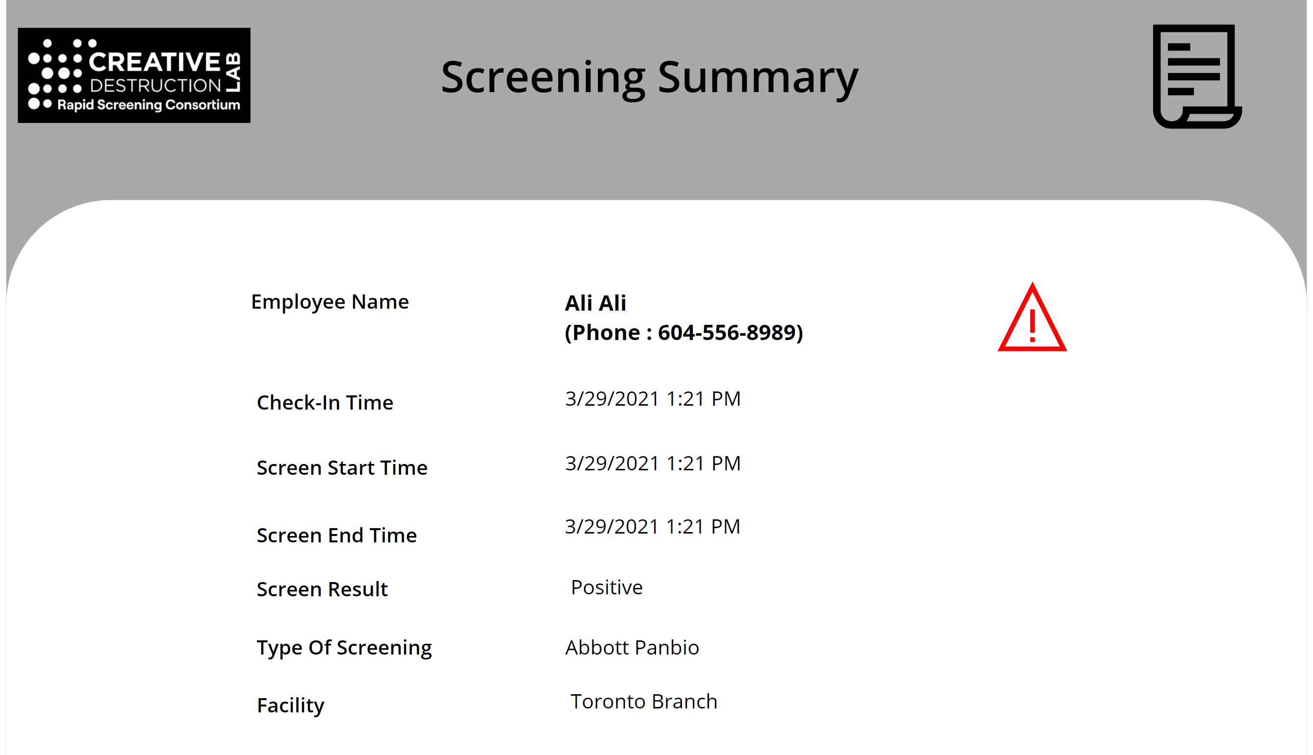

Following screenshot shows HSO screening app result summary screen if both flags are set to **No**:

(**Mask Employee Info in Screening App**: **No**) And (**Hide Phone Number for Employees**: **No**)

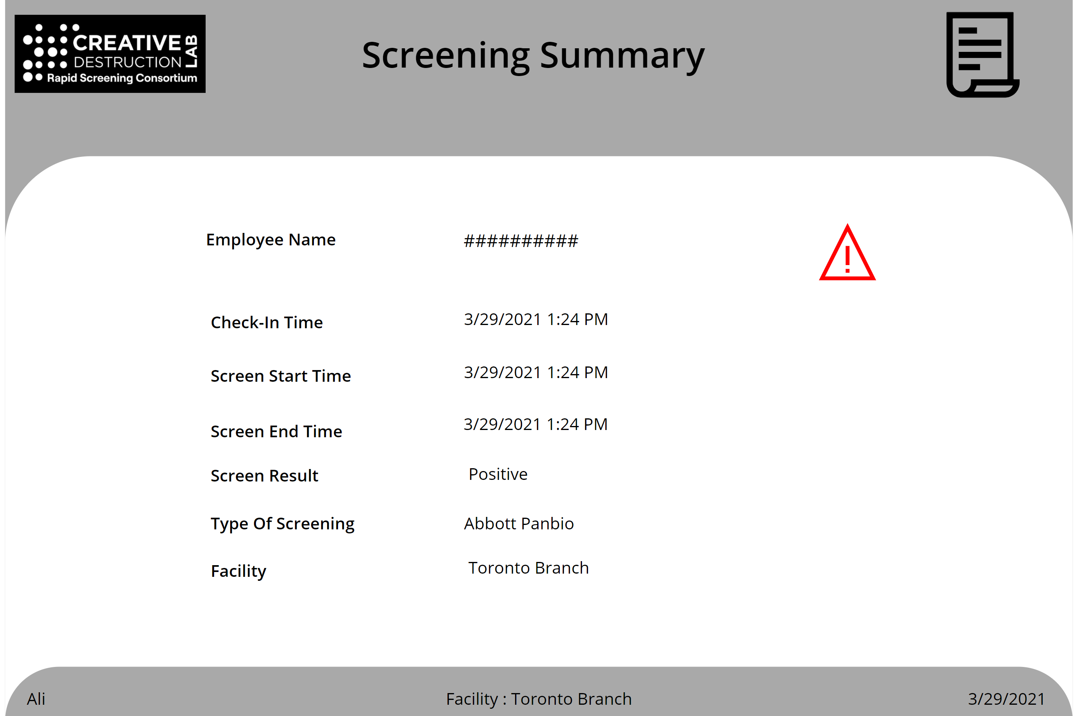

Add/remove/modify solution settings are needed. It is recommended to create a new row in the solution setting table per each facility group. The Default setting (imported earlier) will be used first time employees sign into the application and after they setup their profile and primary location, the related setting will be used based on the primary location on the employees.

##### **Self-screening Settings**

On solution version 2.0.0.x which includes self-screening additional setting includes:

* **Self-screening consent:** consent text that will be displayed to the employees that chose to do self/home screening.
* **Allow Self Screening:** Yes/No - enables self-screening section on the employee app home page.
* **Need to attest for self-screening:** Yes/No enabled or disables self-screening attestation step on the self-screening section of the employee app.
* **Photo mandatory for self-screening:** Yes/No, define if it is required from employees to take photo of the result on the self-screening section of the employee app.

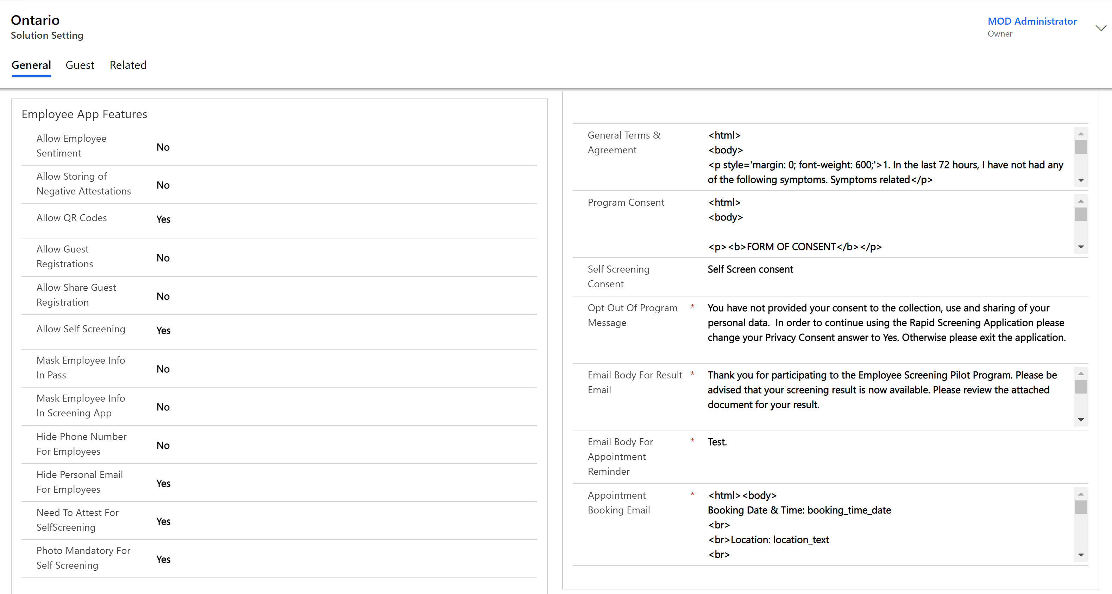

#### Environment Variables

Some of the solution settings are store in the environment variables – these settings apply for solution versions > 2.x.x.x and do not exist in the previous versions of the solution:

To access the environment variables:

1. Go to the **Solutions** section on the maker portal.
2. Open the **RapidScreeningCombined** solution.
3. Filter the solution to **Environment variable** on the top right corner of the solution

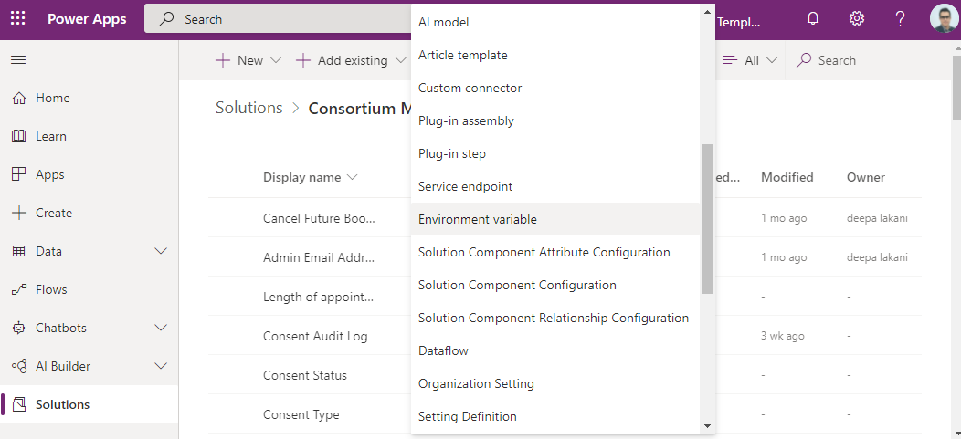

1. You can see environment variables listed.

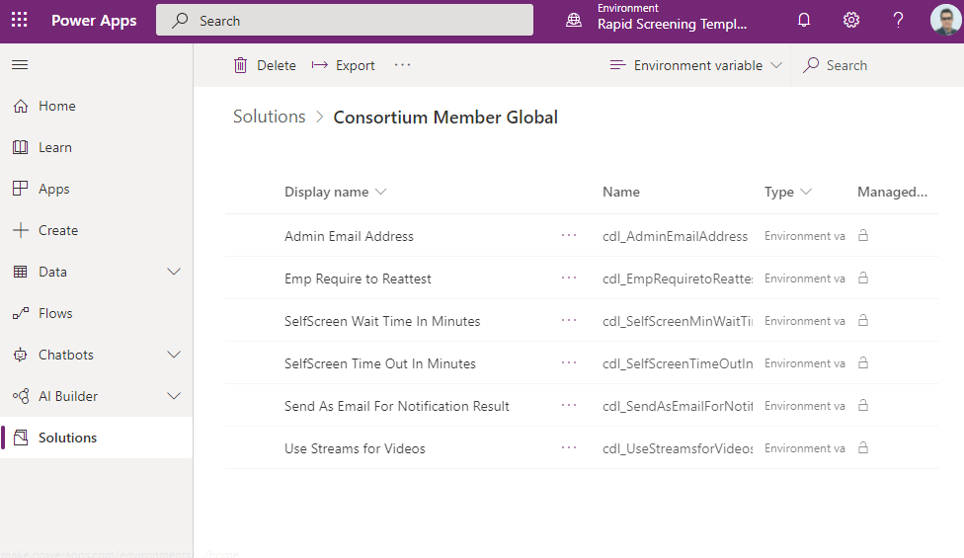

Following is definition of each variable:

* **Admin Email Address**: This email address will be used to send notification if the flow to notify result of employee fails.
* **Auto Generate Operating Hours Days**: The number of days in which time slots are automatically created. For example, if this number is set to “21” then time slots for a specific facility hours template or operating hour will auto generate for 21 days in total.
* **Emp Require to Re-attest**: Yes/No, this setting will force employees to re-attest if they book appointments greater than 24 hours in future.
* **Send As Email For Notification Result**: sender (from) email address for result notification
* **Self-Screen Wait Time In Minutes**: there is a timer in self-screening section. You can define what is the minimum Self Screen Wait time in minutes for employee to wait before update the result- this will configure the timer control time. The variable default is 15 and you can leave it or define a new value under the “current value section”
* **Self-Screen Time Out In Minutes**: Each self-screen test result need to be inputted into the employee app in a timely fashion. This configuration defines the number of minutes the end user needs to enter the results for self-screening after starting the test. If passed the screen will be timed out and employee won’t be able to update the result.
* **Use Streams for Videos**: self-screening uses videos to walk employee through the process. If the value is yes, the app will use video control that allows streaming videos from Microsoft Streams. If it is no the app will use video control that allows streaming from YouTube or Azure Media Service
* **PCR Reminder Hours:** A reminder is sent to employees who tested positive to upload their PCR test results. An email notification is sent with their details and when they tested positive. If the notification fails, an email is sent to the admin of the PowerApps tenant but this can be configured to add other people.
* **Appointment Reminder Hours:** A configurable environment parameter which provides an email reminder to the user by the specified number of hours ahead of their appointment.

#### Facilities

The import does not add any facilities by default into the solution. Facility is a screening location that employees can pick while booking the screening.

Note: For self-screening, is it recommended to create a self-screening location per province so you can report on how many employees are home screening per province. Also associate the home screening facility to “Home screening” facility time

Data fields in each facility record includes:

* **Details**
  + **Facility Number:** Alphanumeric file that can hold the facility ID or number.
  + **Name:** Facility name
  + **Description:** Description of the facility
  + **Facility Closed Days:** Days of the week that facility is operational, and employees can go for rapid screening.
  + **Time Zone:** Time zone of the facility
  + **Facility Type:** Select Screening Site
  + **Facility Group:** Select a group of predefined facility group.
  + **Reopen Phase:** Select Phase 4
  + **Notify for Positive Result:** Email address of the person to get notified if an employee tests positive at this location.
  + **Notify for Positive Result for VIP:** If an employee identified as VIP (in employee(contact) table), this email will be used for positive notification instead of above email.
  + **Screening Test Types:** Types of screens that can be used at a screening location.
  + **Address and Geography section:** addresses of the facility (screening location) – this is not being used currently.
* **Occupancy**
  + **Floors:** Defines floors and structure of the facility
  + **Areas:** Defines areas in each floor, example of this could be specific room in the building or floor
* **Operating Hours:** Operational hours of the facility
* **Timeslots:** Timeslots are being generated automatically from the operating hours and duration of test. Do not modify this table directly as the timeslots are generated using a Power Automate flows based on the operating hours.

The following steps outlines the instructions required to setup a facility:

1. Create a new Facility.
2. Add Screening Types
3. Add Occupancy (Floor and Areas)
4. Add Operating hours

##### 1. Create New Facility

1. To create a new facility, on the facility safety app left navigation click on “Facilities” and then click new.

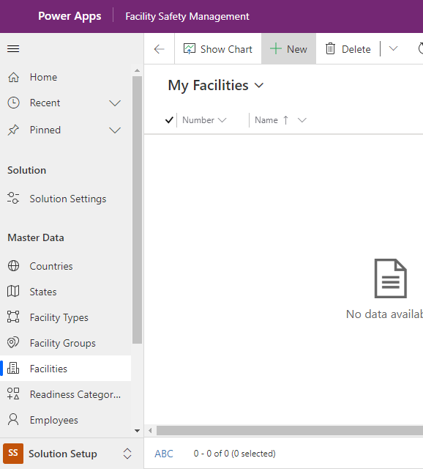

1. Fill up the fields on the “Details” tab as below. Make sure to fill all the field that are not flagged as optional in the following bullet list.

* Details Tab
  + Facility Number: Use incremental number of your choice.
  + Name: Facility name
  + Description: (Optional) Description of the facility
  + Facility Closed Days: (Optional) Days of the week that facility is not operational.
  + Time Zone: Time zone of the facility
  + Facility Type: Hover over this field and click on the magnifying glass and Select Screening Site
  + Facility Group: Hover over this field and click on the magnifying glass and select a facility group from predefined list of facility groups – Note that choosing the group also defines the associated setting for that facility based on the association between solution setting and facility group.
  + Reopen Phase: Hover over this field and click on the magnifying glass and select Phase4.
  + Notify for Positive Result: (Optional) Enter an email address of the person to get notified if an employee tests positive at this location.
  + Notify for Positive Result for VIP: (Optional) Enter an email address for positive notification for your organization VIP employees (i.e., CEO, etc) - If an employee is identified as VIP (in employee(contact) table), this email will be used for positive notification instead of above email.
  + Address and Geography section: (Optional) Addresses of the facility (screening location) – this is not being used currently.

1. From the top ribbon, click on “Save” once above details is entered. Do not close or “Save and Close”.

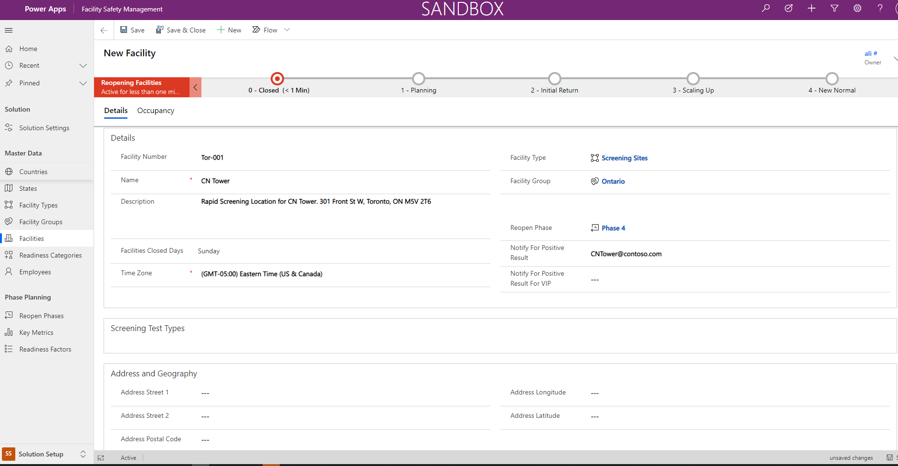

##### 2. Add Screening Types

Once the facility details are saved, the “Screening Test Type” section of the form will become available so you can add types of screens that can be used at that screening location.

1. On the same form click on “+New Screening Type”

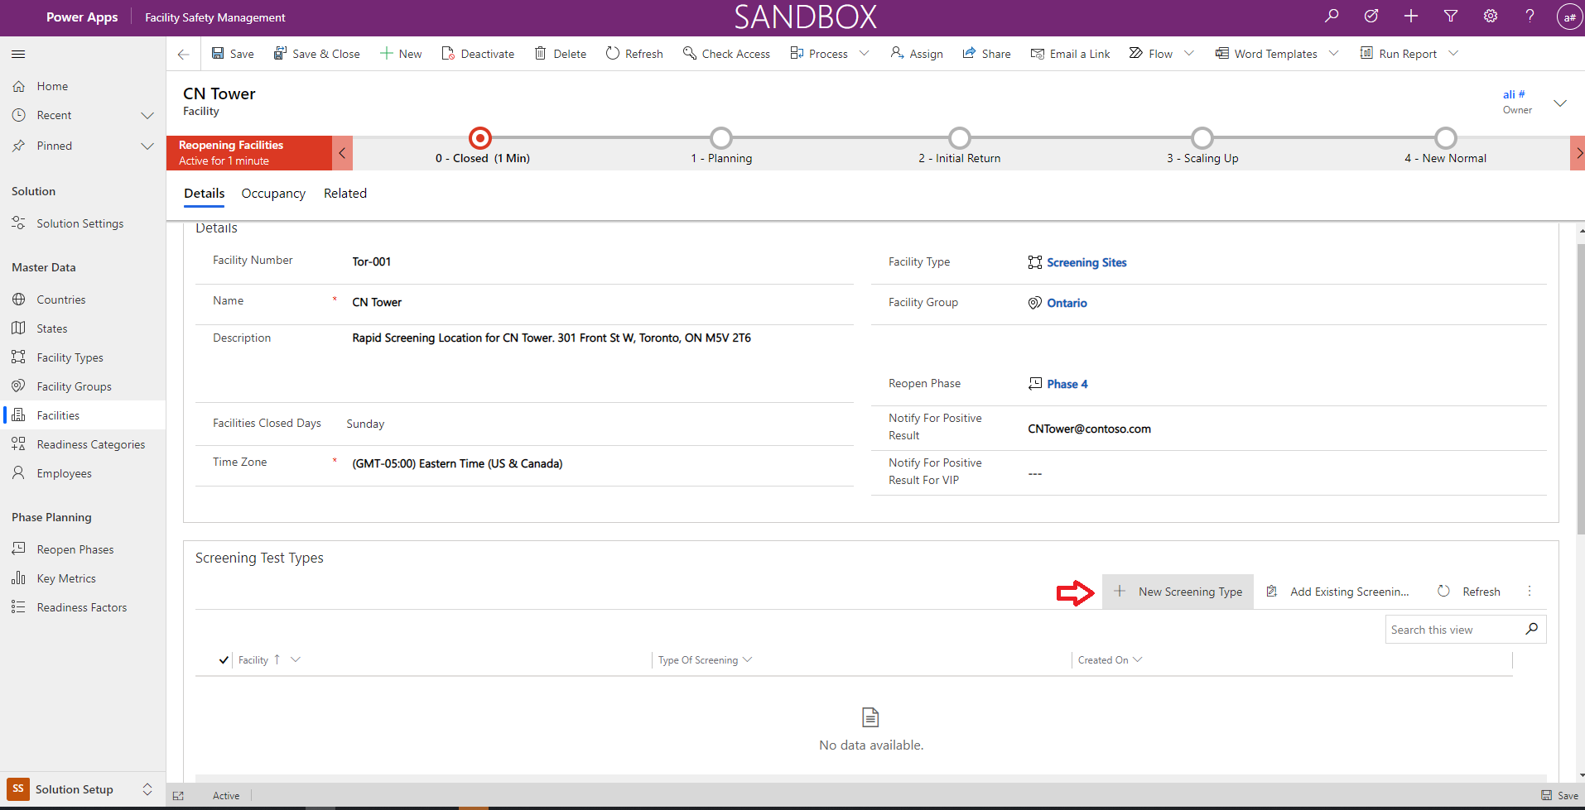

1. This will open a new page, select “Type of Screening” that is going to be available at this specific facility location.

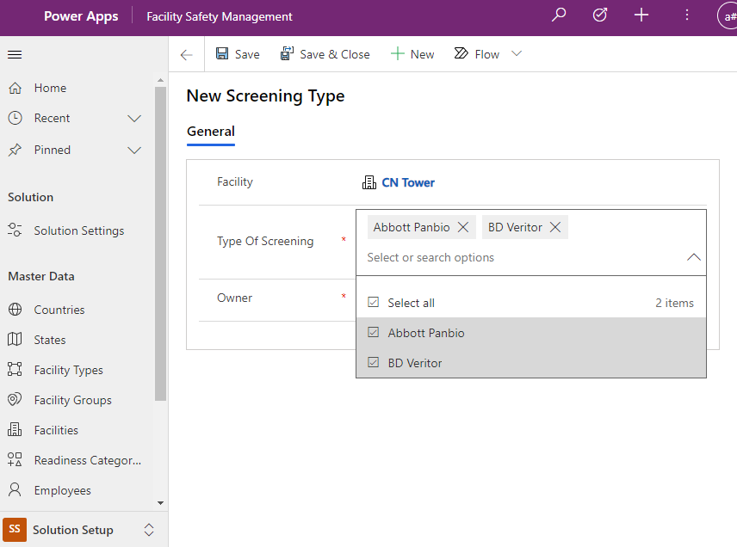

1. Click on the “Save & Close” to save and close the screening type window and auto navigate to facility page – at this point you should see a record under the “Screening Test Types” sub grid.

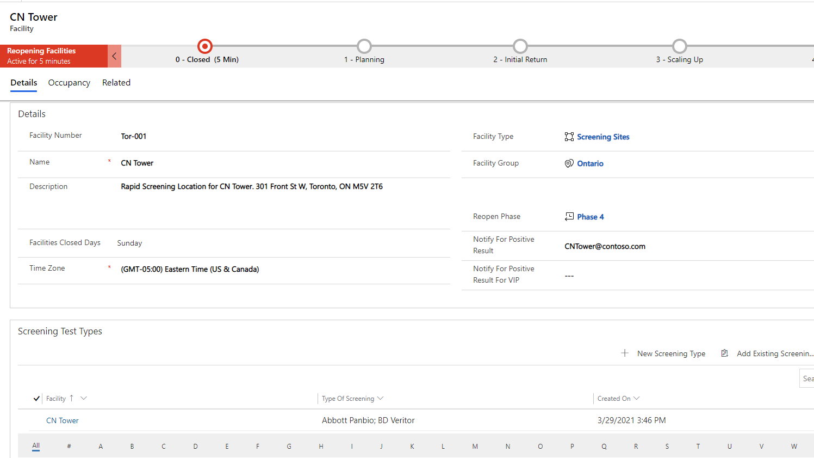

##### 3. Add Occupancy (Floor and Area)

1. Click on Occupancy tab

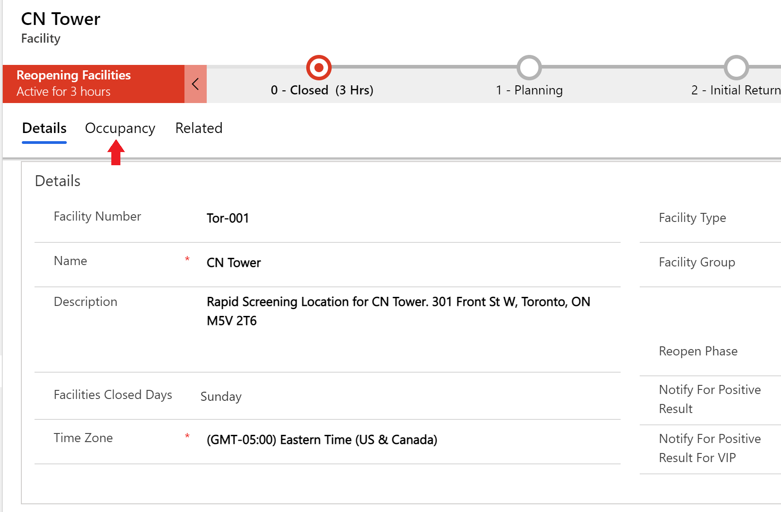

1. Under Floors section click on “+ New Floor”

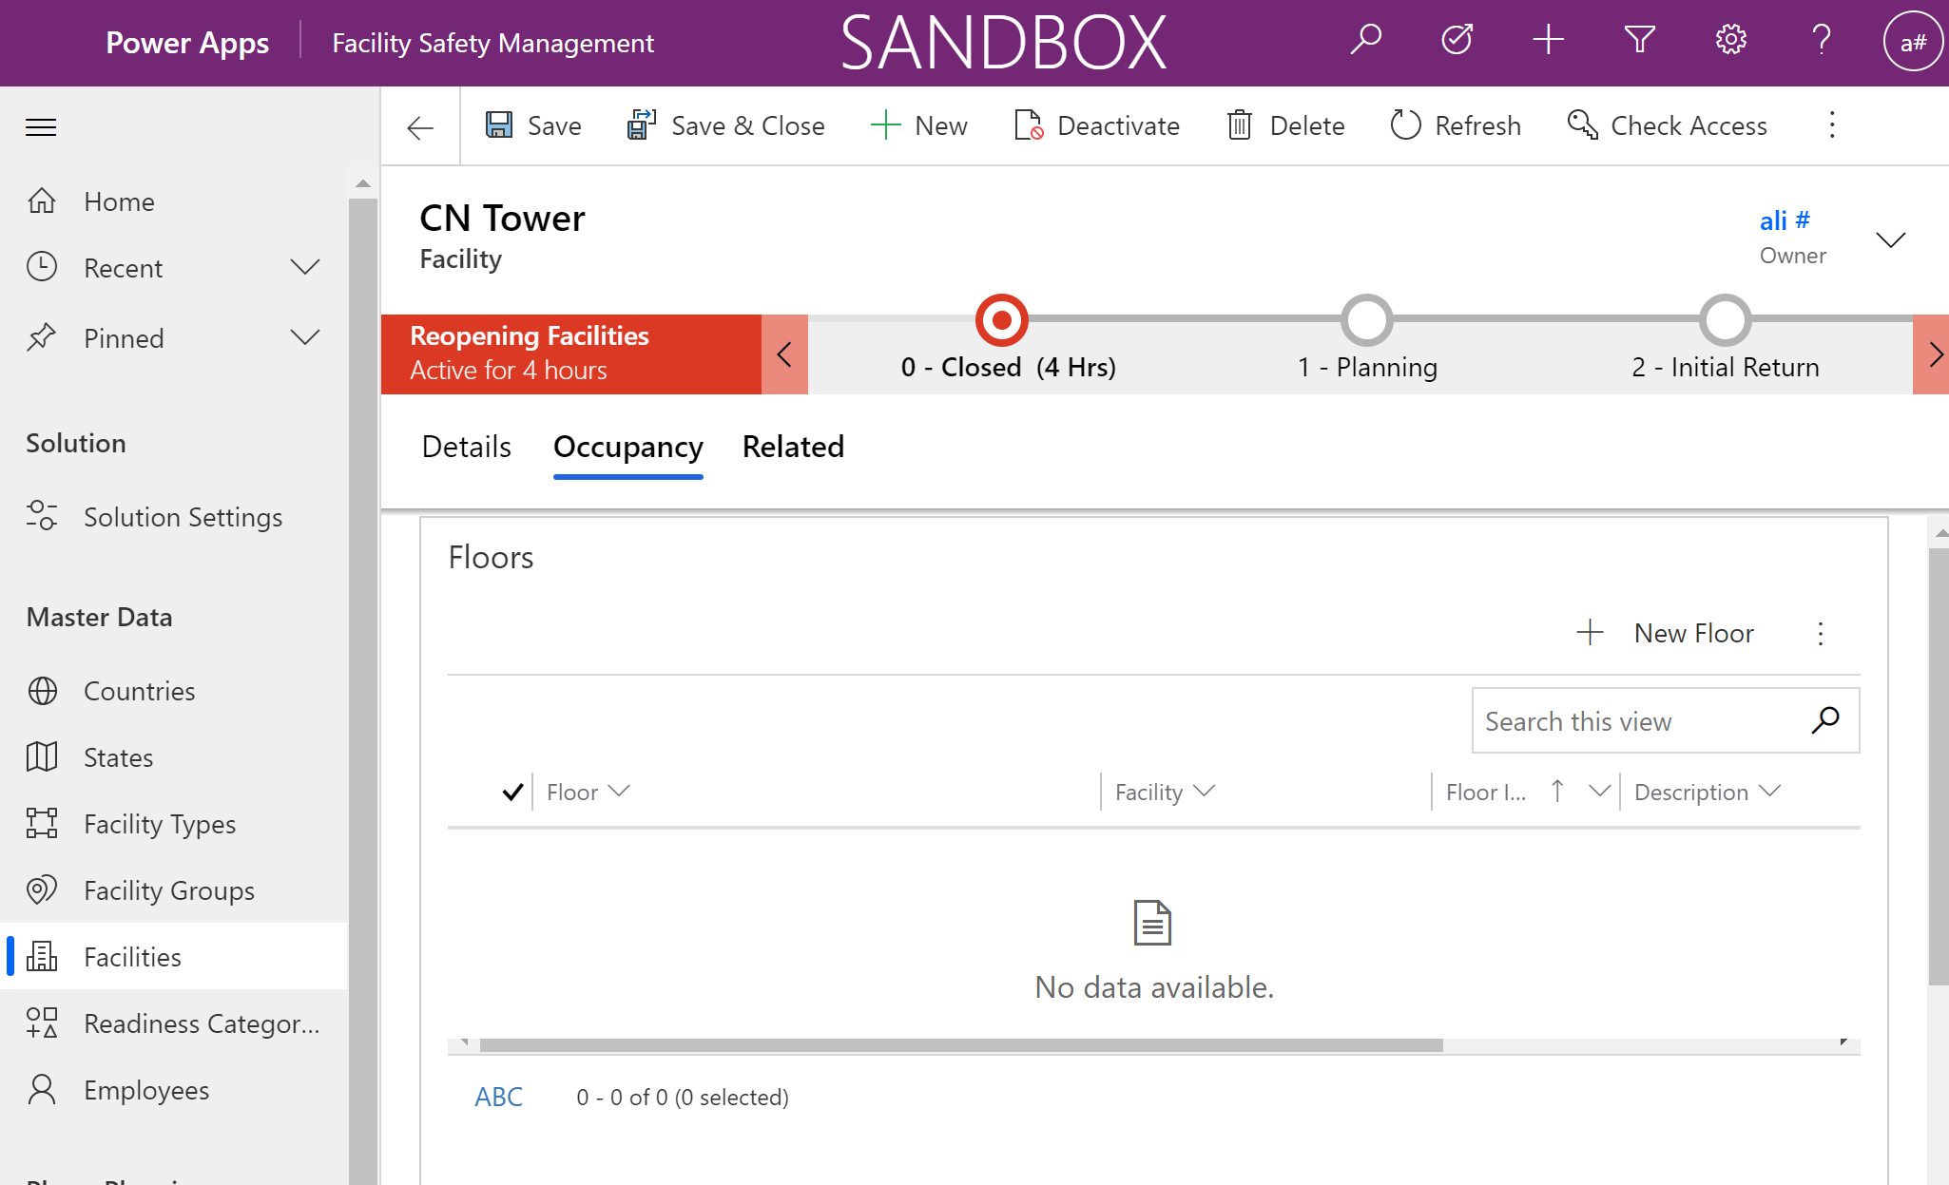

1. Fill the new floor form and click on “Save & Close” to go back to the facility.

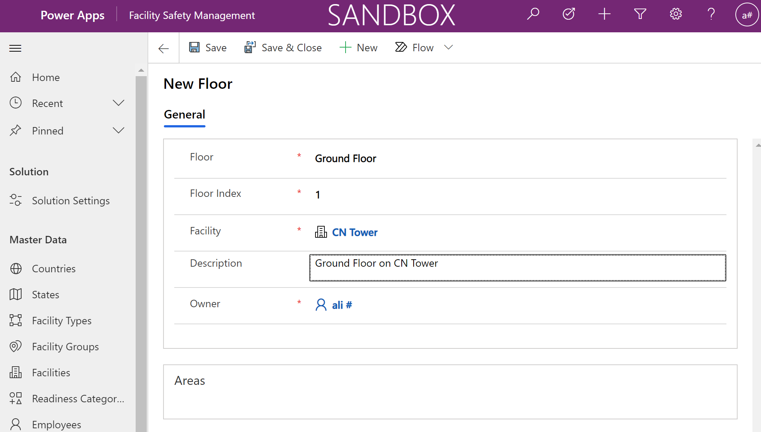

1. Once on the facility form, click on “+ New Area” under the “Areas” section to add a new area for the facility and floor.

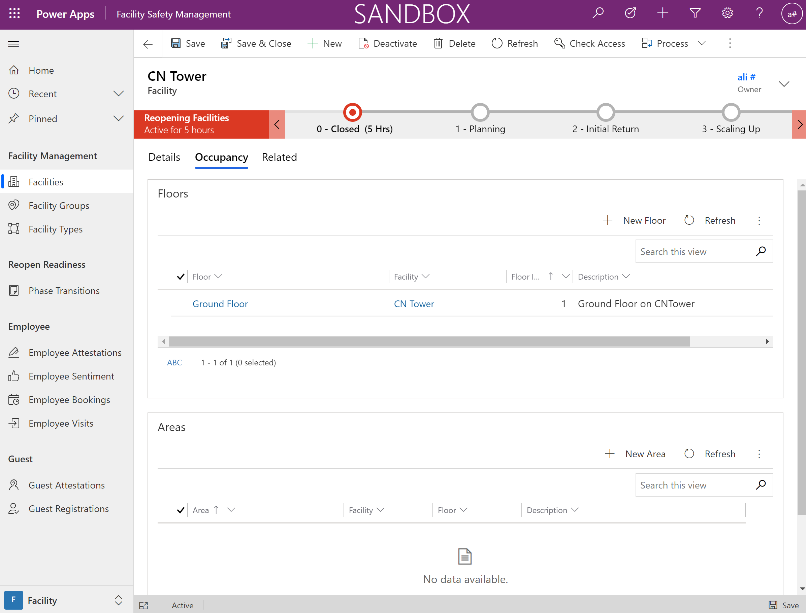

1. Add the Area information and setup the floor lookup to the floor record created earlier.

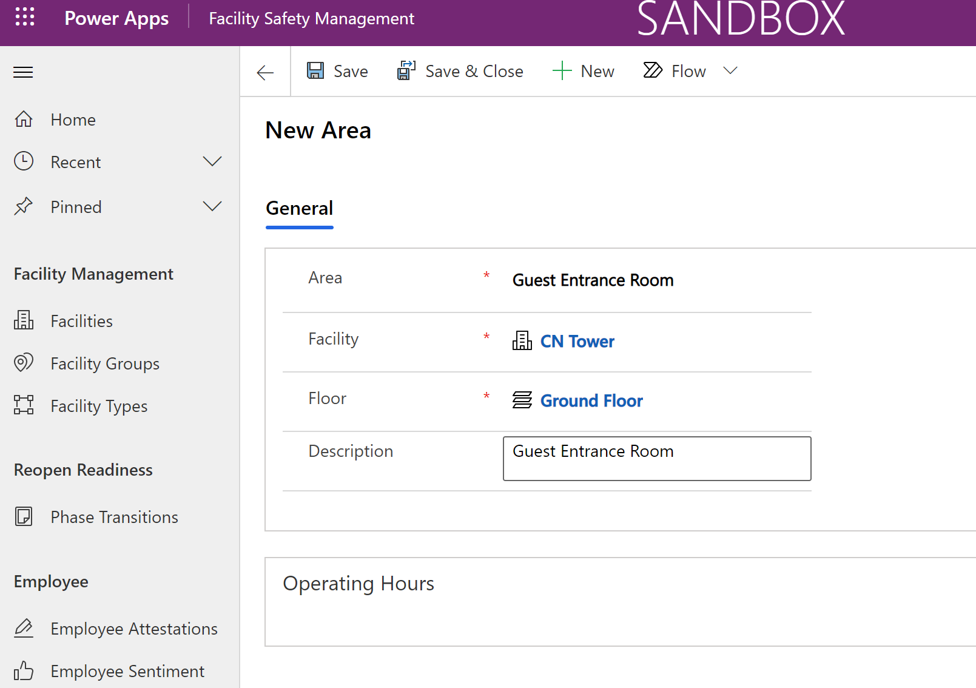

1. Click on “Save” (do not navigate away) and stay on the Area page to enable Operating hours in the next section.

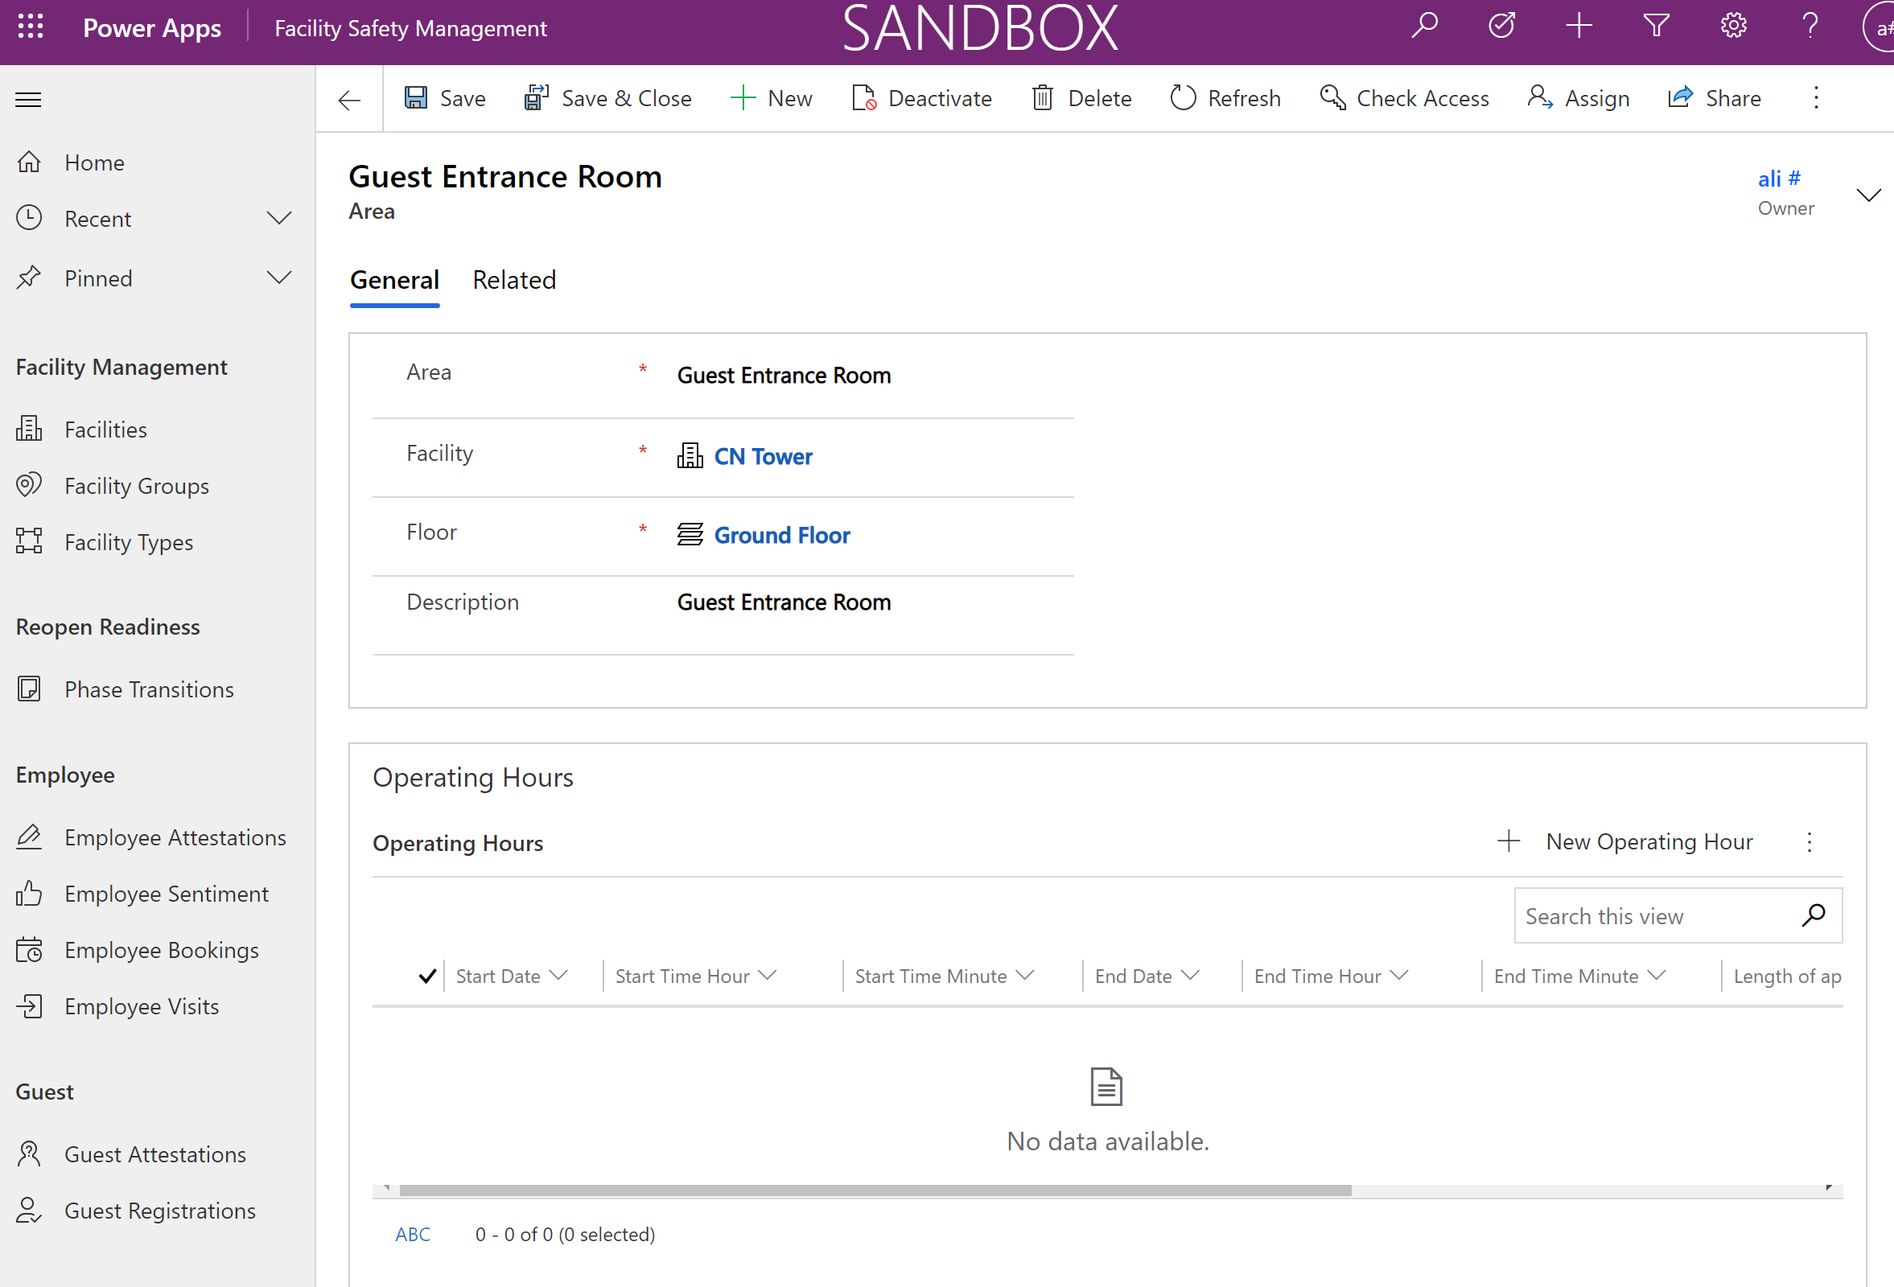

##### Add Operating Hours & Time Slot Options

There are two options for adding Screening Appointment Time Slots to the Employee Application for booking a Screening Appointment. Options are listed below:

|  |  |  |  |  |  |
| --- | --- | --- | --- | --- | --- |
| **Option** | **Timing** | **Recurrence** | **Skip Days** | **Process for adding new time slots** | **Best Use Case** |
| Add new Operating Hour record | *One-time, individual records* | *Not available* | *Not available* | *New record will need to be created by Facility Manager* | *One-off screening appointments or areas with a set end date.* |
| Add new Facility Hours Template record | *One-time* | *Automated recurrence available. Configurable in Power Automate flow. Default is weekly.* | *Available* | *If Facility Manager opted-in to auto generated time slots, new time slots will be generated weekly unless configured otherwise.* | *Consistent screening areas within a facility without a firm end-date.* |

The option to ‘Add new Operating Hour record’ is listed below.

1. On the Area page, Click on “+ New Operating Hour” on the Operating Hours section of the Area form.

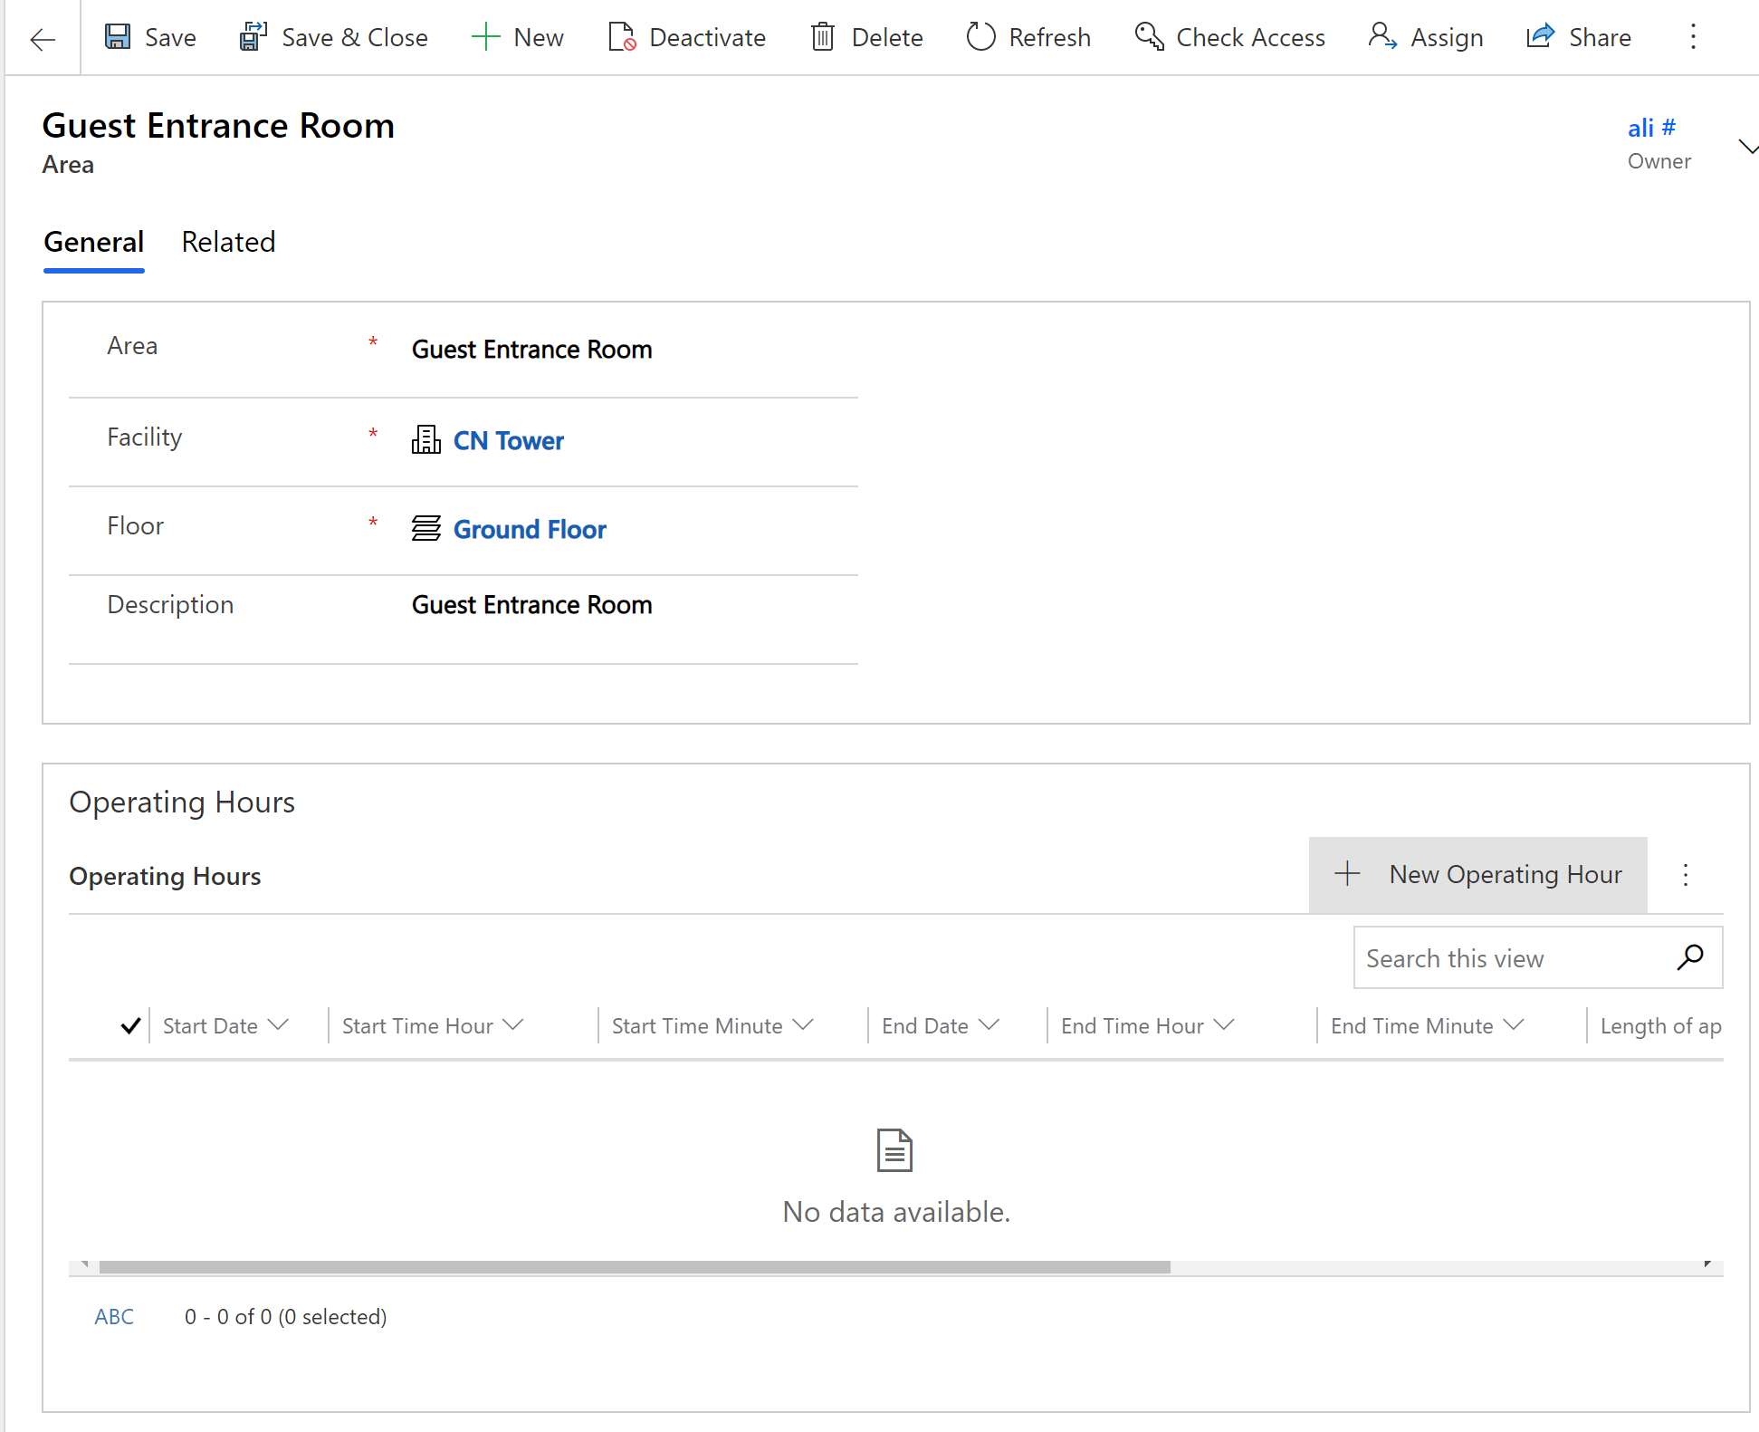

1. Fill out the operating hour form for the facility and click on “Save & Close”.

Note: Enter hour (start/end) in 24 hours format

Important: To avoid hitting the throttling limits of Power Automate (5k API call per day), Setup the operating Dates in 2 weeks period and avoid loading many operating hours in a single day

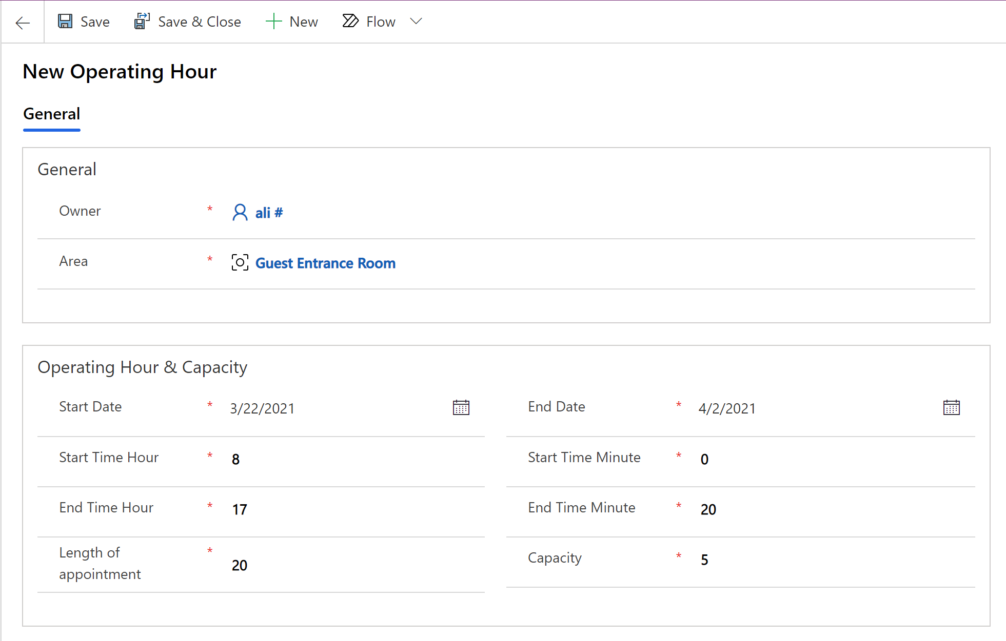

1. Click on “Save & Close” to save and close the operating hours form and land on area form.
2. On the area form click again on “Save & Close” to save and close the Area form and go back to the facility
3. Upon saving the operating hours on step9, a Power Automate flow will be triggered to create timeslots for defined operating dates and hours. This process will take few minutes to complete.

Click on the “Related” tab of the facility record and click on the “Time Slots” table

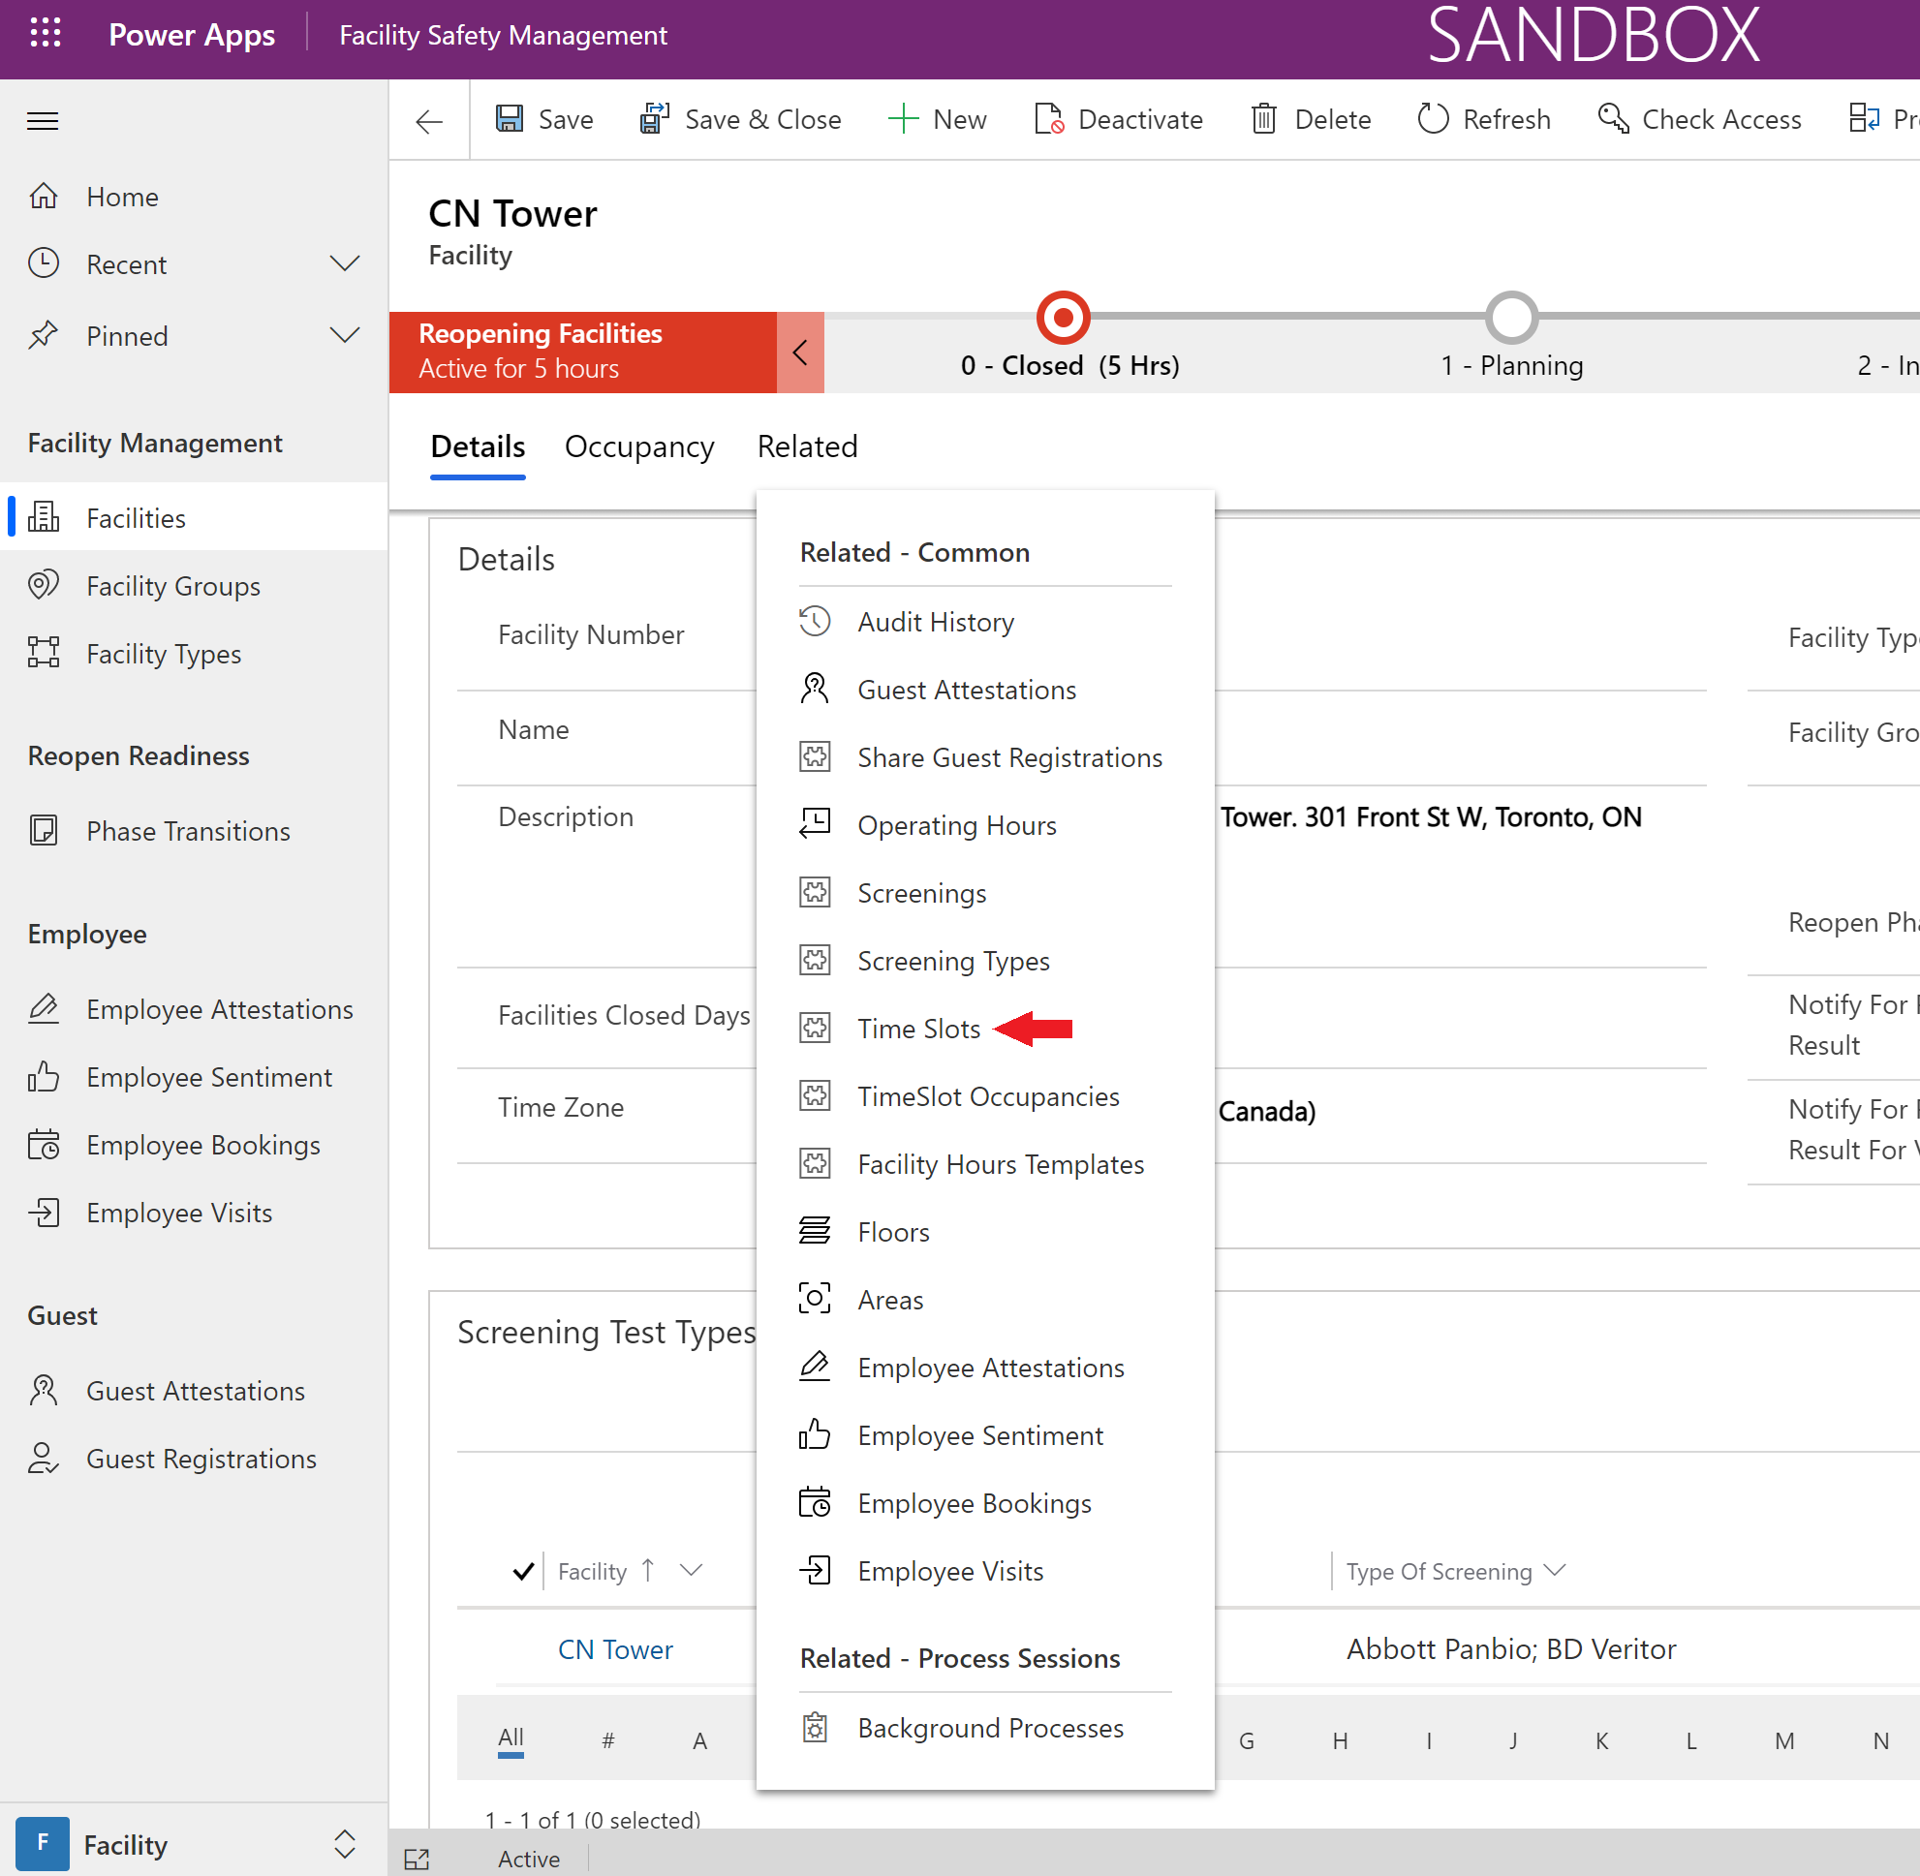

1. On the “Time Slots” tab, change the view to “Active Time Slots” to see more details.

Note: On the bottom left corner of the timeslot sub grid verify the number of timeslots created. For instance, 5 days of 8 hours operating hours per day with appointments of 20 minutes will result in 120 timeslots in the table (8*3*5)

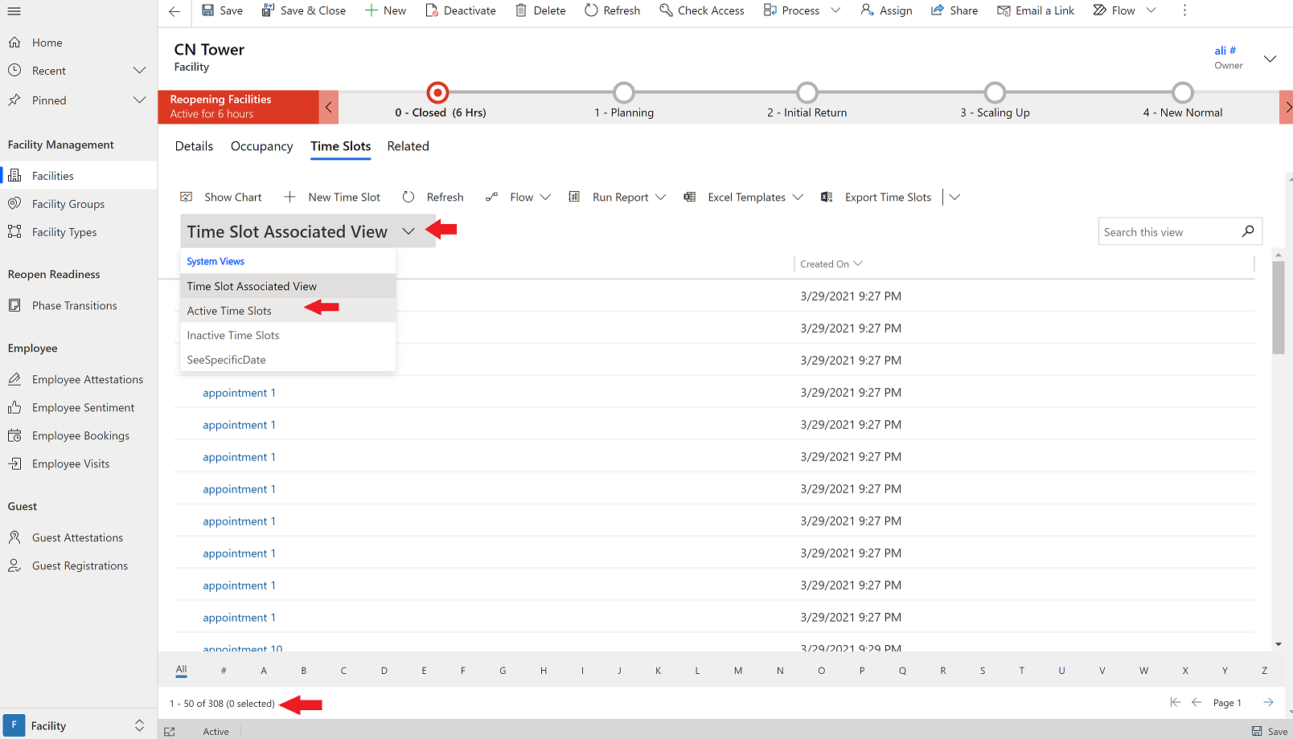

Add new Facility Hours Template record

1. On the Area page, Click on “+ New Facility Hours Template” on the Facility Hours Template section of the Area form 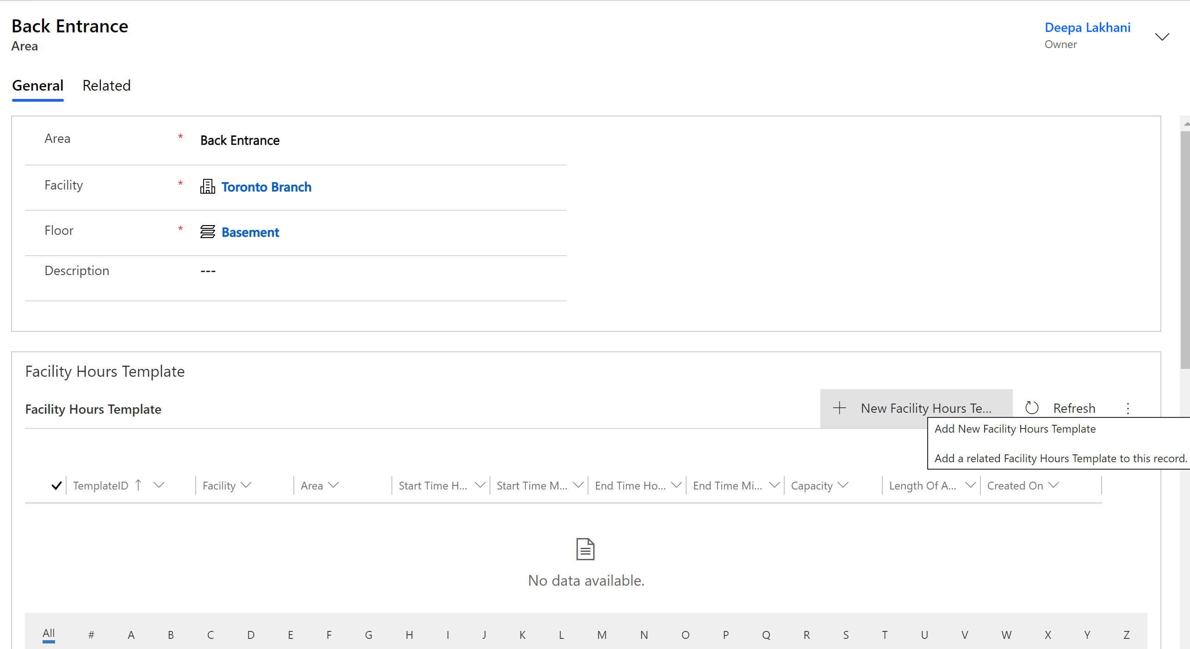
2. Select ‘New’ on the top menu bar to create anew ‘Facility Hours Template’.
3. Fill out the form and click ‘Save & Close’
   1. Ensure the ‘Auto Generate Opt In’ is selected as ‘Yes’ to auto-generate new time slots
   2. Select the ‘Days to Skip’ and the facility template will ensure any days selected will not have any time slots created for those days.

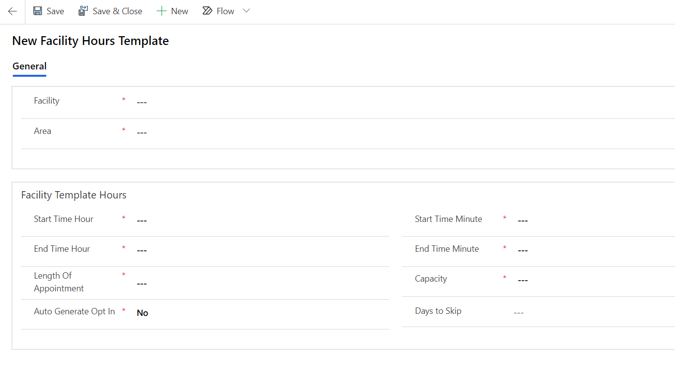

1. The ‘Facility Hours Template’ will not automatically create time slots since it recurs weekly, by default. If time slots are required to be created immediately, open the ‘Auto Generate Operating Hours’ flow in the ‘Consortium Member Global’ solution.
   1. Solutions>Consortium Member Global>Auto Generate Operating Hours
2. Click on the flow to open and select ‘Run’ from the top menu bar.

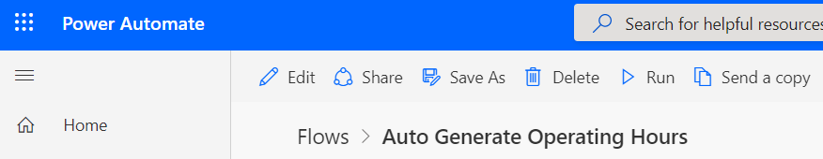

1. Running the flow will create a new operating hour row which will trigger another flow to create new time slots.
2. To update the recurrence of the flow, click ‘Edit’ in the top menu bar of the flow.
3. Open the flow in edit mode and update the recurrence settings.

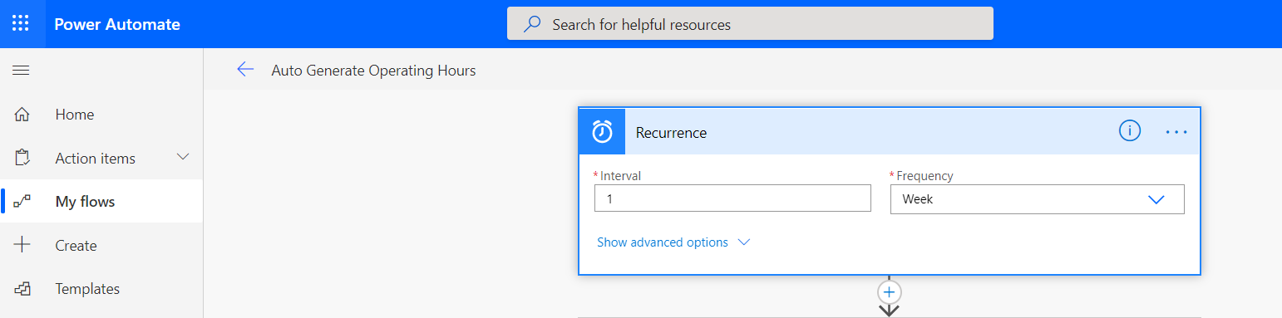

1. Save and close.
2. To update the number of days in which the flow will auto-generate time slots, update the ‘Auto Generate Operating Hours Days’ Environment Variable as highlighted below.

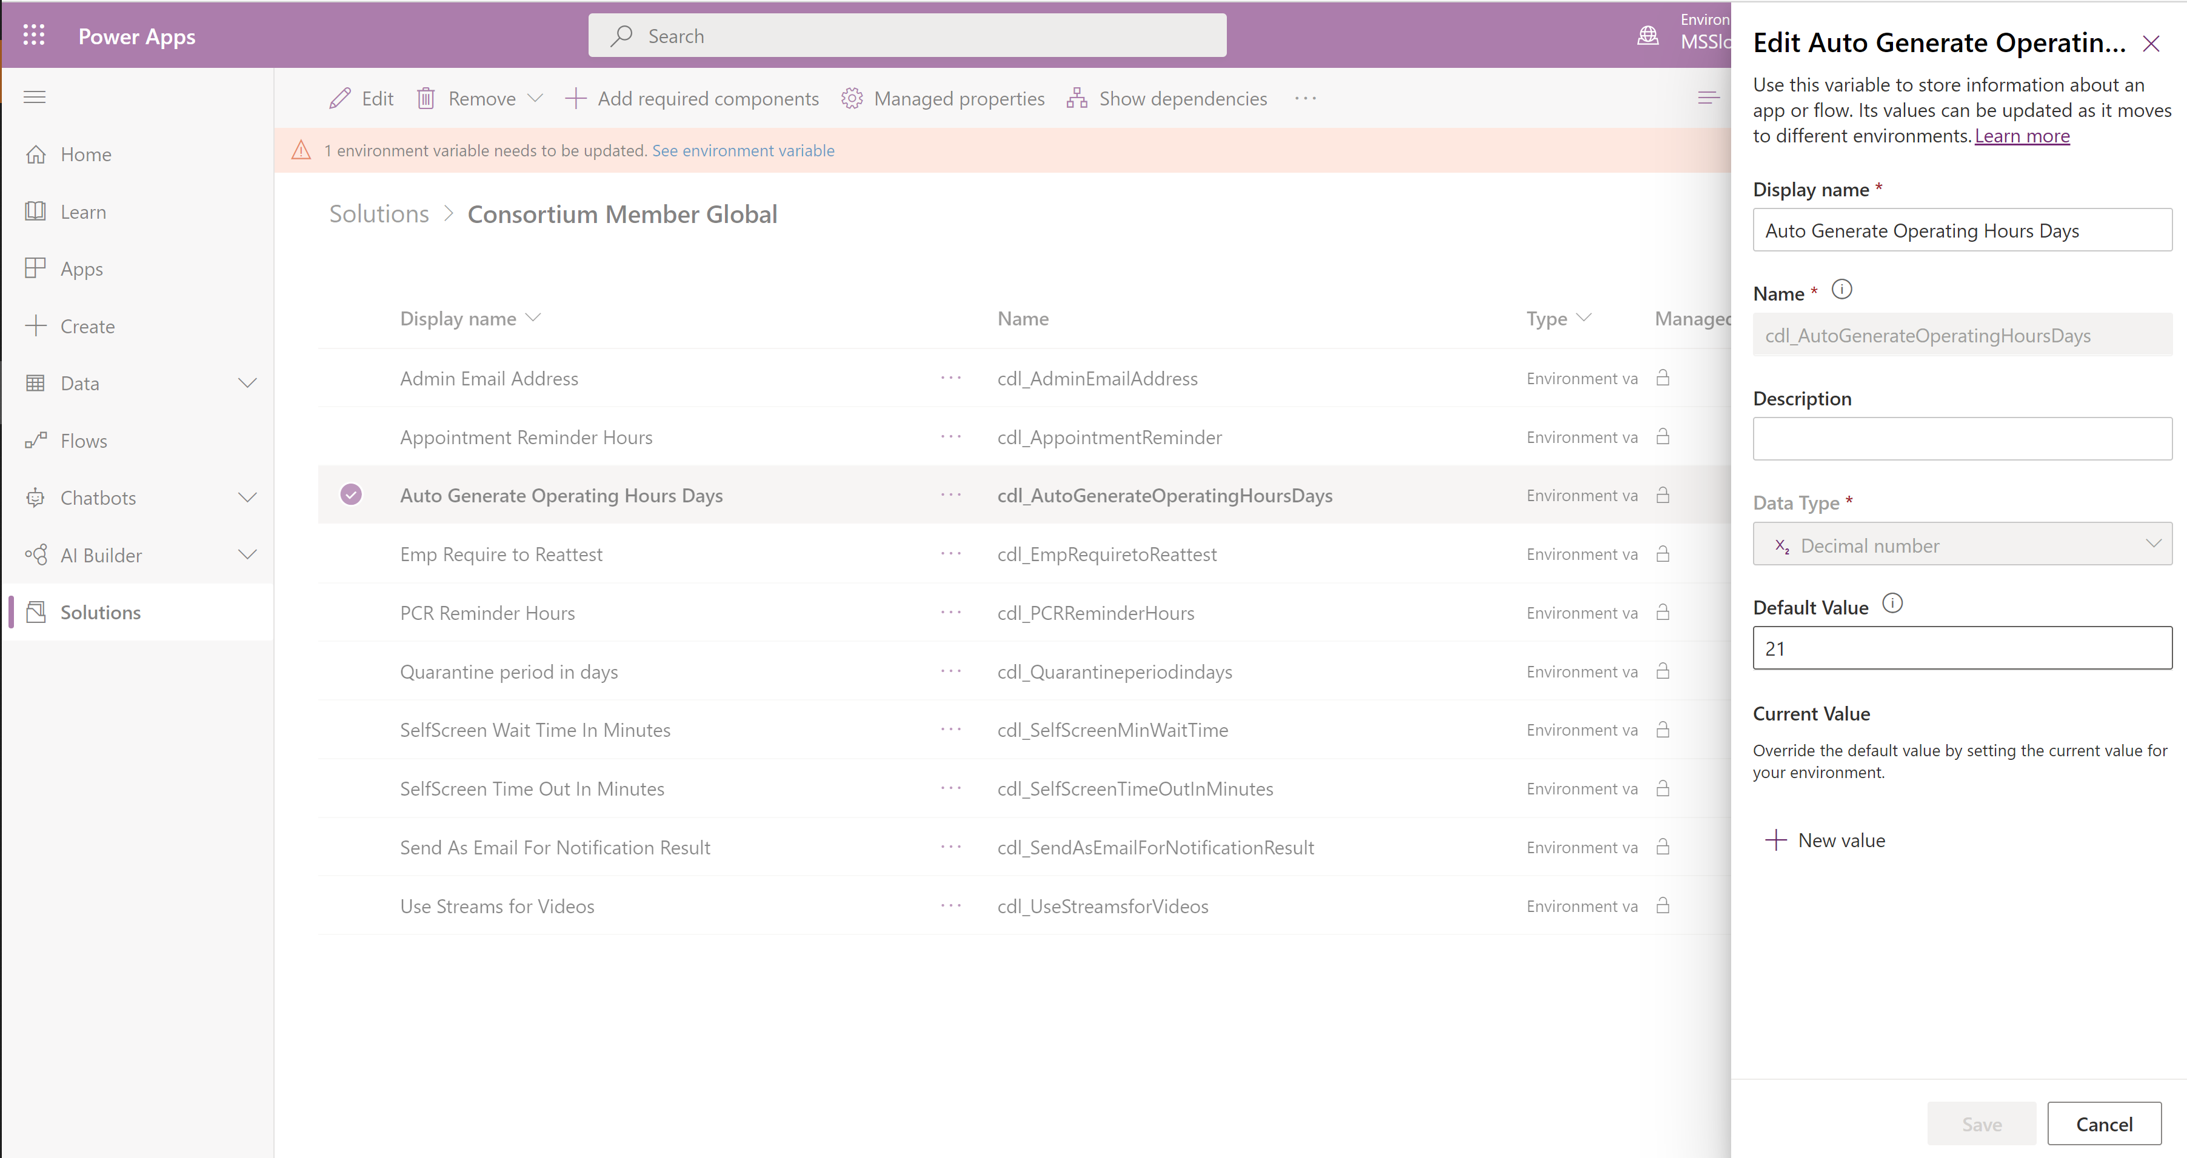

The facility setup is completed. Repeat the steps to add additional facilities or operating hours.

#### Email Templates

The following e-mail templates need to be uploaded to the EmailTemplates Table.

Go to make.poweapps.com portal, on the left navigation click on solution and find the “Consortium member” solution from the list and double click to open it.

Find EmailTemplates Table inside the solution and open it and then click on Data tab to see imported row.

Select each row, click on edit on the header and open the row to attach the pdf files per template.



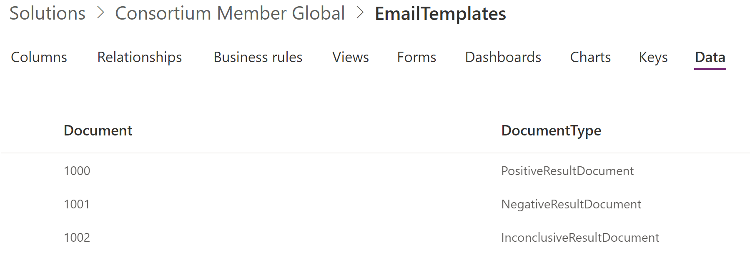

Sample E-mail Templates: -



#### Employee

Employee profile information will be stored in the employee table. When an employee opens the employee app for the first time, the employee record will be created from the Azure Active Directory user table.

On the employee section change the view to “all contacts” to see a list of all employees

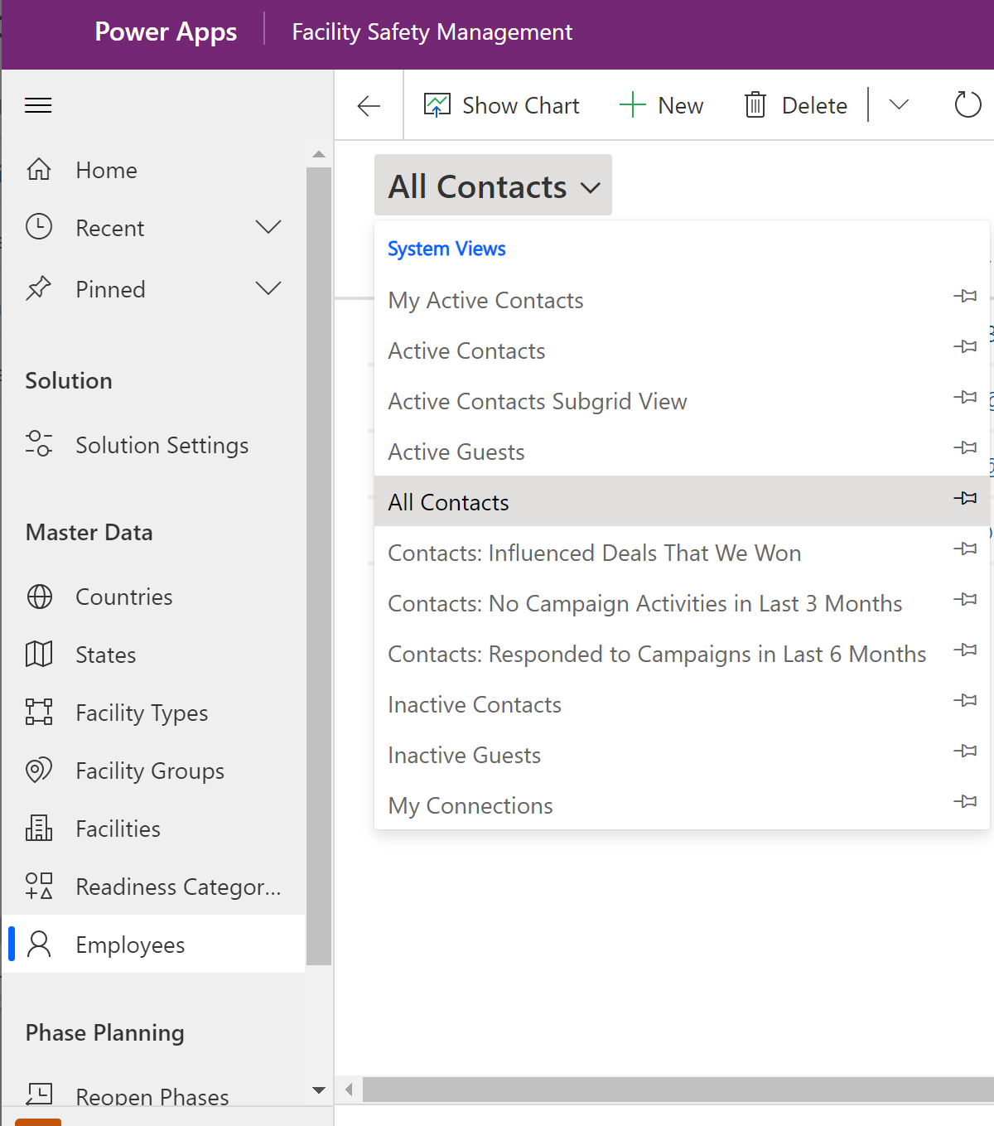

Open a record by select a row to edit/view.

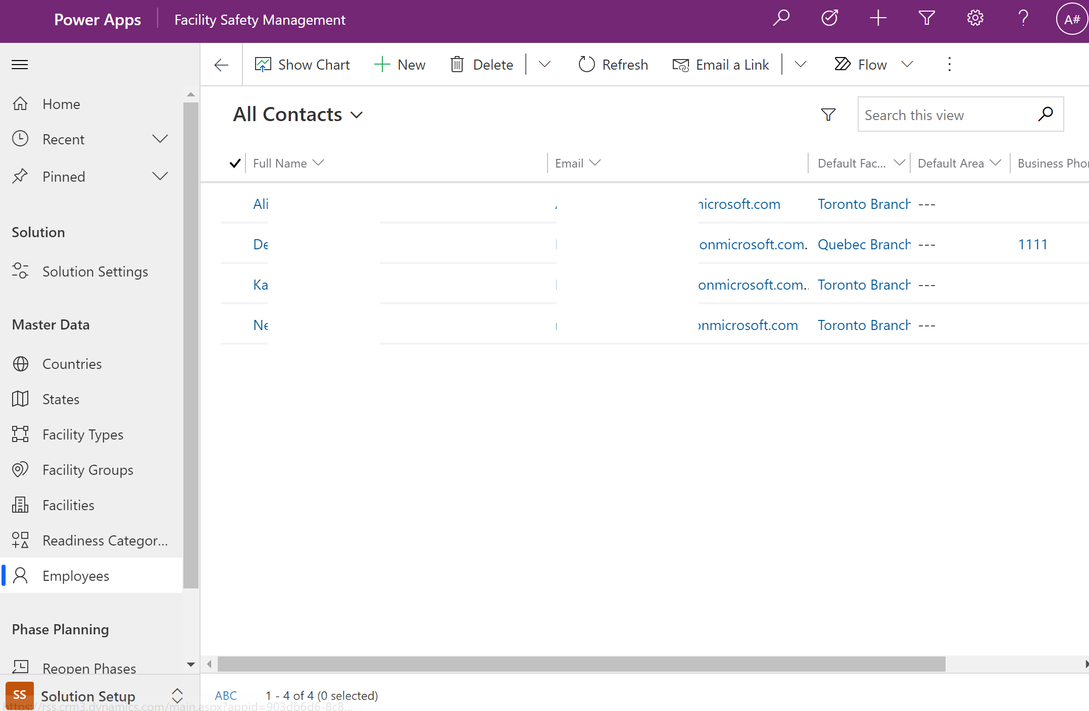

#### SelfScreening Videos

The table contains configuration for self-screening training videos available on solution version > 2.x.x.x

#### Colour Template

Colour theme records must be created in order to render the Rapid Screening Booking App and the Health Safety Officer Screening App as expected.

Select ‘Solution Setup’ in the bottom right of the facility safety management application and the click “Theme Guides”

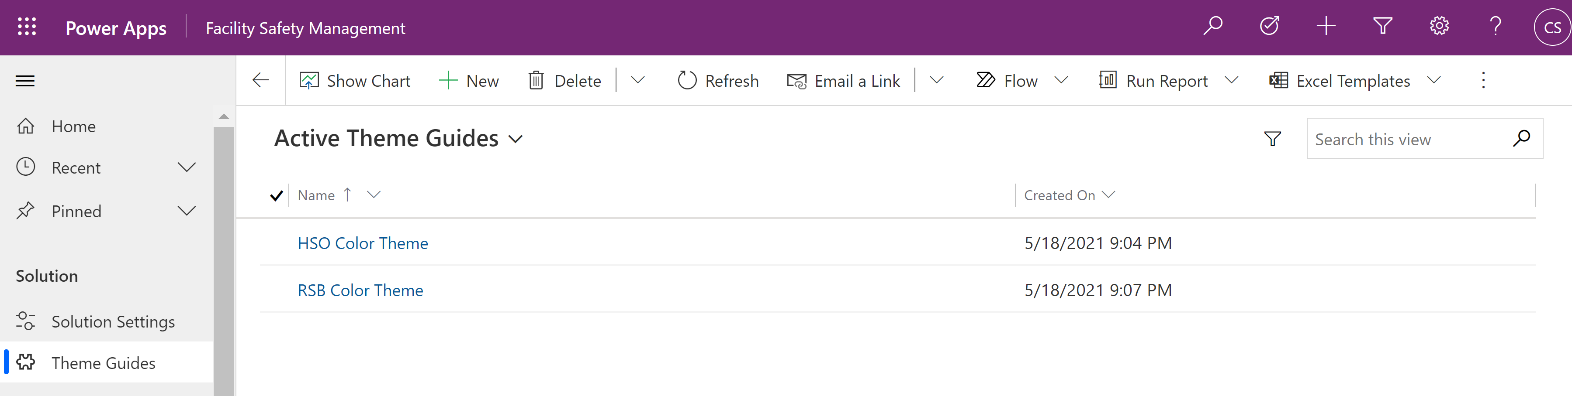

From here select “New”

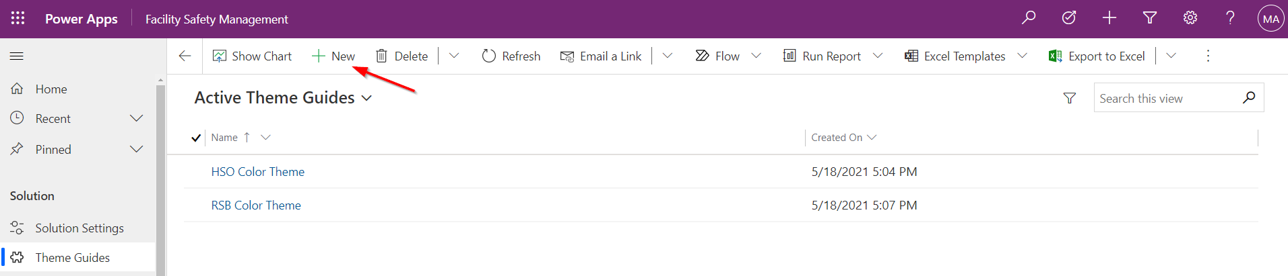

Two records must be created, one for the HSO application and one for the RSB application.

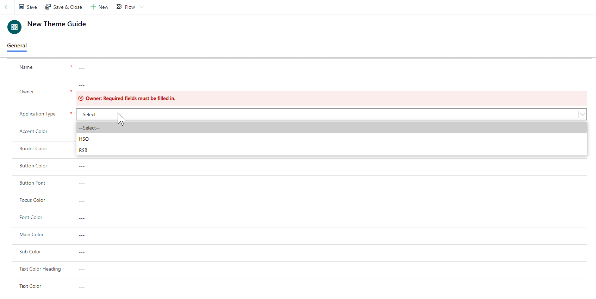

You can change the colors of various items e.g. Text, Button etc. using hex codes; additionally, the client can also upload their logo here.   
  
For the Health Safety Officer application:

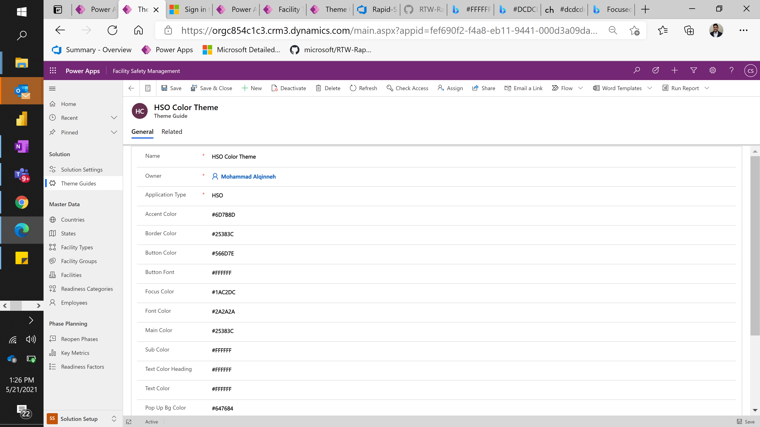

**Accent Colour**: colour of the title textboxes and ‘magnifying glass’ search icon

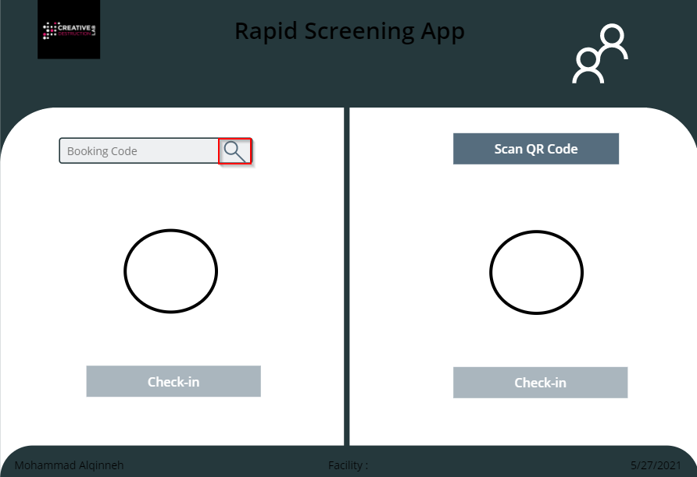

**Border Colour:** colour of the border

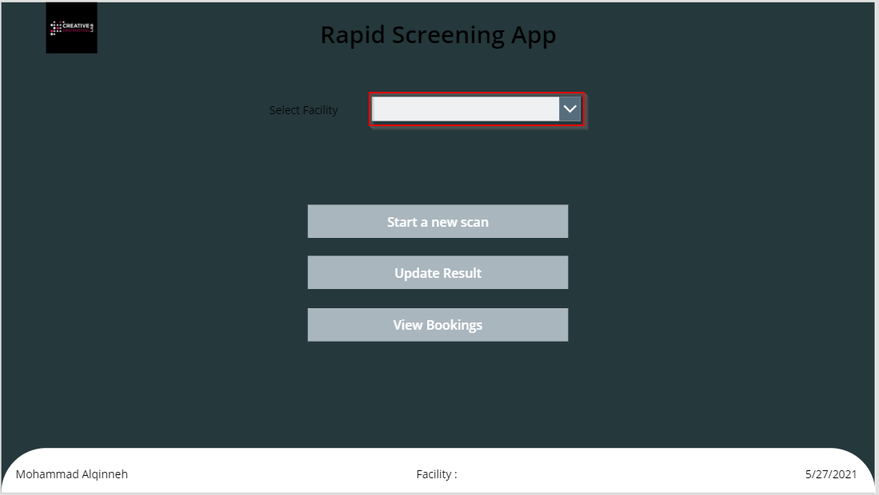

**Button Colour**: fill colour of the button.

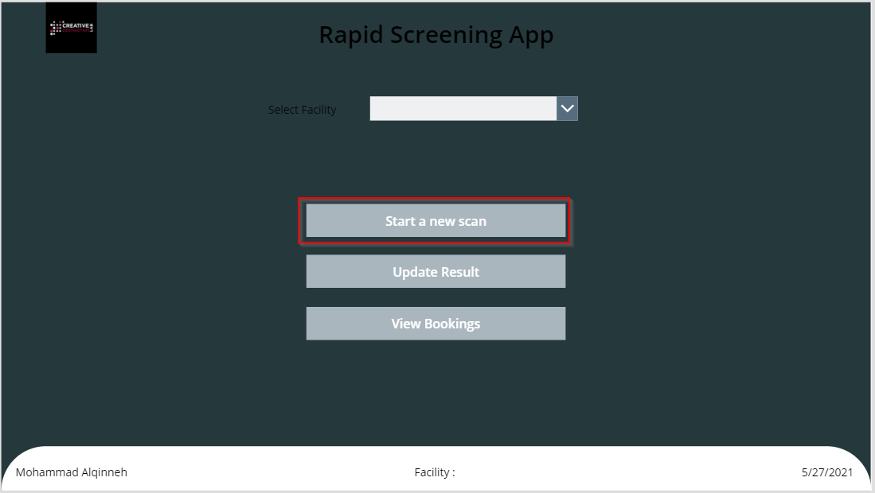

**Button Font**: colour of the text of the buttons

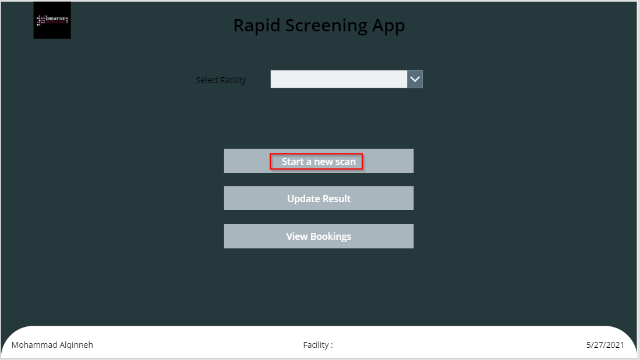

**Focus Colour**: not used.

**Font Colour**: not used.

**Main Colour:** colour of the background footer

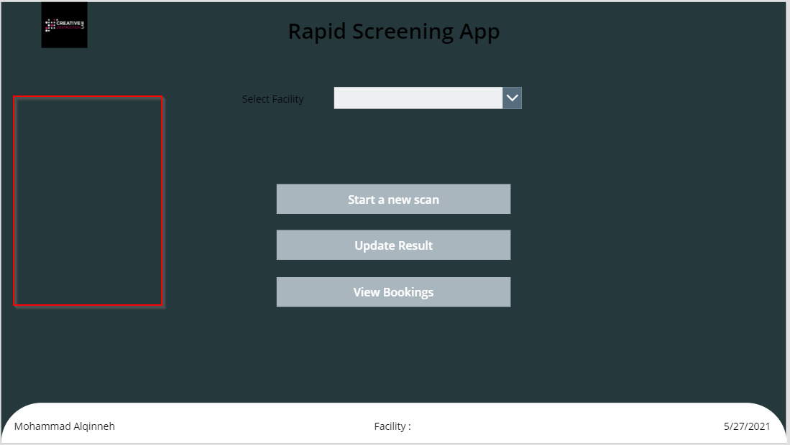

**Sub Colour**: colour of the background frame

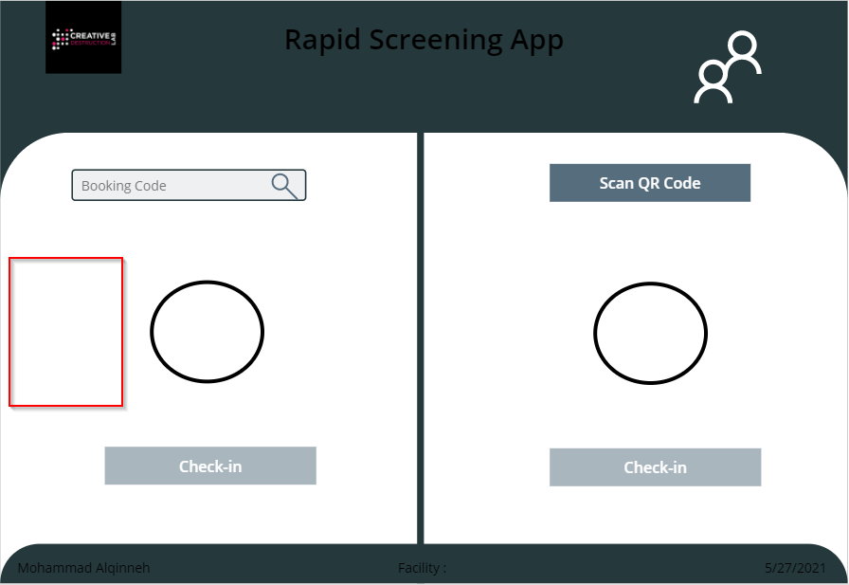

**Text Colour Heading**: colour of all text headings.

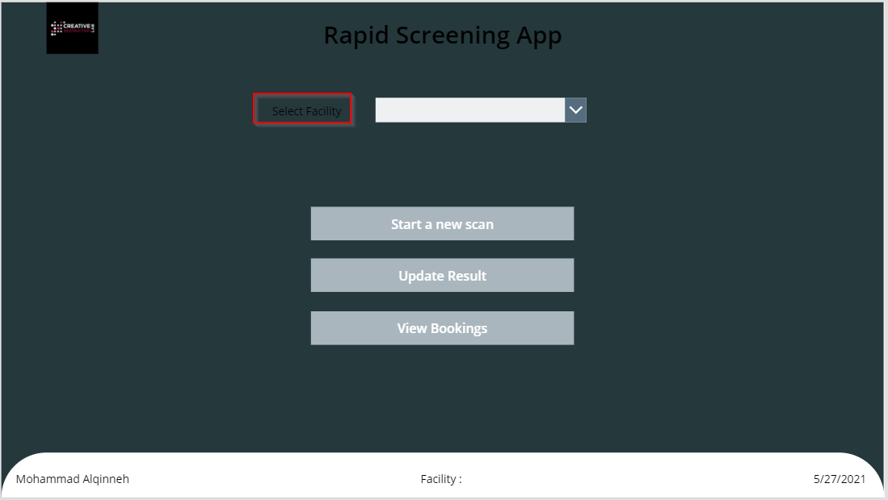

**Text Colour**: colour of all body text



**Pop Up Bg Colour:** Not used.

For the Rapid Screening Booking application:

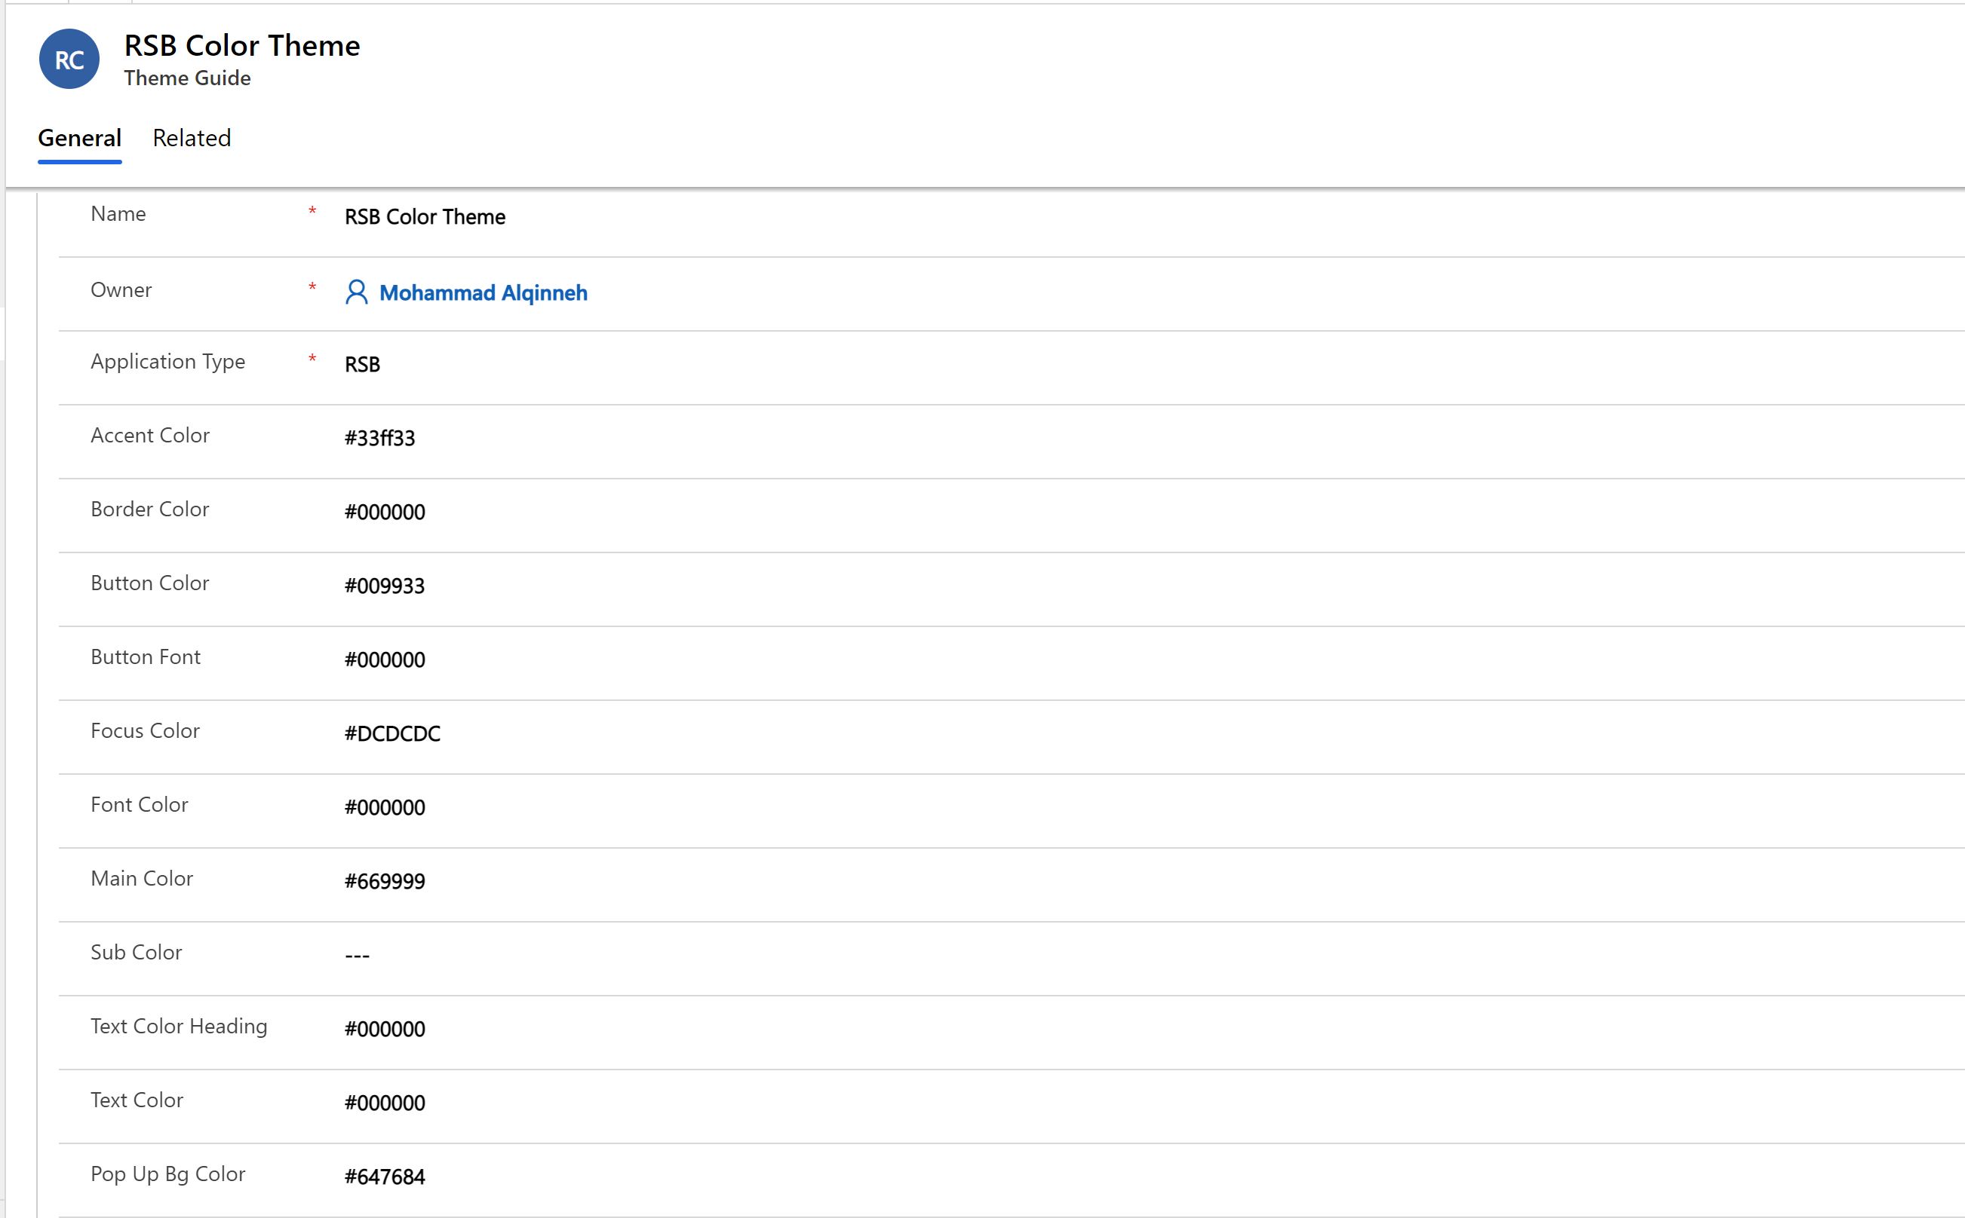

**Accent Colour**: colour of the title textboxes and ‘magnifying glass’ search icon

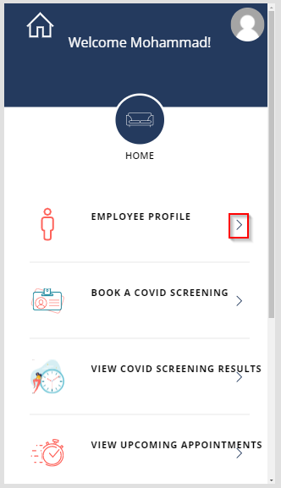

**Border Colour:** colour of the border

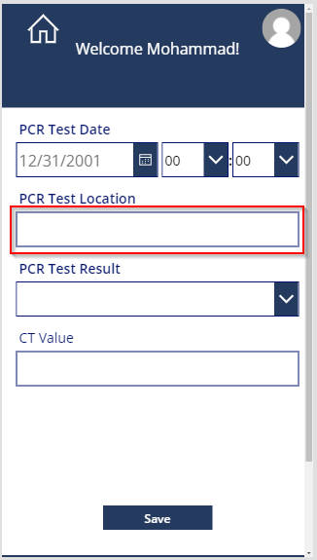

**Button Colour**: colour of the button.

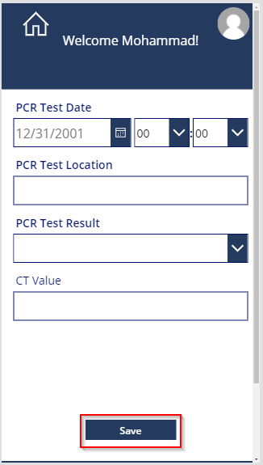

**Button Font**: colour of the text of the buttons

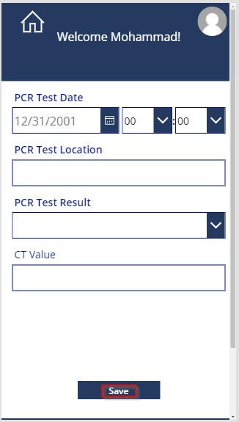

**Focus Colour**: colour when an object is in focus.

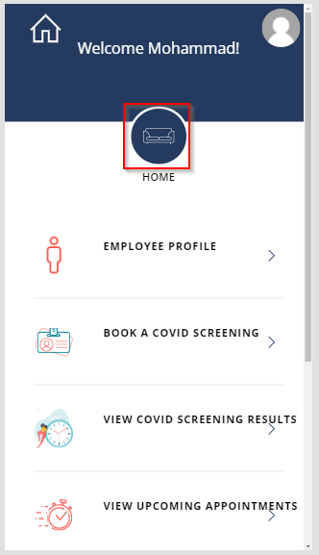

**Font Colour**: colour of all text.

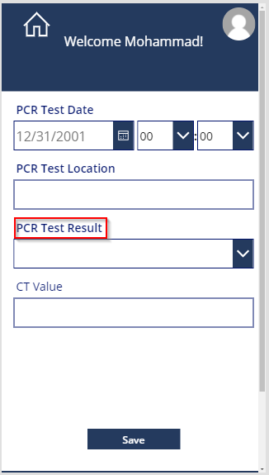

**Main Colour:** colour of the background footer

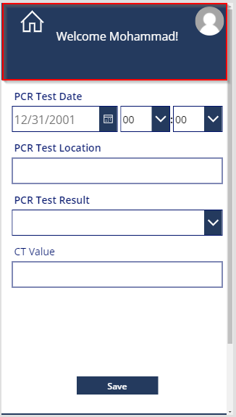

**Sub Colour**: Not used.

**Text Colour Heading**: Not used.

**Text Colour**: Not used.

**Pop Up Bg Colour:** Not used.

## 6. Sharing Apps

Share each of the 3 Applications to the AAD groups created in Step 1.

* RSC_Employee – Rapid Screening Booking App
* RSC_HSO – Health Safety Officer Screening App
* RSC_FacilityMgrs – Facility Safety Management

Sharing to employee ADD group:

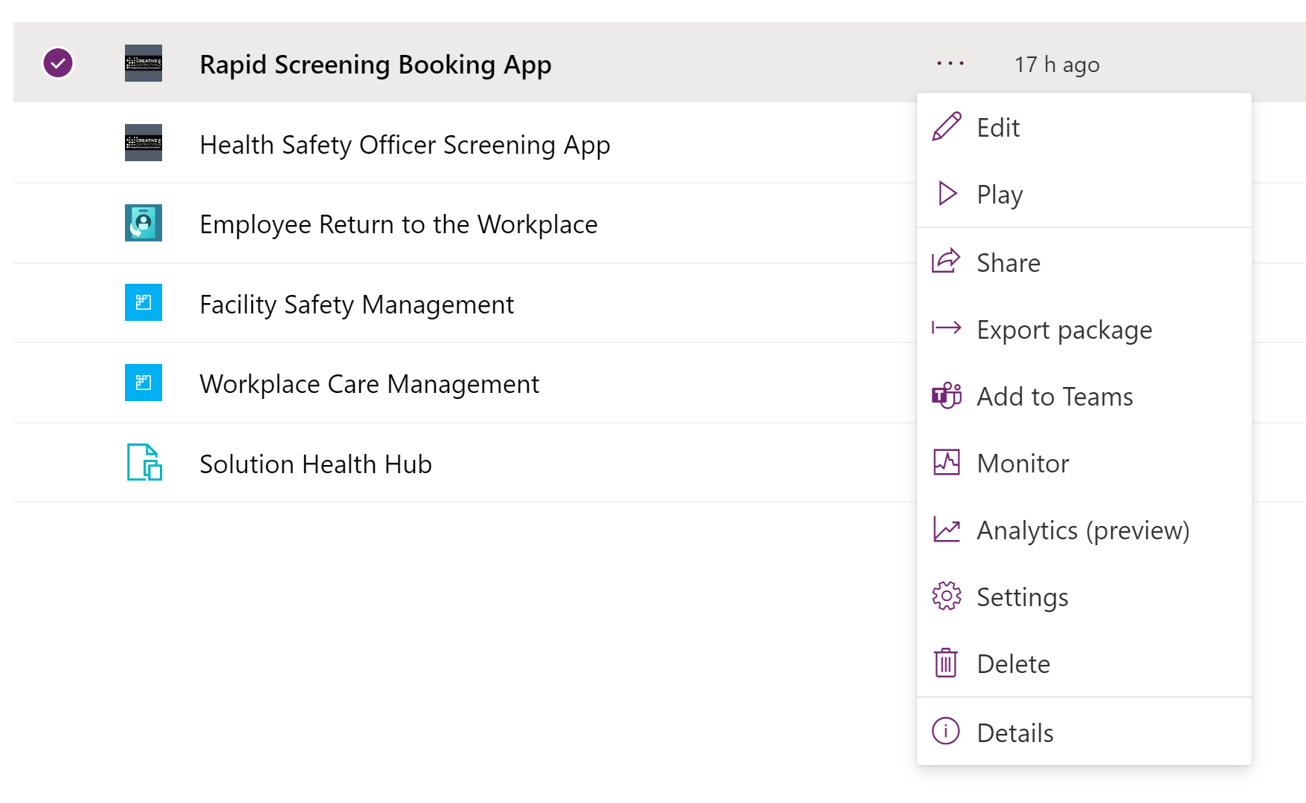

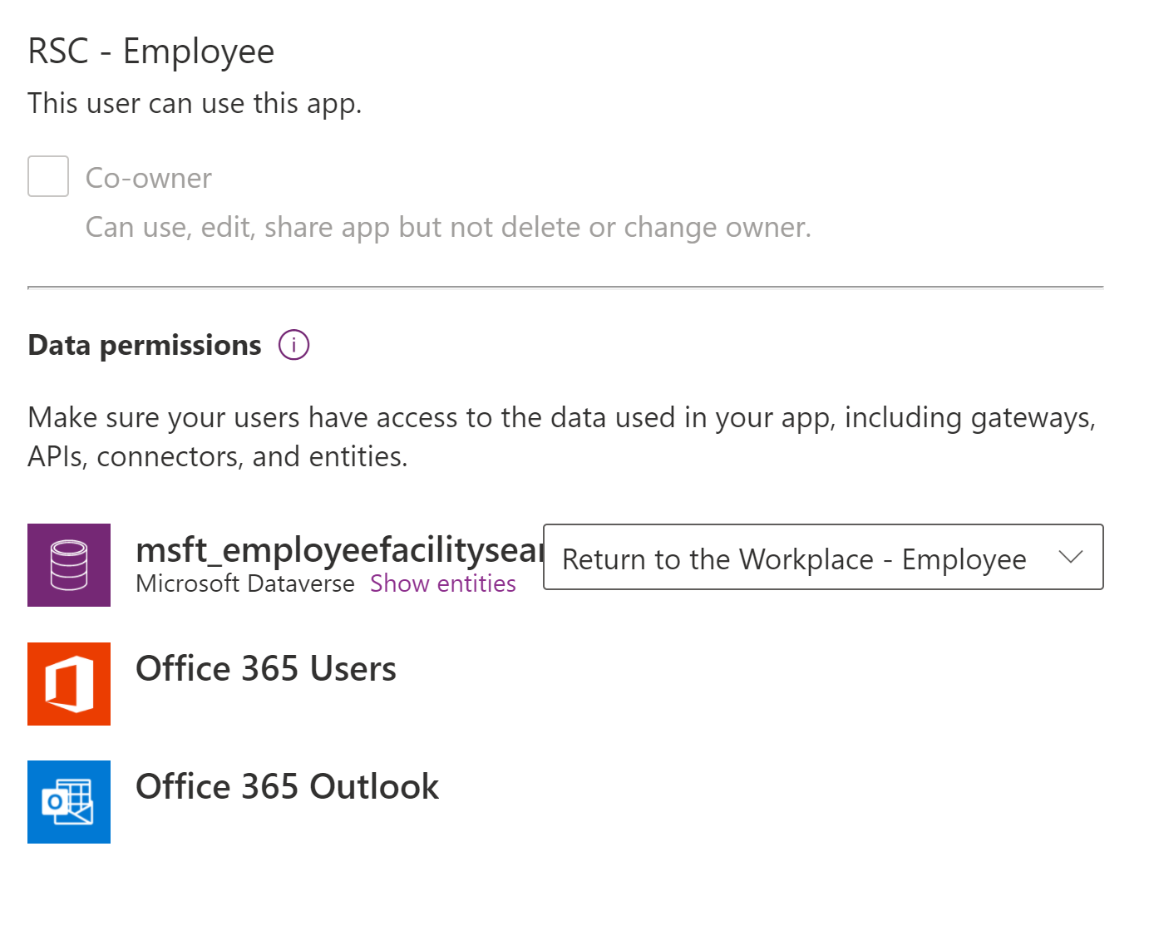

Sharing to HSO AAD group:

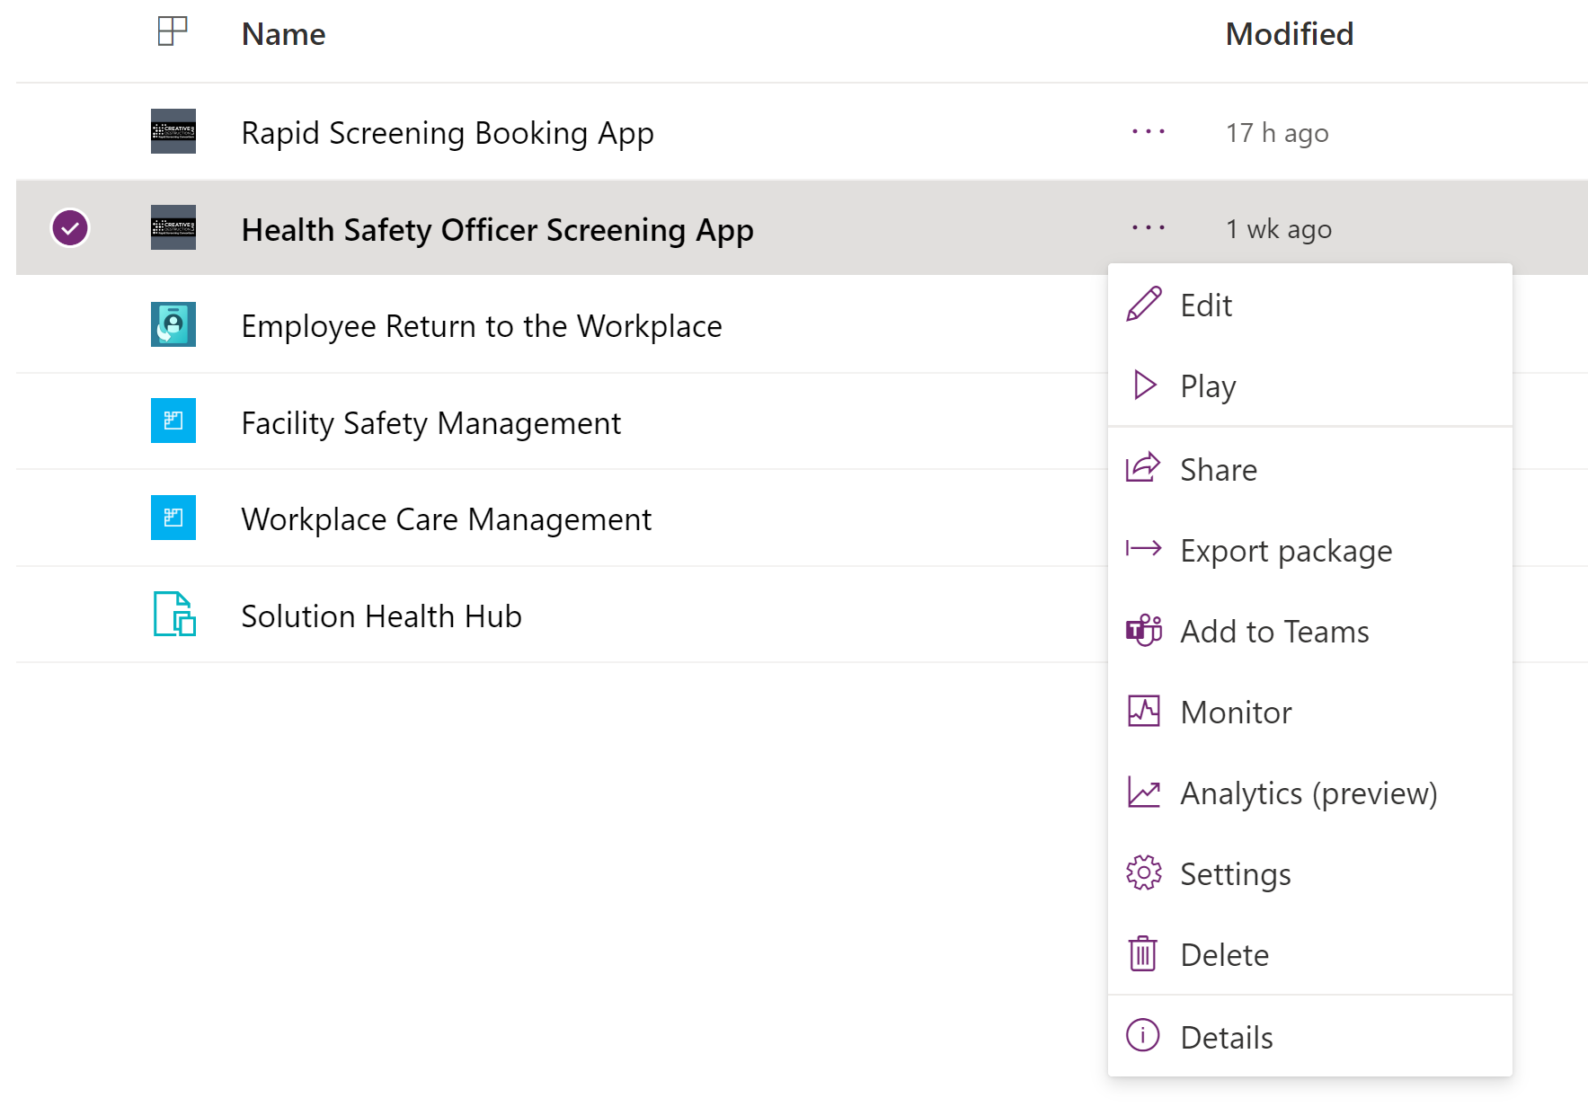

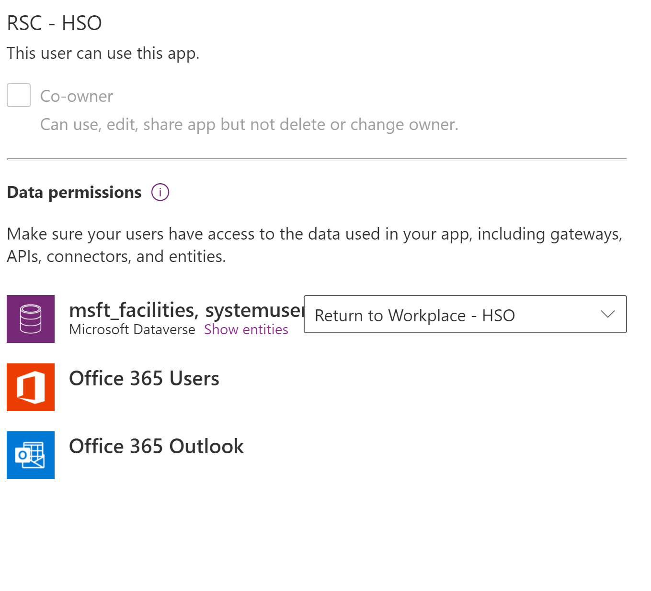

Sharing to Facility managers AAD group:

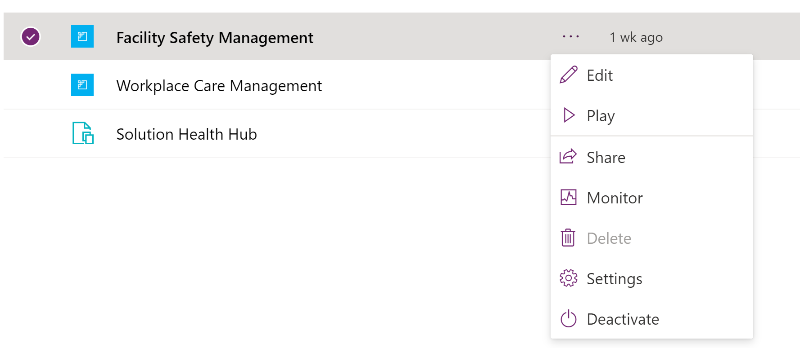

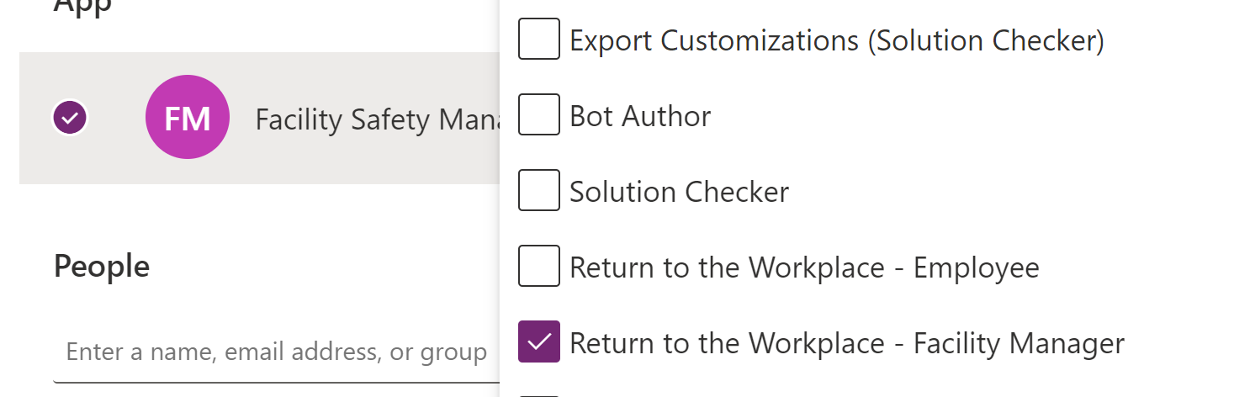

Note:

There might be an error message upon sharing the app to the AAD group. To overcome the error:

1. Share the app to the group with security group selected

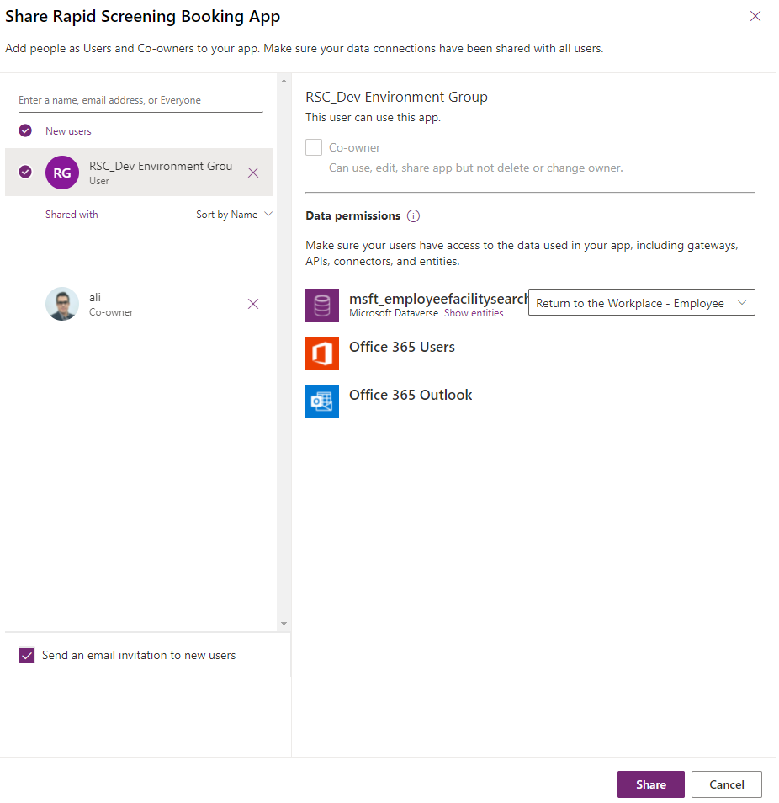

1. Upon clicking on share, you might see below error

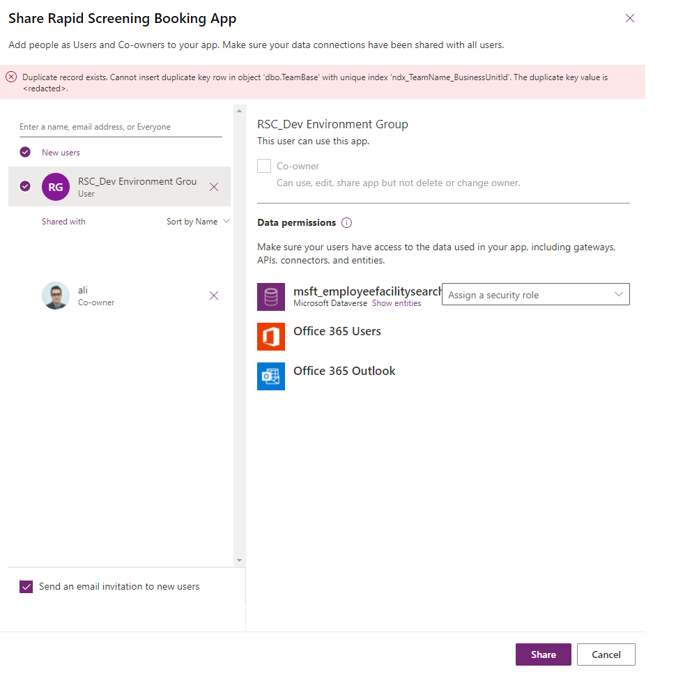

1. Click on share few times for the system to take affect – you can also click on cancel and click to close to share screen and try sharing again – this time you will see the group listed with no security role.

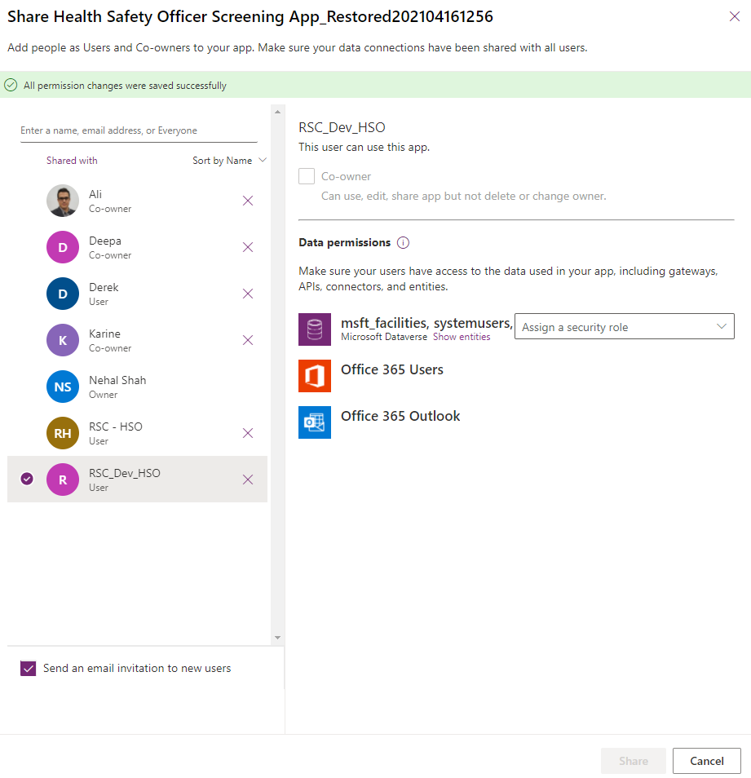

1. Update the security role as needed

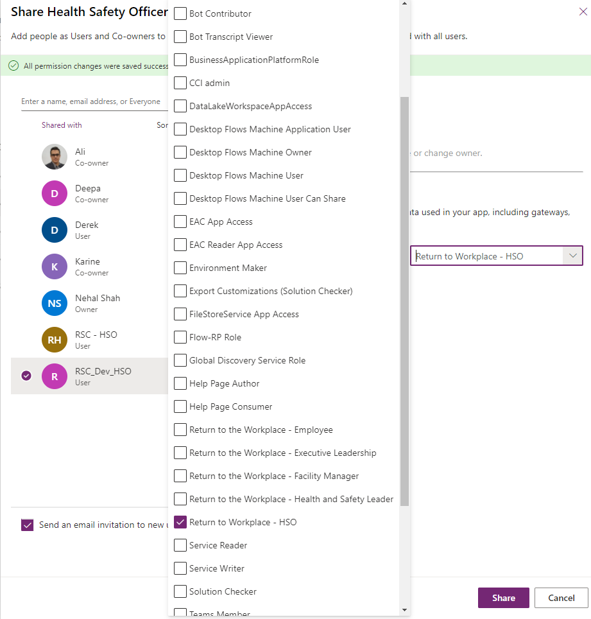

## 7. Launch Apps for the First Time

If you’re part of both Employee and HSO groups – Please start the **Employee Application** First, fill in your **Profile** information, **Save** and then Launch the **HSO Application**. Please **DO NOT** start both applications at the same time for the FIRST time. Launch each application one at a time to ensure it works.

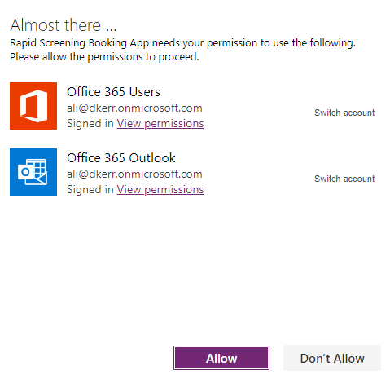

HSO

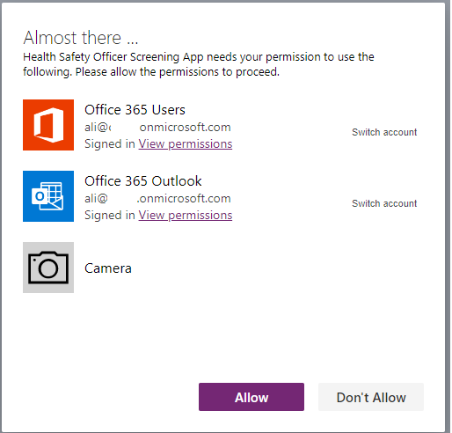

## 8. Add Power Apps in Microsoft Teams

If you have Microsoft Teams deployed, you can leverage Teams for distribution of the Canvas apps. For more details see: [Power Apps and Microsoft Teams integration - Overview - Power Apps | Microsoft Docs](https://docs.microsoft.com/en-us/powerapps/teams/overview)

# Post Deployment Steps

## Enable Auditing

[Audit data and user activity for security and compliance - Power Platform | Microsoft Docs](https://docs.microsoft.com/en-us/power-platform/admin/audit-data-user-activity)

## Audit & Activity Loging

#### Dataverse Audit logs

Dataverse supports an auditing capability where entity and attribute data changes within an organization can be recorded over time for use in analysis and reporting purposes. Auditing is supported on all custom and most customizable entities and attributes.

Member can enable auditing in the Power Platform admin center: [Configure entities and attributes for auditing (Microsoft Dataverse) - Power Apps | Microsoft Docs](https://docs.microsoft.com/en-us/powerapps/developer/data-platform/configure-entities-attributes-auditing)

#### Consent Audit Logs

A custom table in Dataverse called consent audit log is being leveraged to keep track of the employee PII profile consent and medical consent. Any changes employee consent will be captured in this table – this is on top of existing system audit logs mentioned on previous section.

#### Office 365 Security and Compliance Logs

Power app activities can be tracked from Office 365 security and compliance center. Member can enable this on O365 admin center. [Power Apps activity logging - Power Platform | Microsoft Docs](https://docs.microsoft.com/en-us/power-platform/admin/logging-powerapps)

## Availability Monitoring

Microsoft admins can view the status of services and find out when maintenance is scheduled. Service health information is available at any time by signing in to O365 admin center:

[How to check Microsoft 365 service health - Microsoft 365 Enterprise | Microsoft Docs](https://docs.microsoft.com/en-us/microsoft-365/enterprise/view-service-health?view=o365-worldwide)

## Power Platform Center of Excellence(COE) Starter Kit

The Microsoft Power Platform CoE Starter Kit is a collection of components and tools that are designed to help you get started with developing a strategy for adopting and supporting Microsoft Power Platform, with a focus on Power Apps and Power Automate. There are many governance and administration components inside the CoE starter kit that you can deploy to your tenant and start capturing and monitoring the platform on more granular level:

[Microsoft Power Platform Center of Excellence Kit - Power Platform | Microsoft Docs](https://docs.microsoft.com/en-us/power-platform/guidance/coe/starter-kit)

# Processes

List all the flows and explain.

## Application Process Flows

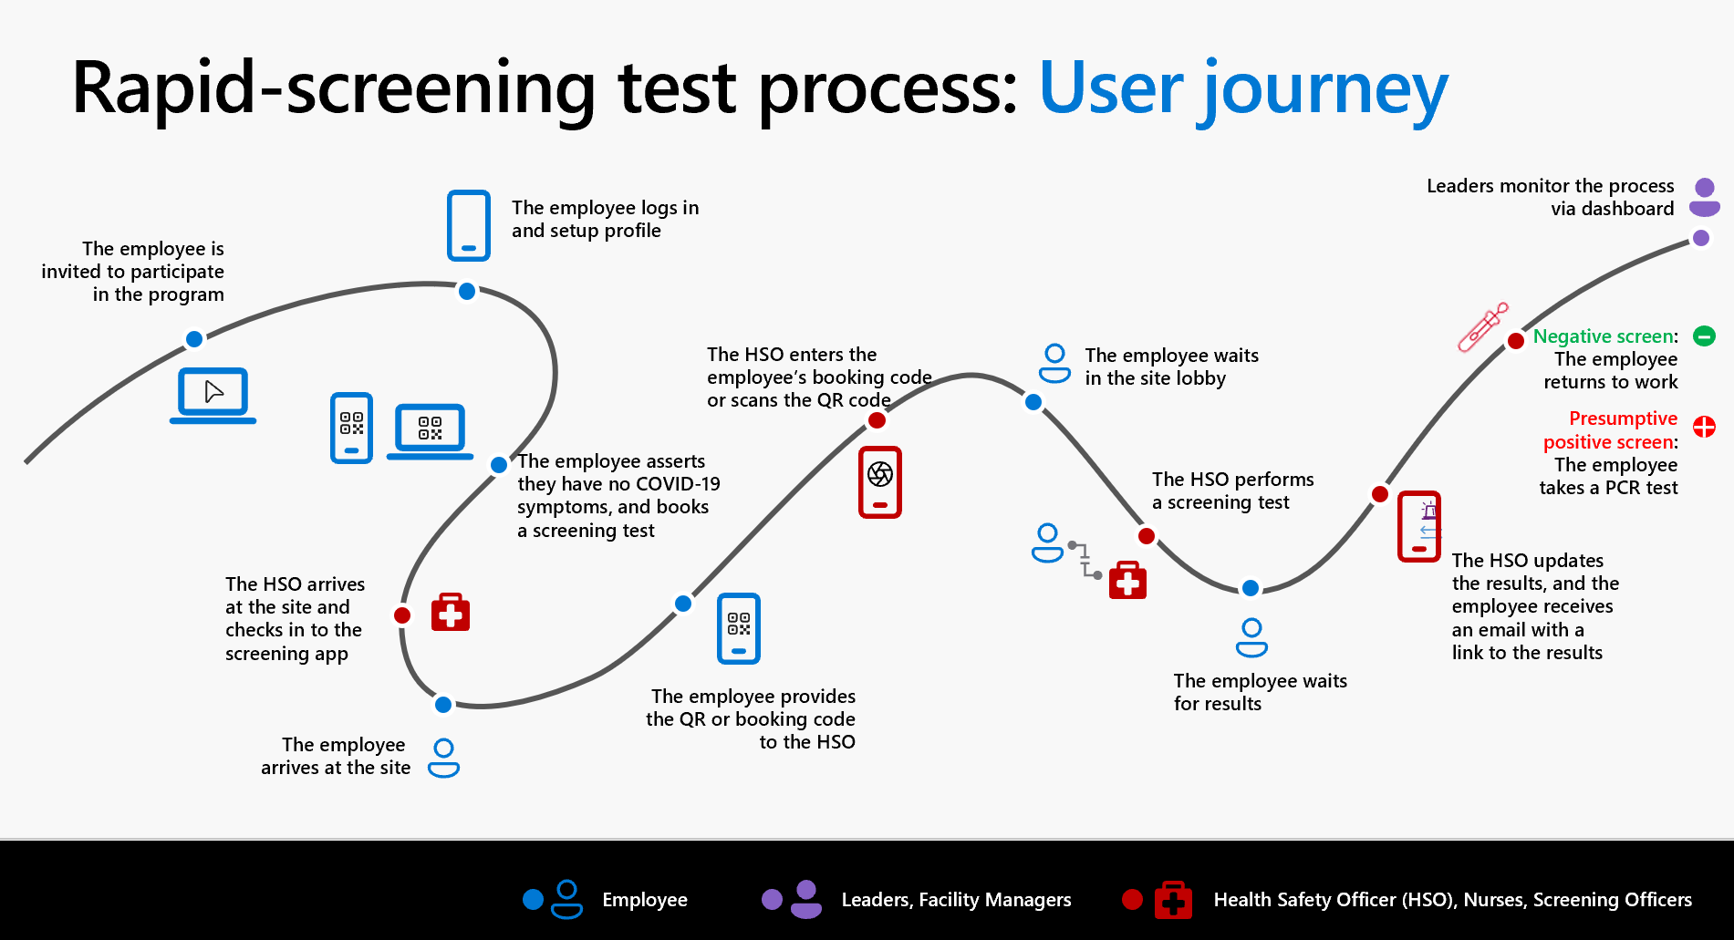

## Power Automate Flows

List of Power Automate Flows in the solution

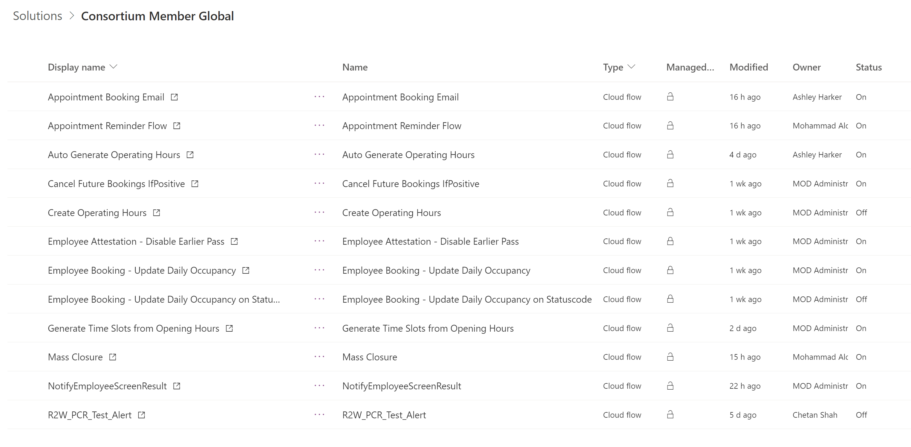

# Power BI Deployment

## Assign Licenses

[Purchase and assign Power BI Pro licenses - Power BI | Microsoft Docs](https://docs.microsoft.com/en-us/power-bi/admin/service-admin-purchasing-power-bi-pro#:~:text=Power%20BI%20License%20Assign%201%20Sign%20in%20to,a%20user%2C%20then%20select%20Assignment%20options...%20See%20More.)

## Power BI – Deployment

The Power BI reports are hosted in GitHub under “Reporting-Template” folder : [RTW-Rapid-Screening/Reporting-Template at main · microsoft/RTW-Rapid-Screening (github.com)](https://github.com/microsoft/RTW-Rapid-Screening/tree/main/Reporting-Template)

There are two Power BI files exist in the GitHub folder and depending on your privacy decision you can chose one of these files to deploy:

1. **RapidScreening_PBITemplate_HSO_v1.pbit** : this report includes the HSO page in the template which includes employees personal information such as screening result and full names. See below for the example of this page.

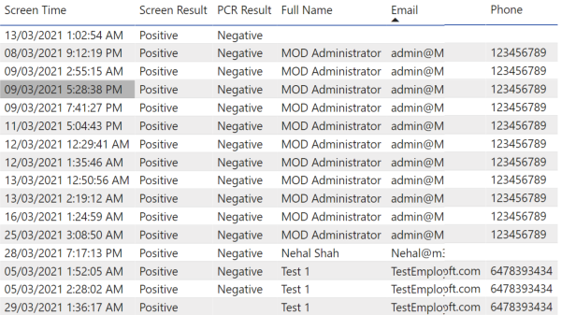

1. **RapidScreening_PBITemplate_without_HSO_v1.pbit** : This report template excludes above report page

Follow below steps to deploy the solution:

1. Make sure to satisfy the requirement and licensing to user Power BI defined on the requirement section of this document earlier.
2. Install Power BI desktop on to your machine: [Downloads | Microsoft Power BI](https://powerbi.microsoft.com/en-us/downloads/)
3. Once installed, double-click on the file downloaded from GitHub – this might take few minutes to open the file depending on your machine performance.
4. Once opened, sign in with an account that has access to Dataverse (with a proper role such as HSO or System admin and license) by clicking on the top right corner.
5. From the toolbar, select **Transform Data** to open **Power Query Editor**

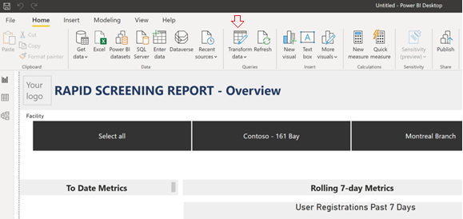

1. Select **cdl_screening** on the left query window and select the **Advanced Editor**

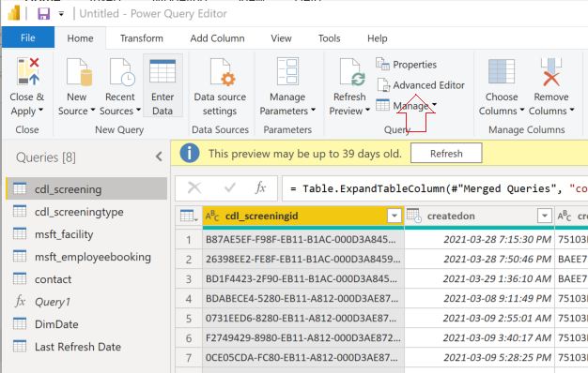

1. On the advanced editor, change the **Dataverse URL** to your target Power Platform URL : CommonDataService.Database("xxxx.crm3.dynamics.com")

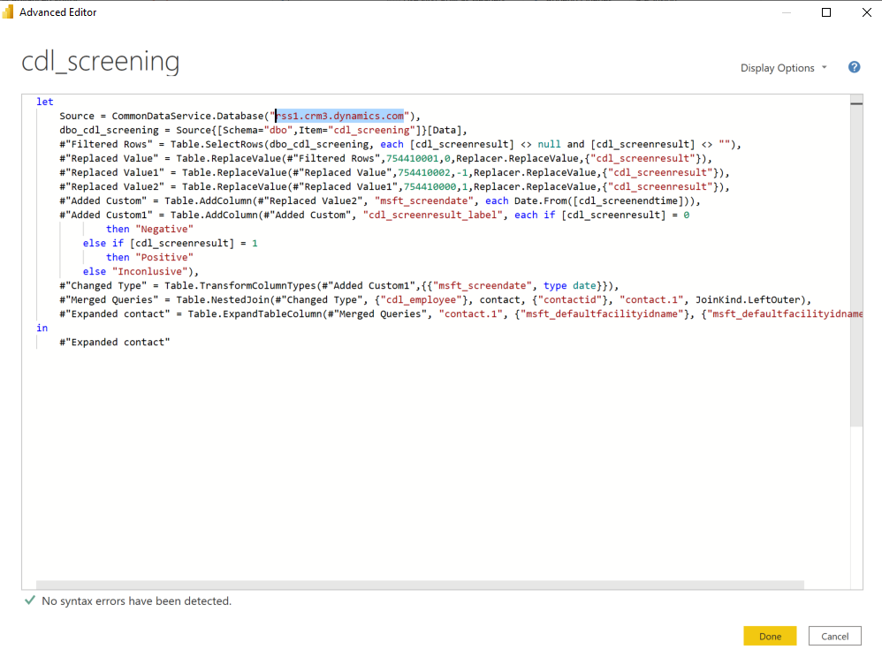

**Note:** to get the Power Platform environment URL :

* Browse to [Power Platform admin center (microsoft.com)](https://admin.powerplatform.microsoft.com/)
* Select the target environment from the list
* Copy the **Environment URL** from the **Details** section

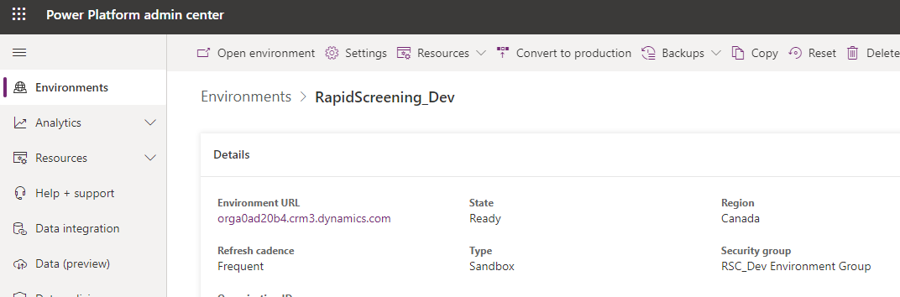

1. Repeat the steps 6 and 7 for **cdl_screeningtype**, **msft_facility**, **msft_employeebooking**, and **contact**.

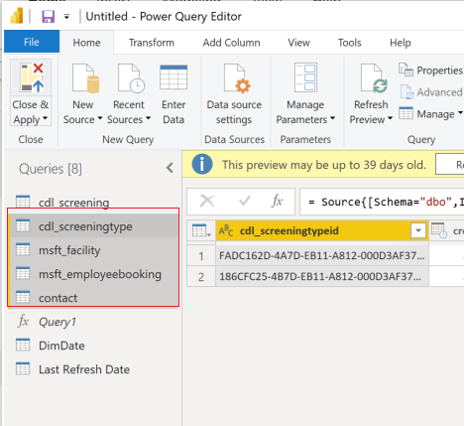

1. Once completed, select **Save and Apply** on top left corner of the **Power Query Editor**
2. Select **Publish** and publish the report to the defined workspace in the Power BI service

### Refreshing Data

Currently refreshing every day. The data must be configured by the member in Power BI Service.

### Security

The report access is managed through sharing and can also be managed through implementing field-level security.

Sharing  
The report can be share through a workspace or Power BI App.   
The access is controlled through AAD permissions. AAD Security groups can be leveraged.

**Field-level Security**

For some records, it will be important to implement field-level security within the application to protect PII-level data. The following example will illustrate how to implement field-level security within the application to protect the email address, personal email address, and phone number of employees. To read more about field-level security in the Power Platform, visit <https://docs.microsoft.com/en-us/power-platform/admin/field-level-security>

1. Field-level security is available for most entities, including custom fields and entities and is managed by the security profiles set up in the application. The System Administrator will be required to set the field-level security settings. It is a two-step process as described below:
   1. Secure the individual fields (email address, personal email address, and phone number)
   2. Configure the security profiles of users who have full access, read, edit, or no access.
2. To begin securing the individual fields, browse to Make.PowerApps.com and login.
3. Ensure the correct **Environment** is selected in the top right-hand corner.
4. Select the **Settings** icon and open the **Settings** panel.
5. Select **Advanced Settings**
6. Select **Settings** > **Customizations** > **Customize the System** > **Entities**

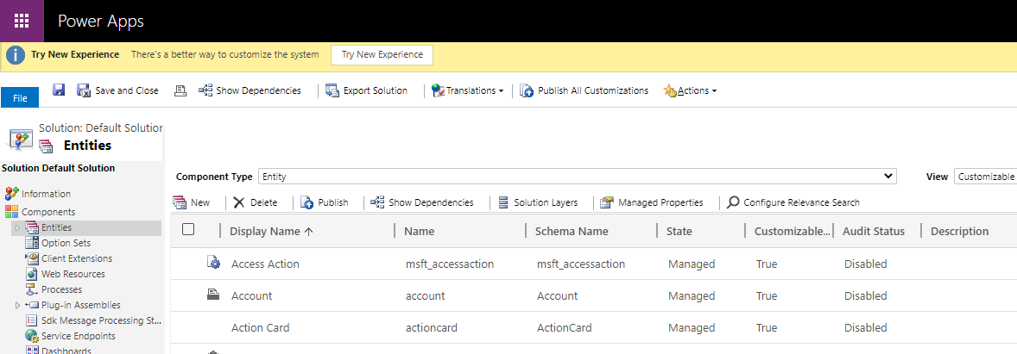

1. Select the appropriate entity which contains the fields requiring field-level security. For the example of email address, personal email address, and phone number, we will use the **Contact** entity.
   1. Scroll down on the left side menu and click on the **Contact** entity.
   2. Select **Fields** under the **Contact** entity and locate the **cdl_personalemail** field.

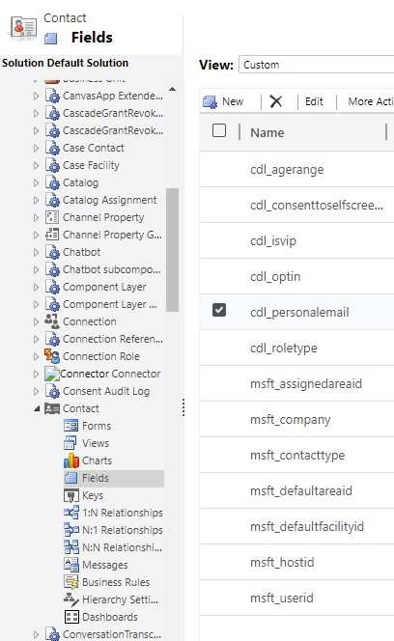

1. Double-click on the **Personal Email** record. A new screen will pop-up. Enable **Field Security**. Select **Save and Close**. Repeat action for **Email Address** and **Phone Number**.

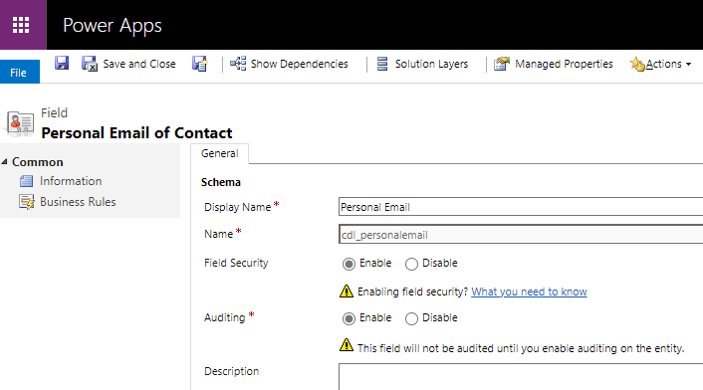

1. Select **Publish all customizations**.

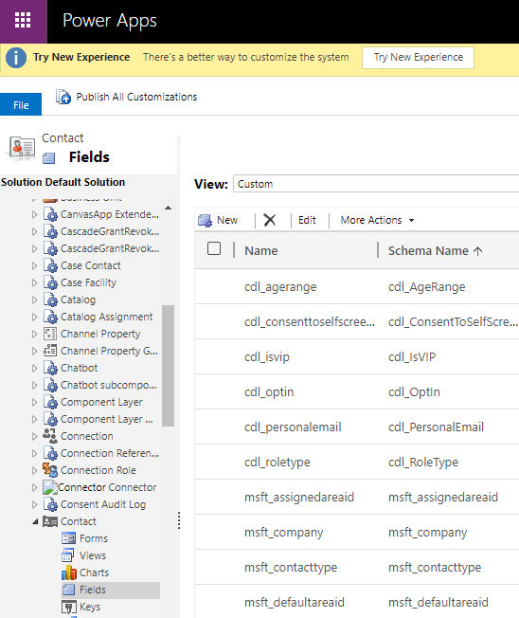

1. Return to the **Settings** menu and select **Settings**>**Security**>**Field Security Profiles**.

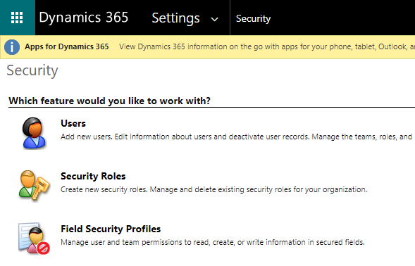

1. On this screen, users can either update the permissions of current users or add new users.
   1. When a new user is added, a ‘Team’ can be added to the user to allow for a larger number of users, instead of adding individual users at one time.
2. To update field-level permissions, select a user and select **Field Permissions** on the left side menu. Double-click on the appropriate field (e.g.: **Personal Email**) and select options for **Read**, **Update**, or **Create**. Select **Save and Close**.

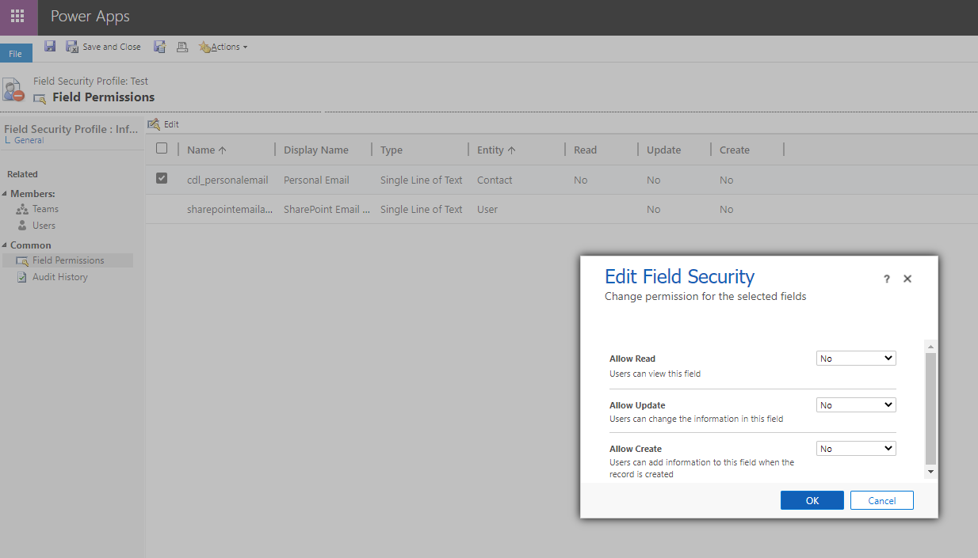

# Application Lifecycle Management

## Backup & Restore

Dataverse provides two types of backups: automatic backups, referred to as *system* backups, and *manual* backups. System backups back up all environments. They take place automatically and continuously. The underlying technology used is Azure SQL Database. Both back up types are stored in the cloud for 28 days.

It is highly recommended to take manual backup of the Dataverse before deploying solution or performing any changes on the UAT and Production environments:

[Back up and restore environments - Power Platform | Microsoft Docs](https://docs.microsoft.com/en-us/power-platform/admin/backup-restore-environments)

## Solutions Deployment

Power Platform Application lifecycle management (ALM) is mainly based on the concept of the solution. The main solution that contains the customization for repaid screening is called “Consortium Member Global”. this solution contains all the apps, processes, and data structure.

Environment admins can export this solution from development environment and deploy it to the target environment as a managed solution.

### Test/UAT Deployment

#### First Time Deployment

Use environment copy to create an exact copy of the fully configured development environment into the Test/UAT environment.

#### Subsequent Deployments

For any deployment after initial copy from development to Test/UAT use solution package.

Exported solution file from development environment and deploy.

### Production Deployment

For production deployment, use managed solution. package the

### Application Lifecycle Management (ALM)

[Application lifecycle management (ALM) with Microsoft Power Platform - Power Platform | Microsoft Docs](https://docs.microsoft.com/en-us/power-platform/alm/overview-alm#:~:text=ALM%20for%20Power%20Apps%2C%20Power%20Automate%2C%20and%20Common,ALM%20must%20include%20a%20Common%20Data%20Service%20database.)

# Extensibility

Members organizations have full access to the solution files once it is deployed to their tenant. It is possible to modify the solution to some extent, but it is important to not modify the core data model (in Dataverse) as it might cause Azure Function integration issues.

Also, modification might get overwritten if member orgs are planning to upgrade or update the solution with future versions from Microsoft.

# Appendix A - Reference

* 1. **Microsoft Power Platform - PowerApps**

**Power Apps** - Power Apps provides a low-code approach to rapidly build apps for any device while seamlessly working with Azure services through a rich extensibility model for professional developers.

<https://azure.microsoft.com/en-us/services/developer-tools/power-platform/>

<https://azure.microsoft.com/en-us/solutions/low-code-application-development/>

* 1. **Microsoft Power Platform – Dataverse**

General info on Dataverse: <https://powerplatform.microsoft.com/en-us/dataverse/>

The Dataverse Web API: <https://docs.microsoft.com/en-us/powerapps/developer/data-platform/webapi/overview>